Filed by The Shyft Group, Inc.

(Commission File No.: 001-33582)

Pursuant to Rule 425 of the Securities Act of 1933
Subject Company: The Shyft Group, Inc.
(Commission File No.: 001-33582)

On April 24, 2025, The Shyft Group, Inc. (“Shyft”) made the following investor presentation available to investors in connection with Shyft’s financial results for the quarter ended March 31, 2025, which includes supplemental information regarding its proposed merger with an indirect, wholly owned subsidiary of Aebi Schmidt Holding AG (“Aebi Schmidt”):
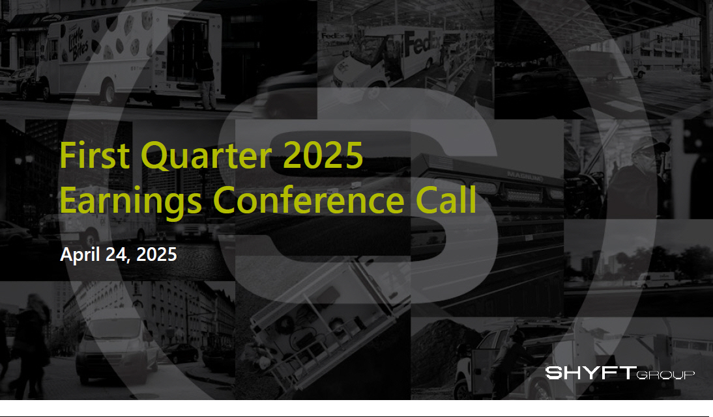

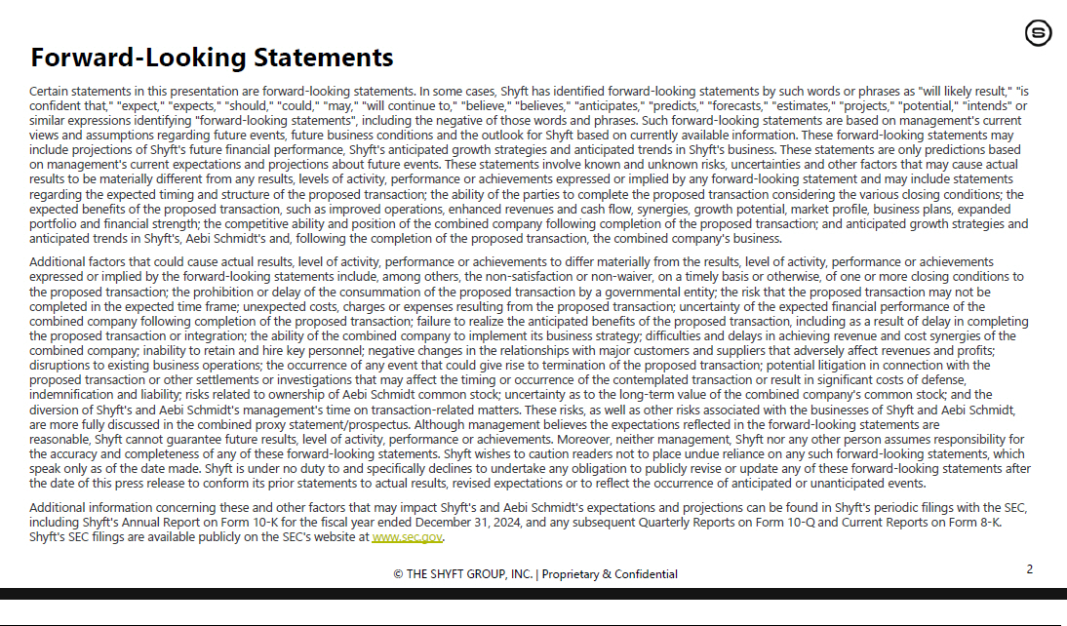

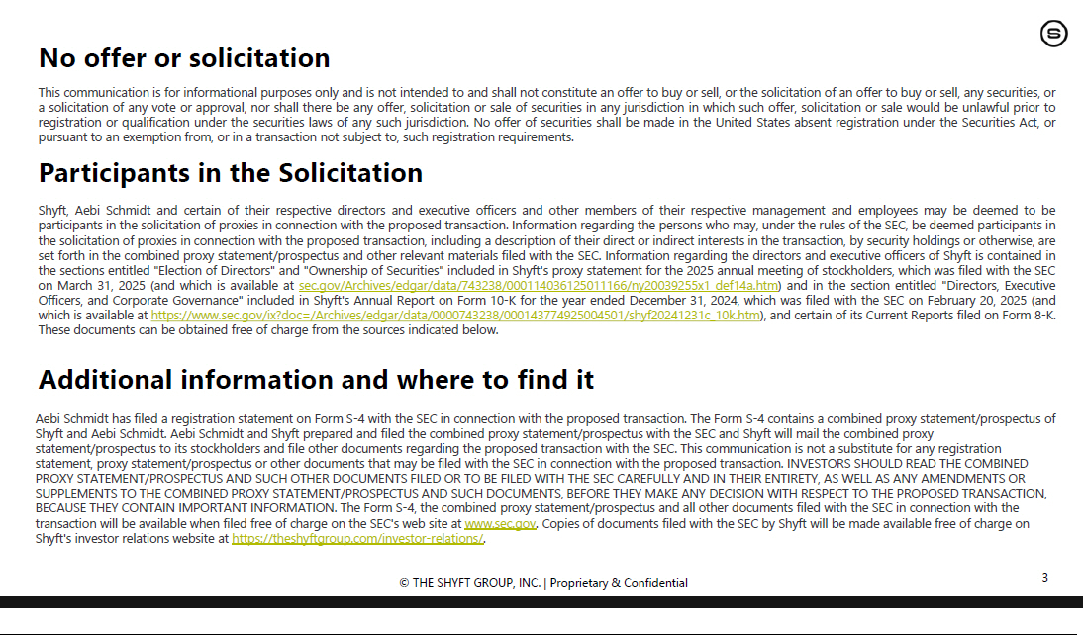

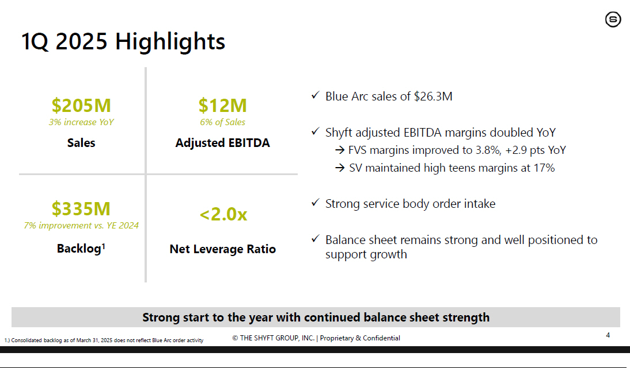

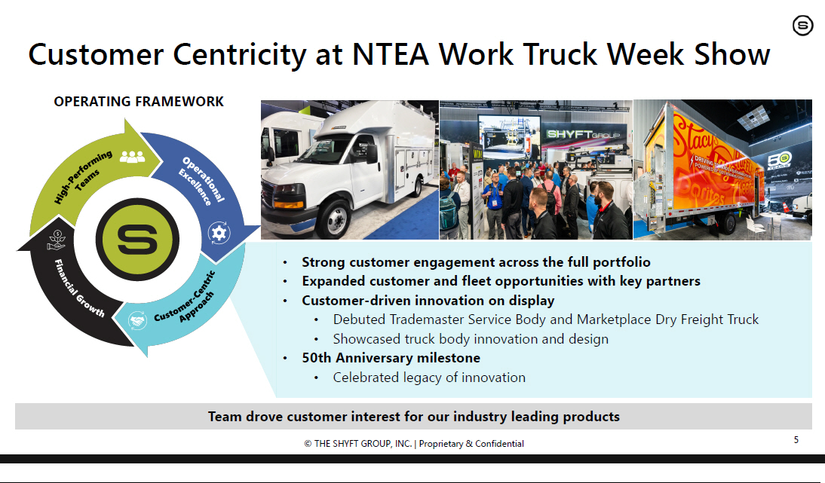

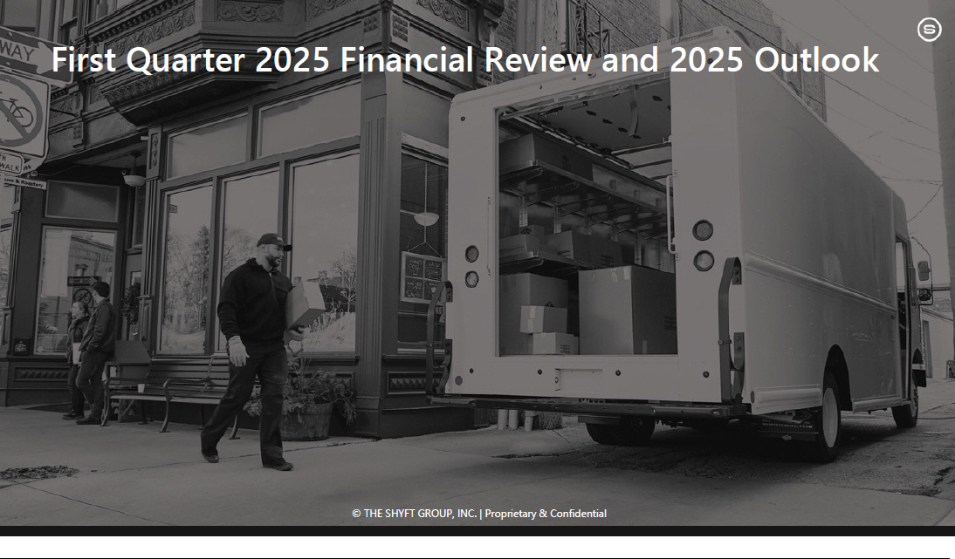

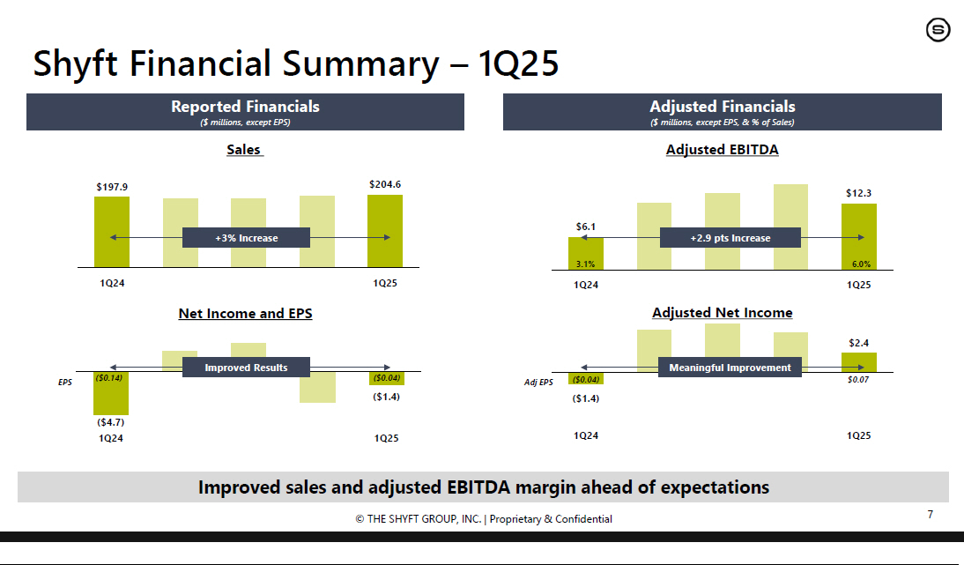

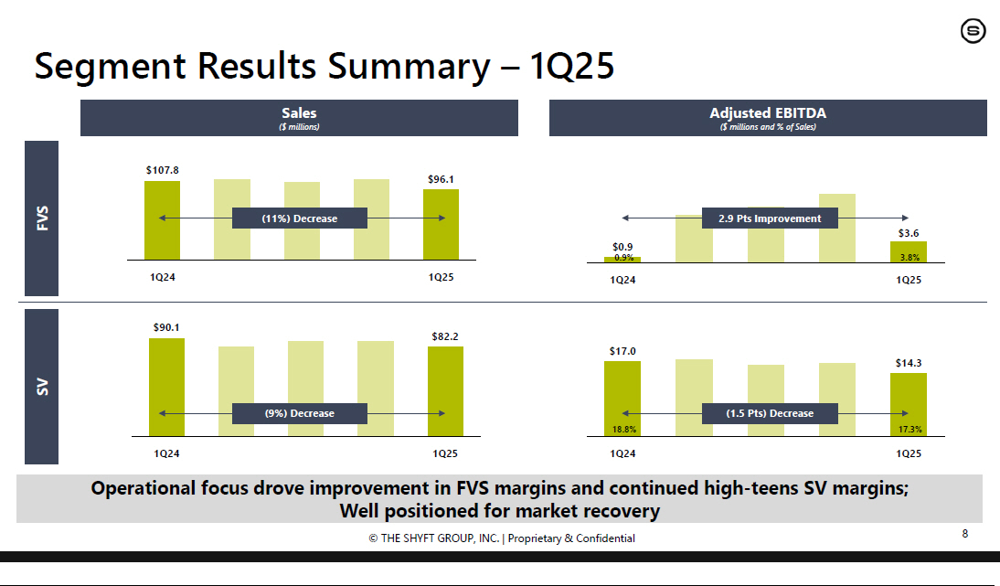

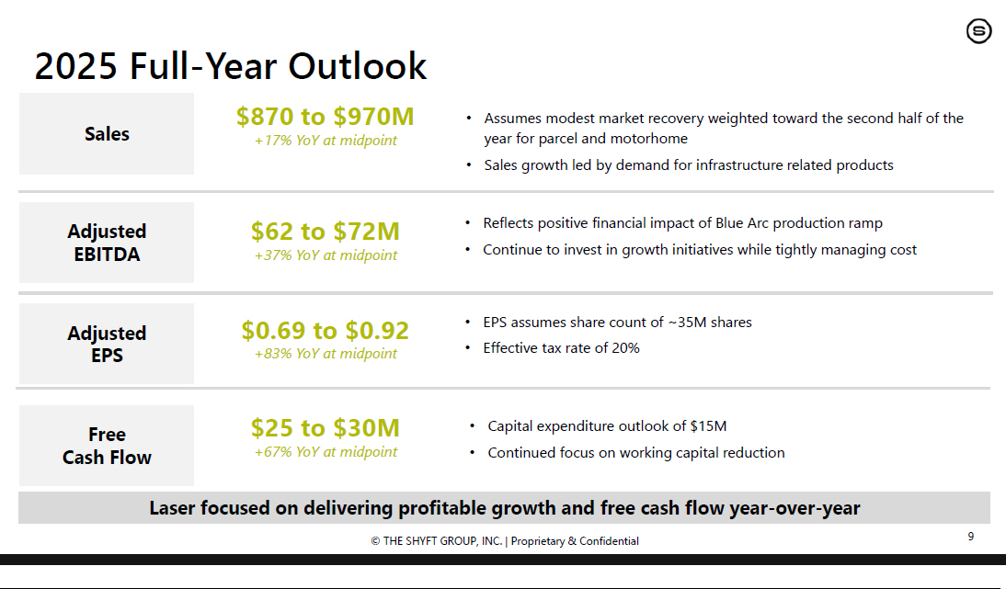



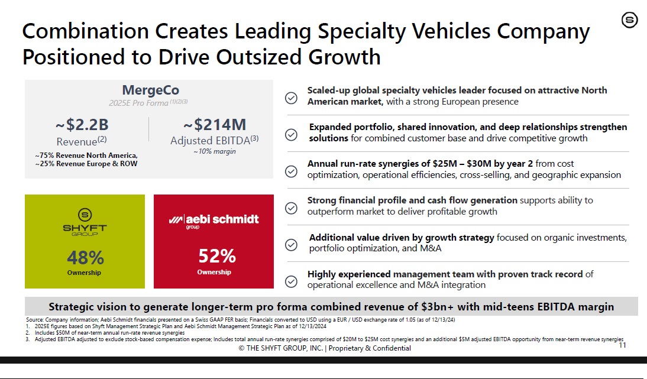

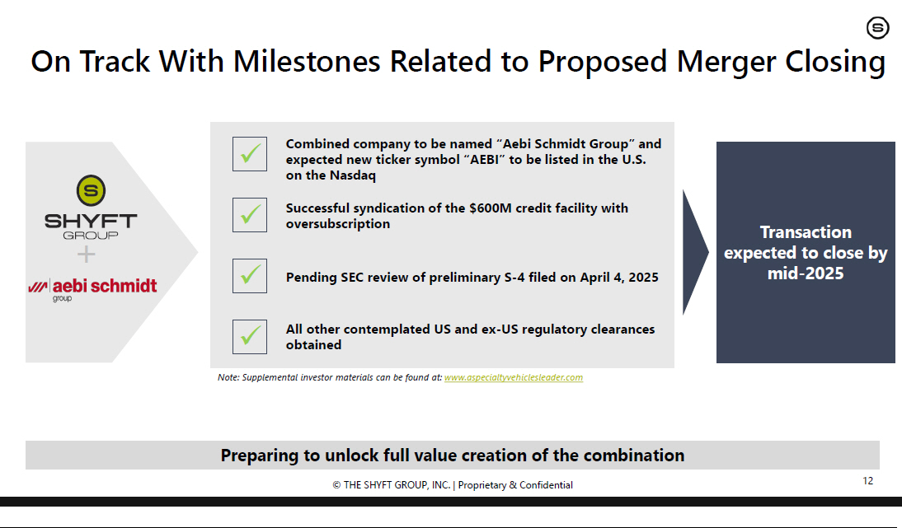

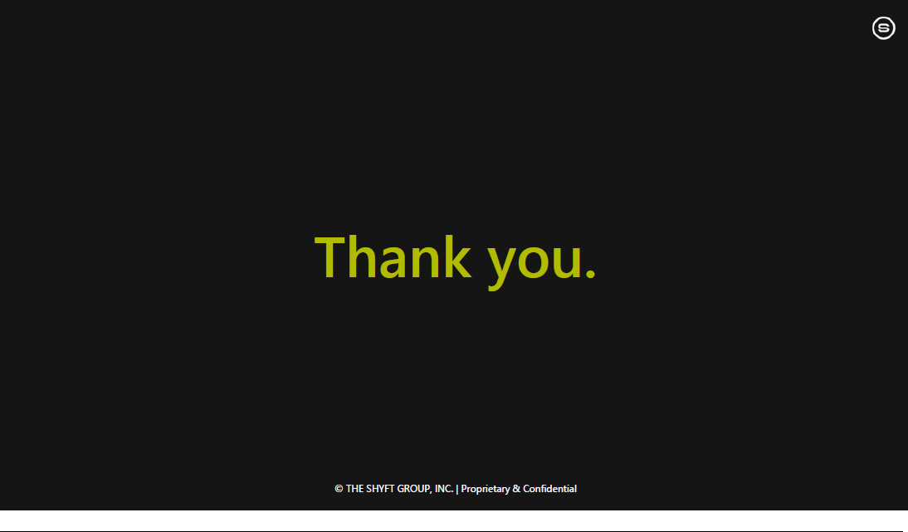

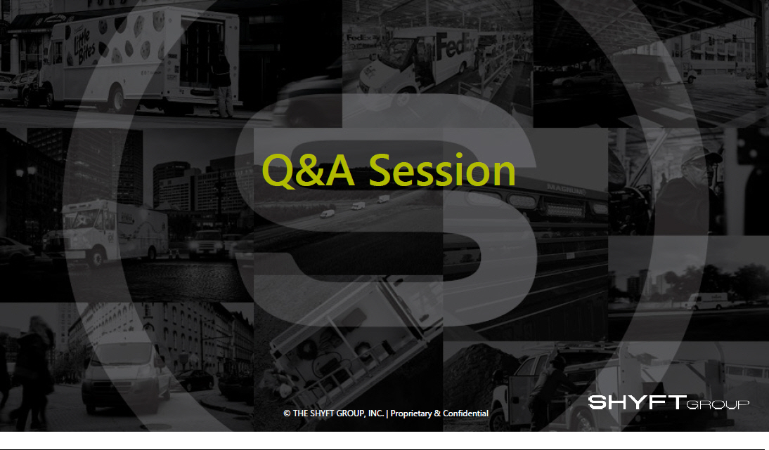



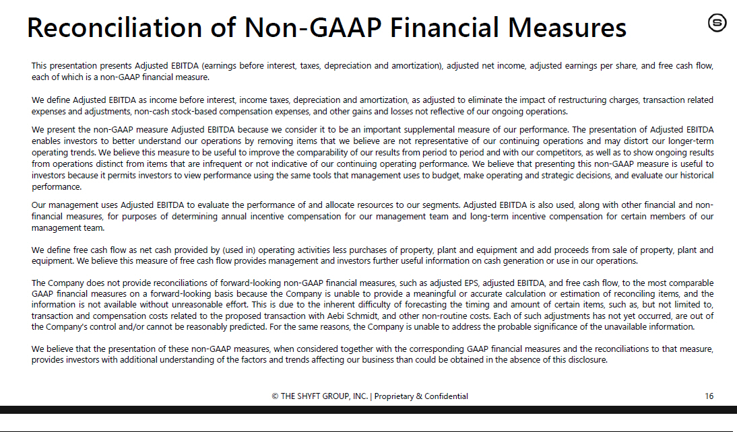

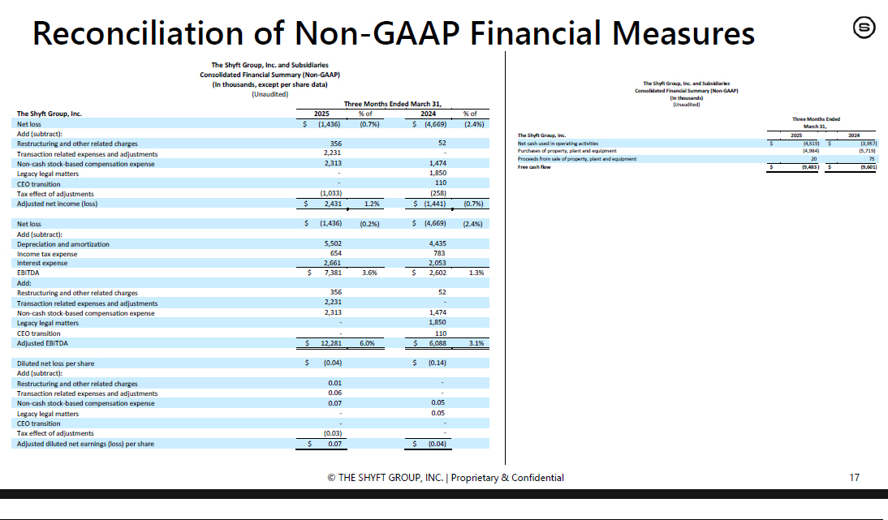

No offer or solicitation

This communication is for informational purposes only and is not intended to and shall not constitute an offer to buy or sell, or the solicitation of an offer to buy or sell, any securities, or a solicitation of any vote or approval, nor shall there be any offer, solicitation or sale of securities in any jurisdiction in which such offer, solicitation or sale would be unlawful prior to registration or qualification under the securities laws of any such jurisdiction. No offer of securities shall be made in the United States absent registration under the U.S. Securities Act of 1933, as amended (“Securities Act”), or pursuant to an exemption from, or in a transaction not subject to, such registration requirements.

Participants in the Solicitation

Shyft, Aebi Schmidt and certain of their respective directors and executive officers and other members of their respective management and employees may be deemed to be participants in the solicitation of proxies in connection with the proposed transaction. Information regarding the persons who may, under the rules of the Securities and Exchange Commission (“SEC”), be deemed participants in the solicitation of proxies in connection with the proposed transaction, including a description of their direct or indirect interests in the transaction, by security holdings or otherwise, are set forth in the combined proxy statement/prospectus and other relevant materials filed with the SEC. Information regarding the directors and executive officers of Shyft is contained in the sections entitled “Election of Directors” and “Ownership of Securities” included in Shyft’s proxy statement for the 2025 annual meeting of stockholders, which was filed with the SEC on March 31, 2025 (and which is available at https://www.sec.gov/ix? doc=/Archives/edgar/data/0000743238/000114036125011166/ny20039255x1_def14a.htm) and in the section entitled “Directors, Executive Officers and Corporate Governance” included in Shyft’s Annual Report on Form 10-K for the year ended December 31, 2024, which was filed with the SEC on February 20, 2025 (and which is available at https://www.sec.gov/ix?doc=/Archives/edgar/data/0000743238/000143774925004501/shyf20241231c_10k.htm), and certain of its Current Reports filed on Form 8-K. These documents can be obtained free of charge from the sources indicated below.

Additional information and where to find it

Aebi Schmidt filed a registration statement on Form S-4 with the SEC in connection with the proposed transaction. The Form S-4 contains a combined proxy statement/prospectus of Shyft and Aebi Schmidt. Aebi Schmidt and Shyft prepared and filed the combined proxy statement/prospectus with the SEC and Shyft will mail the combined proxy statement/prospectus to its stockholders and file other documents regarding the proposed transaction with the SEC. This communication is not a substitute for any registration statement, proxy statement/prospectus or other documents that may be filed with the SEC in connection with the proposed transaction. INVESTORS SHOULD READ THE COMBINED PROXY STATEMENT/PROSPECTUS AND SUCH OTHER DOCUMENTS FILED OR TO BE FILED WITH THE SEC CAREFULLY AND IN THEIR ENTIRETY, AS WELL AS ANY AMENDMENTS OR SUPPLEMENTS TO THE COMBINED PROXY STATEMENT/PROSPECTUS AND SUCH DOCUMENTS, BEFORE THEY MAKE ANY DECISION WITH RESPECT TO THE PROPOSED TRANSACTION, BECAUSE THEY CONTAIN IMPORTANT INFORMATION. The Form S-4, the combined proxy statement/prospectus and all other documents filed with the SEC in connection with the transaction will be available when filed free of charge on the SEC’s web site at www.sec.gov. Copies of documents filed with the SEC by Shyft will be made available free of charge on Shyft’s investor relations website at https://theshyftgroup.com/investor-relations/.

Forward-Looking Statements

Certain statements in this communication are forward-looking statements. In some cases, Shyft has identified forward-looking statements by such words or phrases as “will likely result,” “is confident that,” “expect,” “expects,” “should,” “could,” “may,” “will continue to,” “believe,” “believes,” “anticipates,” “predicts,” “forecasts,” “estimates,” “projects,” “potential,” “intends” or similar expressions identifying “forward-looking statements”, including the negative of those words and phrases. Such forward-looking statements are based on management’s current views and assumptions regarding future events, future business conditions and the outlook for Shyft based on currently available information. These forward-looking statements may include projections of Shyft’s future financial performance, Shyft’s anticipated growth strategies and anticipated trends in Shyft’s business. These statements are only predictions based on management’s current expectations and projections about future events. These statements involve known and unknown risks, uncertainties and other factors that may cause actual results to be materially different from any results, levels of activity, performance or achievements expressed or implied by any forward-looking statement and may include statements regarding the expected timing and structure of the proposed transaction; the ability of the parties to complete the proposed transaction considering the various closing conditions; the expected benefits of the proposed transaction, such as improved operations, enhanced revenues and cash flow, synergies, growth potential, market profile, business plans, expanded portfolio and financial strength; the competitive ability and position of the combined company following completion of the proposed transaction; and anticipated growth strategies and anticipated trends in Shyft’s, Aebi Schmidt’s and, following the completion of the proposed transaction, the combined company’s business.

Additional factors that could cause actual results, level of activity, performance or achievements to differ materially from the results, level of activity, performance or achievements expressed or implied by the forward-looking statements include, among others, the non-satisfaction or non-waiver, on a timely basis or otherwise, of one or more closing conditions to the proposed transaction; the prohibition or delay of the consummation of the proposed transaction by a governmental entity; the risk that the proposed transaction may not be completed in the expected time frame; unexpected costs, charges or expenses resulting from the proposed transaction; uncertainty of the expected financial performance of the combined company following completion of the proposed transaction; failure to realize the anticipated benefits of the proposed transaction, including as a result of delay in completing the proposed transaction or integration; the ability of the combined company to implement its business strategy; difficulties and delays in achieving revenue and cost synergies of the combined company; inability to retain and hire key personnel; negative changes in the relationships with major customers and suppliers that adversely affect revenues and profits; disruptions to existing business operations; the occurrence of any event that could give rise to termination of the proposed transaction; potential litigation in connection with the proposed transaction or other settlements or investigations that may affect the timing or occurrence of the contemplated transaction or result in significant costs of defense, indemnification and liability; risks related to ownership of Aebi Schmidt common stock; uncertainty as to the long-term value of the combined company’s common stock; and the diversion of Shyft’s and Aebi Schmidt’s management’s time on transaction-related matters. These risks, as well as other risks associated with the businesses of Shyft and Aebi Schmidt, are more fully discussed in the combined proxy statement/prospectus. Although management believes the expectations reflected in the forward-looking statements are reasonable, Shyft cannot guarantee future results, level of activity, performance or achievements. Moreover, neither management, Shyft nor any other person assumes responsibility for the accuracy and completeness of any of these forward-looking statements. Shyft wishes to caution readers not to place undue reliance on any such forward-looking statements, which speak only as of the date made. Shyft is under no duty to and specifically declines to undertake any obligation to publicly revise or update any of these forward -looking statements after the date of this communication to conform its prior statements to actual results, revised expectations or to reflect the occurrence of anticipated or unanticipated events.

Additional information concerning these and other factors that may impact Shyft’s and Aebi Schmidt’s expectations and projections can be found in Shyft’s periodic filings with the SEC, including Shyft’s Annual Report on Form 10-K for the fiscal year ended December 31, 2024, and any subsequent Quarterly Reports on Form 10-Q and Current Reports on Form 8-K. Shyft’s SEC filings are available publicly on the SEC’s website at www.sec.gov.

