TABLE OF CONTENTS

UNITED STATES

SECURITIES AND EXCHANGE COMMISSION

Washington, D.C. 20549

SCHEDULE 14A

Proxy Statement Pursuant to Section 14(a) of the
Securities Exchange Act of 1934

Filed by the Registrant ☒ Filed by a Party other than the Registrant ☐

Check the appropriate box:

  - Preliminary Proxy Statement

  - Confidential, for Use of the Commission Only (as permitted by Rule 14a-6(e)(2))

- Definitive Proxy Statement

  - Definitive Additional Materials

  - Soliciting Material Pursuant to Section 240.14a-12

The Shyft Group, Inc.

(Name of Registrant as Specified In Its Charter)

(Name of Person(s) Filing Proxy Statement, if other than the Registrant)

Payment of Filing Fee (Check the appropriate box):

- No fee required.

  - Fee computed on table below per Exchange Act Rules 14a-6(i)(1) and 0-11.

    - Title of each class of securities to which transaction applies:

    - Aggregate number of securities to which transaction applies:

    - Per unit price or other underlying value of transaction computed pursuant to Exchange Act Rule 0-11 (set forth the amount on which the filing fee is calculated and state how it was determined):

    - Proposed maximum aggregate value of transaction:

    - Total fee paid:

  - Fee paid previously with preliminary materials.

  - Check box if any part of the fee is offset as provided by Exchange Act Rule 0-11(a)(2) and identify the filing for which the offsetting fee was paid previously. Identify the previous filing by registration statement number, or the Form or Schedule and the date of its filing.

    - Amount Previously Paid:

    - Form, Schedule or Registration Statement No.:

    - Filing Party:

    - Date Filed:

TABLE OF CONTENTS
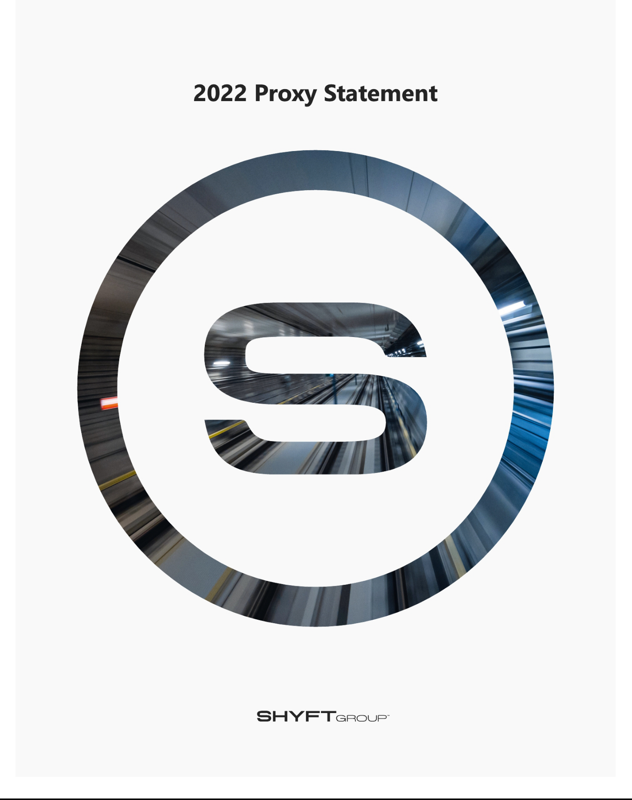

TABLE OF CONTENTS

41280 Bridge St. // Novi, MI

48375

theshyftgroup.com



April 5, 2022

Dear Fellow Shyft Shareholder:

We are pleased to report that, in a year filled with industry-wide challenges and uncertainty, the Shyft team proactively managed through it all with resourcefulness and relentless focus on execution for all of our stakeholders, to deliver consistent, industry-leading results quarter after quarter.

Highlights of Shyft performance in 2021 include:

- Achieving 47% year-over-year revenue growth with sales of $992 million and Adjusted EBITDA of $108 million, each of which are performance records.

- Generating $51 million in free cash flow.

- Upsizing our credit facility to $400 million from $175 million to optimize Shyft’s ability to pursue growth opportunities.

- Finishing the year with no debt.

- Creating shareholder value with a 73% increase in share price.

- Being named as one of Fortune’s Top 100 Fastest Growing Companies.

- Announcing in June 2021 plans to develop our new electric delivery vehicle on our proprietary chassis – and unveiling the prototype in March 2022.

Looking ahead, it is our pleasure to invite you to join us for The Shyft Group, Inc. 2022 Annual Meeting of Shareholders, which will be webcast on Wednesday, May 18, 2022, at 10:00 a.m. Eastern Time.

The annual meeting will be conducted in a virtual-only format. Information regarding attending the virtual annual meeting can be found in the proxy statement. Details about the annual meeting, nominees for election to the Board of Directors and other matters to be acted on at the annual meeting are presented in the notice of the annual meeting and proxy statement to follow.

Thank you for your continued support of Shyft.

Sincerely,
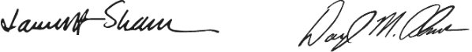

James A. Sharman | Daryl M. Adams
Chair of the Board | President and CEO

TABLE OF CONTENTS

Notice of 2022 Annual Meeting of Shareholders

To the Shareholders of The Shyft Group, Inc.:

The 2022 Annual Meeting of Shareholders (the “Annual Meeting”) of The Shyft Group, Inc. (the “Company” or “Shyft”) will be held on Wednesday, May 18, 2022, at 10:00 a.m. Eastern Time. This year’s Annual Meeting will be a completely virtual meeting of shareholders. You will be able to attend and vote during the Annual Meeting, via live webcast by visiting www.virtualshareholdermeeting.com/SHYF2022. You may also submit questions online before the start of the Annual Meeting. Prior to the Annual Meeting, you may vote at www.proxyvote.com on the following matters:
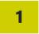

Elect three directors to serve until the Annual Meeting of Shareholders in 2025;

Ratify the appointment of Deloitte & Touche LLP (“Deloitte”) as the Company’s independent registered public accounting firm for the fiscal year ending December 31, 2022;
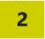

Approve, on a non-binding advisory basis, the compensation paid to the Company’s named executive officers (“NEOs”); and
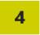

Transact other business as may properly come before the meeting.

We encourage you to read this proxy statement and our 2021 Annual Report and to visit our website at www.theshyftgroup.com to learn more about Shyft. There you will find additional information about our performance and how we are working to enhance shareholder value.

Finally, we encourage you to vote regardless of the size of your holdings. Every vote is important, and your participation helps us do a better job of understanding and acting on what matters to you as a shareholder. You can cast your vote by internet, by telephone or by mailing a printed proxy card as outlined in this document.
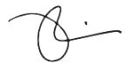

Joshua Sherbin

Corporate Secretary

April 5, 2022

This notice of Annual Meeting, proxy statement and form of proxy are being distributed and made available on or about April 5, 2022.


IMPORTANT NOTICE REGARDING THE AVAILABILITY OF PROXY MATERIALS FOR THE
ANNUAL MEETING OF SHAREHOLDERS TO BE HELD ON MAY 18, 2022

The Proxy Statement and 2021 Annual Report of The Shyft Group, Inc. are available free of charge on our website at www.theshyftgroup.com or www.proxyvote.com

41280 Bridge St. // Novi, MI

48375

theshyftgroup.com


YOUR VOTE IS

IMPORTANT

Even if you intend to participate electronically during the Annual Meeting, please sign and date your proxy card or voting instruction card and return it in the accompanying envelope, or vote via telephone or internet (as indicated on your proxy card or voting instruction card), to ensure the presence of a quorum. Any proxy may be revoked in the manner described in the accompanying proxy statement at any time before it has been voted at the Annual Meeting.

TABLE OF CONTENTS


Table of Contents

 | Proxy Statement Summary |  |  |  |  |  |  |  |  |  |  |  |  |  |  |  | 1
 | Corporate Governance Highlights |  |  |  |  |  |  |  |  |  |  |  |  |  |  |  | 3
 | Environmental, Social and Governance Highlights |  |  |  |  |  |  |  |  |  |  |  |  |  |  |  | 3
 | Corporate Governance and Board Matters |  |  |  |  |  |  |  |  |  |  |  |  |  |  |  | 4
 | Environmental, Social and Governance Matters |  |  |  |  |  |  |  |  |  |  |  |  |  |  |  | 9
 | Proposal 1 |  | Election of Directors |  |  |  |  |  |  |  |  |  |  |  |  |  | 15
 | Report of the Audit Committee of the Board of Directors |  |  |  |  |  |  |  |  |  |  |  |  |  |  |  | 22
 | Proposal 2 |  | Ratification of the Selection of Auditors |  |  |  |  |  |  |  |  |  |  |  |  |  |  | 23
 | Proposal 3 |  | Advisory Vote on Compensation of Named Executive Officers |  |  |  |  |  |  |  |  |  |  |  |  |  | 25
 | Compensation Discussion and Analysis |  |  |  |  |  |  |  |  |  |  |  |  |  |  |  |  | 27
 | Summary Compensation Table |  |  |  |  |  |  |  |  |  |  |  |  |  |  |  |  | 44
 | Compensation Committee Report |  |  |  |  |  |  |  |  |  |  |  |  |  |  |  |  | 53
 | Ownership of Securities |  |  |  |  |  |  |  |  |  |  |  |  |  |  |  |  | 54
 | Delinquent Section 16(a) Reports |  |  |  |  |  |  |  |  |  |  |  |  |  |  |  | 55
 | Additional Information |  |  |  |  |  |  |  |  |  |  |  |  |  |  |  |  | 56
 | Appendix A Non-GAAP Reconciliations |  |  |  |  |  |  |  |  |  |  |  |  |  |  |  | A-1

Cautionary note regarding forward-looking statements.

This document contains information that may constitute “forward-looking statements” within the meaning of Section 27A of the Securities Act of 1933, as amended, and Section 21E of the Securities Exchange Act of 1934, as amended. We intend the forward-looking statements to be covered by the safe harbor provisions for forward-looking statements in those sections. Generally, we have identified such forward-looking statements by using words such as “believe,” “expect,” “intend,” “potential,” “future,” “may,” “will,” “should,” and similar expressions or by using future dates in connection with any discussion of, among other things, the construction or operation of new or existing facilities, operating performance, trends, events or developments that we expect or anticipate will occur in the future, statements relating to volume changes, share of sales and earnings per share changes, anticipated cost savings, potential capital and operational cash improvements, anticipated disruptions to our operations and industry due to the COVID-19 pandemic, changes in supply and demand conditions and prices for our products, trade duties and other aspects of trade policy, statements regarding our future strategies, products and innovations, and statements expressing general views about future operating results. However, the absence of these words or similar expressions does not mean that a statement is not forward-looking. Forward-looking statements are not historical facts, but instead represent only the Company’s beliefs regarding future events, many of which, by their nature, are inherently uncertain and outside of the Company’s control. It is possible that the Company’s actual results and financial condition may differ, possibly materially, from the anticipated results and financial condition indicated in these forward-looking statements. Management believes that these forward-looking statements are reasonable as of the time made. However, caution should be taken not to place undue reliance on any such forward-looking statements because such statements speak only as of the date when made. We undertake no obligation to publicly update or revise any forward-looking statements, whether as a result of new information, future events or otherwise, except as required by law. In addition, forward-looking statements are subject to certain risks and uncertainties that could cause actual results to differ materially from the Company’s historical experience and our present expectations or projections. In addition, forward-looking statements are subject to certain risks and uncertainties that could cause actual results to differ materially from the Company’s historical experience and our present expectations or projections. These risks and uncertainties include, but are not limited to the risks and uncertainties described in “Item 1A. Risk Factors” in our Annual Report on Form 10-K for the year ended December 31, 2021, and those described from time to time in our future reports filed with the Securities and Exchange Commission.

Shyft does not incorporate into this document the contents of any website or the documents referred to in this proxy statement.

Throughout this proxy statement, we refer to certain non-GAAP measures, including Adjusted EBITDA, and free cash flow. See the reconciliation to the corresponding GAAP measure set forth in Appendix A of this proxy statement.

TABLE OF CONTENTS


Proxy Statement Summary

This summary highlights information contained elsewhere in this proxy statement. It does not contain all the information that you should consider. Please read this entire proxy statement carefully before voting.

Annual Meeting of Shareholders General Information

Date: Wednesday, May 18, 2022 Stock Symbol: SHYF

Time: 10:00 a.m. Eastern Time Exchange: Nasdaq

Location: Meeting live via the Internet – please visit Shares Outstanding (as of the record date): 35,022,947

www.virtualshareholdermeeting.com/SHYF2022. Transfer Agent: American Stock & Transfer Co.

Record Date: March 21, 2022 Corporate Website: TheShyftGroup.com

Shareholder Voting Matters

 | Board’s
Proposal | Recommendation | Page

Election of Directors
- Carl A. Esposito
- Terri A. Pizzuto
- James A. Sharman

FOR EACH

NOMINEE

Page 15

Ratification of Appointment of Independent Registered Public Accounting Firm

FOR

Page 23

Advisory Vote to Approve Named Executive Officer Compensation

FOR

Page 25

Board Meeting Information Named Executive Officers

No. of Meetings in 2021: Daryl Adams, President and Chief Executive Officer

Board of Directors - 5 Jonathan Douyard, Chief Financial Officer

Audit Committee - 8 Stephen Guillaume, President, Specialty Vehicles

Human Resources and Compensation Committee - 5 Todd Heavin, Chief Operating Officer

Governance and Sustainability Committee - 4 Chad Heminover, President, Fleet Vehicles and Services

2021 Performance Highlights

Key achievements of the Company during the year included:


$991.8 M $108.1M

Sales increase of 46.7% year over year | Adjusted EBITDA increase of 41.5% year over year

73% 2X

Share price increase during 2021 | Doubled the quarterly dividend beginning Q1 2022

1 Shyft Group // 2022 Proxy Statement

TABLE OF CONTENTS

Compensation Best Practices

- Pay for performance, aligning executive pay with Company results and shareholder returns

- Robust stock ownership guidelines

- Clawback policy

- Restrictive covenants for executives as a condition to receipt of severance compensation

- Independent compensation consultant

- Anti-hedging and anti-pledging policies

- “Double trigger” change in control severance

- External benchmarking of compensation practices
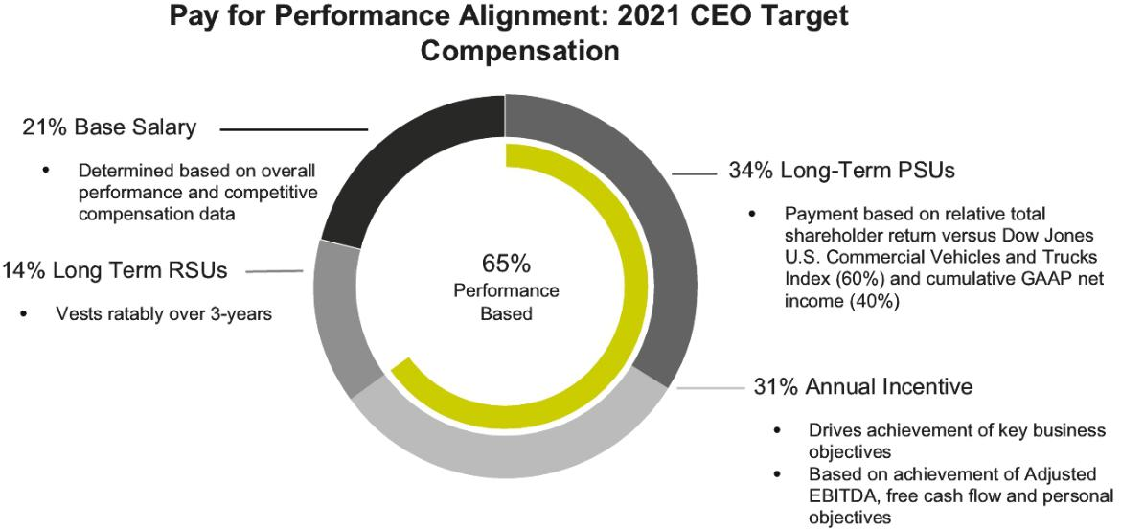

2 Shyft Group // 2022 Proxy Statement

TABLE OF CONTENTS


Corporate Governance Highlights

OUR MISSION

To provide the tools

and technologies to
safely and efficiently

- Separate Chair and CEO roles

- Independent Chair

- 100% independent Board committees

- Regular executive sessions of independent directors

- Robust shareholder engagement

- Active risk oversight by Board and Committees

- Director retirement policy (74)

- No stockholder rights plan

- Active Board refreshment approach to align Board composition with corporate strategy

- Annual Board and committee self-evaluations

- Diverse Board with appropriate mix of skills, experience and perspective

deliver people, packages, and services where they're needed most.


OUR VISION

Purpose-built technology for the road ahead.

Environmental, Social, and Governance Highlights

- Capital investment exceeding $8.5 million in 2021 in support of Shyft’s commitment to environmental stewardship and creating a clean, energy efficient future

- Robust Code of Conduct applies to our directors and all employees reflecting our commitment to doing the right thing

- Signatory to the United Nations Global Compact on Human Rights

- Partnering with the Center for Automotive Diversity Inclusion & Advancement to expand our strategic commitment to diversity, equity, and inclusion

- Enhanced employee engagement through virtual townhalls, employee surveys, and regular communication

- Commitment to supporting the communities where our employees live and work through direct contributions to local non-profit organizations

OUR CORE VALUES


Are engrained in how we do our work every day on behalf of our stakeholders.

- Honesty and Integrity

  - Do what’s right every time.

- Accountability

  - Own it.

- Trust

  - With trust comes empowerment.

- Performance Excellence

  - Improving never ends.

3 Shyft Group // 2022 Proxy Statement

TABLE OF CONTENTS

Corporate Governance and Board Matters

CORPORATE GOVERNANCE

GENERAL

Our Board believes that strong corporate governance is critical to achieving our performance goals and to maintaining the trust and confidence of investors, employees, customers, business partners, regulatory agencies and other stakeholders.

CORPORATE GOVERNANCE PRINCIPLES

Our Corporate Governance Principles provide a framework for the governance of Shyft and address the operation, structure, and practice of the Board and its committees. The Corporate Governance Principles can be found in the Corporate Responsibility section of our website. The Governance and Sustainability Committee reviews these principles at least annually and recommends changes to the Board, as necessary.

STRATEGIC PLANNING

Throughout the year, the Board meets with management to discuss and approve strategic plans, financial goals, capital spending, and other factors critical to successful performance. The Board also reviews the Company’s long-term strategic planning at least annually and monitors the implementation of the Company’s strategic plan throughout the year. During Board meetings, directors review key issues and financial performance. The CEO regularly communicates with the Board regarding the implementation of the Company’s strategic and financial plans.

BOARD, COMMITTEE, AND DIRECTOR EVALUATIONS

The Board and each of its committees conduct annual evaluations and self-assessments. The results of those reviews are made available to all directors. The evaluation process is reviewed annually by the Governance and Sustainability Committee which considers general trends and feedback regarding the prior year’s evaluations. In addition, the Corporate Governance Principles and the Governance and Sustainability Committee Charter provide that individual directors will be evaluated, as necessary.

CEO EVALUATION AND MANAGEMENT SUCCESSION

The Board and CEO annually discuss and collaborate to set the CEO’s performance goals and objectives. The Board annually meets in executive session to assess the CEO’s performance. The Board’s focus includes orderly succession for the CEO and other executive positions and the oversight of executive officer development.

BOARD LEADERSHIP STRUCTURE

Pursuant to our Corporate Governance Principles, the Board has a policy to separate the offices of Chair of the Board and CEO. At this time, the Board believes that having an independent Board Chair is the most appropriate Board leadership structure. However, the Board has the flexibility to revise this structure under circumstances involving management and Board transition or succession. The Board believes that having an independent Chair aids in the Board’s oversight of management and promotes communications among the Board, the CEO, and other members of senior management. In addition, having a separate Chair of the Board and CEO allows our CEO to focus on his responsibilities in managing the Company.

4 Shyft Group // 2022 Proxy Statement

TABLE OF CONTENTS

CORPORATE GOVERNANCE AND BOARD MATTERS

Director Education

We believe it is important for directors to stay current and informed on developments in corporate governance best practices in order to effectively discharge their duties. Our directors are provided updates on corporate governance developments at regularly scheduled Board meetings and are encouraged to participate in programs offered by nationally recognized organizations that specialize in director education. The Company reimburses its directors for their reasonable costs and attendance fees to participate in such programs.

BOARD OVERSIGHT OF RISK MANAGEMENT

The Board has oversight responsibility regarding the assessment of the major risks inherent in our business. Accordingly, the Board reviews management’s efforts to address and mitigate risks, including strategic, regulatory, compliance, operational, financial, reputational, and cybersecurity risks, among others. The Board reviews risk in the context of discussions and management reports at each regular Board meeting. The Board also evaluates the risks inherent in significant transactions. While the Board is ultimately responsible for risk oversight, the committees of the Board assist it in fulfilling its oversight responsibilities. The Board’s committees do so by considering the risks within their respective areas of expertise. For example:

- The Audit Committee oversees risks relating to financial reporting related to internal controls and cybersecurity. The Audit Committee meets periodically with management to review, discuss, and provide oversight with respect to our processes and controls, including controls to assess, monitor, manage, and mitigate potential significant risk exposures relating to the integrity of the Company’s financial statements and related compliance with legal and regulatory requirements. In providing such oversight, the Audit Committee may also discuss such processes and controls with our internal and external independent auditors. We recently amended the charter of the Audit Committee to reflect its leadership in the oversight of the Company’s cybersecurity initiatives.

- The Human Resources and Compensation Committee oversees risks associated with compensation program design and management development and retention. We recently updated the charter of the Human Resources and Compensation Committee to reflect its leadership in the oversight of diversity, equity, and inclusion (“DEI”) initiatives, as well as human capital management more generally.

- The Governance and Sustainability Committee oversees structural governance and composition matters including recommending to the Board the allocation of oversight responsibilities to the Board committees. We recently changed the name of the Corporate Governance & Nominating Committee to the Governance and Sustainability Committee and expanded its responsibilities to reflect the committee’s broader oversight regarding our environmental, social, and governance (“ESG”) initiatives.

At each regular Board meeting, the Board receives reports on significant committee activities, including oversight of risks addressed by each committee. In addition, risk management is incorporated in the Company’s annual strategic planning process, which is periodically reviewed by the Board. The Board also periodically reviews with management the Company’s insurance program and policies, including its cyber insurance coverage.

Management also plays an important role in implementing the processes and procedures designed to mitigate risk and assist the Board in the exercise of its oversight function. For example, we use a risk-based prioritization approach, involving risk ranking and assessment of management progress in monitoring and mitigating each identified risk. Our Chief Compliance Officer, who also serves as our Chief Legal Officer, oversees our corporate ethics and compliance program, our Code of Conduct training, and compliance with Company policies, standards and procedures. Our Chief Compliance Officer, or his delegee, reports on an as-needed basis to the Audit Committee regarding Code of Conduct matters and calls to our ethics hotline related to accounting and auditing concerns. This officer also reports throughout the year to the Governance and Sustainability Committee regarding all other Code of Conduct concerns and calls to our ethics hotline. At least annually, our Chief Compliance Officer meets with the Governance and Sustainability Committee to review the effectiveness of our corporate ethics and compliance program.

Management also periodically engages in a review of the critical risks to the Company and establishes and implements policies and procedures to address and mitigate such risks. For example, our Chief Information Officer assesses our information security and oversees our enterprise-wide cybersecurity risk management program. This program includes, among other elements, mandatory

5 Shyft Group // 2022 Proxy Statement

TABLE OF CONTENTS

CORPORATE GOVERNANCE AND BOARD MATTERS

cybersecurity training for our employees and third parties who may have access to our systems, the maintenance of industrial control systems that meet or exceed industry cybersecurity standards, and the ongoing evaluation of the threat landscape. We engage assessments of our implementation of the NIST Cybersecurity Framework and conduct ongoing penetration testing of our information technology infrastructure.

The Chief Information Officer also meets quarterly with the Audit Committee to present a cybersecurity update, including an analysis of our cybersecurity risk management program’s strengths, weaknesses and opportunities, and cyber threats to the Company.

EXECUTIVE SESSIONS OF NON-EMPLOYEE DIRECTORS

Non-employee directors meet without management present at each regularly scheduled Board meeting. Additional meetings may be called at the discretion of the Board Chair or at the request of any Board member.

DIRECTOR INDEPENDENCE

Our Corporate Governance Principles require that the Board annually determine whether our directors are independent. In evaluating independence, Nasdaq’s rules require that the Board affirmatively determine that a director does not have a relationship that would interfere with the exercise of independent judgment in carrying out the responsibilities of a director. Prior to making a recommendation to the Board, our Governance and Sustainability Committee considers relationships that, while not constituting related party transactions in which a director had a direct or indirect material interest, nonetheless involved transactions between the Company and a company with which a director is affiliated, whether through employment status or by virtue of serving as a director. Based on the evaluations performed and recommendations made by the Governance and Sustainability Committee, the Board affirmatively determined that each of our directors other than our CEO is independent as defined by Nasdaq rules.

TRANSACTIONS WITH RELATED PARTIES

The Board has adopted written policies and procedures with respect to related party transactions, as defined in rules issued by the Securities and Exchange Commission (“SEC”). Any proposed related party transaction must be reviewed and approved by the full Board. There were no such transactions that required review or approval by the Board in 2021.

MAJORITY VOTE STANDARD

We have a majority vote standard for the election of directors in uncontested elections, which requires any nominee for director who receives more “withheld” votes for their re-election than “for” votes to promptly offer their resignation to the Board Chair. The Governance and Sustainability Committee will act on an expedited basis to determine whether to recommend acceptance of the resignation and will then submit its recommendation for consideration by the Board. The Board will act on the recommendation, and publicly disclose its decision, within 90 days following the date of the shareholder meeting at which the election occurred. The Board expects the director whose tendered resignation is under consideration to abstain from participating in any decision regarding the resignation. The Governance and Sustainability Committee and the Board may consider any factors they deem relevant in deciding whether to make such recommendation or to accept a director’s tendered resignation. If the Board accepts a director’s resignation, the Governance and Sustainability Committee will recommend to the Board whether to fill such vacancy or to reduce the size of the Board.

DIRECTOR ATTENDANCE AT ANNUAL MEETING OF SHAREHOLDERS

We have a policy that all directors are expected to attend our annual meeting of shareholders. All Board members attended the 2021 Annual Meeting of Shareholders.

6 Shyft Group // 2022 Proxy Statement

TABLE OF CONTENTS

CORPORATE GOVERNANCE AND BOARD MATTERS

SHAREHOLDER ENGAGEMENT

We are committed to ongoing, constructive, and meaningful engagement with our shareholders. During 2021, members of our executive management team attended investor conferences, engaged in non-deal roadshows where they met with existing and potential shareholders, and hosted our annual analyst day. Due to the ongoing pandemic, we participated virtually in a number of these events. Presentations from these meetings and conferences are typically posted on the Investors page of our website.

We also engage with investors concerning ESG matters. These various engagements allow us to receive feedback concerning our operational, financial, and strategic results, as well as ESG matters important to shareholders.

In addition, we host a quarterly earnings call during which our executive management team responds to analyst questions regarding both historical results and forward-looking information. Transcripts of our quarterly earnings calls, including the question and answer sessions, are posted on our website. In addition to the required reports we file with the SEC, we make available on our website earnings analyst packages, investor presentations, and other reports with supplementary financial and operational information. In addition to having a dedicated Investor Relations function that receives and responds to shareholder telephone calls and other communications, we also provide a means for shareholders to communicate directly with our Board, as provided under “Communications with Directors” below.

COMMUNICATION WITH DIRECTORS

Any shareholder or other interested party may communicate with our directors, individually or as a group, by contacting our Corporate Secretary or our Board Chair. The contact information is maintained through the Investors page of our website at www.theyshyftgroup.com. Inquiries may also be addressed as follows:

The Shyft Group, Inc.

Corporate Headquarters

41280 Bridge Street

Novi, Michigan 48375

Attn: Chair of the Board

The Shyft Group, Inc.

Corporate Headquarters

41280 Bridge Street

Novi, Michigan 48375

Attn: Corporate Secretary

Communications will be forwarded to the relevant director(s) except for solicitations or other matters not related to the Company.

CODE OF CONDUCT

Our Code of Conduct is applicable to all employees, including our CEO and CFO, as well as our directors.

HOW TO OBTAIN COPIES OF OUR GOVERNANCE-RELATED DOCUMENTS

The following documents are available through the Corporate Responsibility page of our website at www.theshyftgroup.com:

- Corporate Governance Principles;

- Shyft Code of Conduct; and

- Charters of the Audit Committee, the Human Resources and Compensation Committee, and the Governance and Sustainability Committee.

If you prefer to receive printed copies of these documents, please send a written request to our Corporate Secretary at The Shyft Group, Inc., 41280 Bridge Street, Novi, Michigan 48375.

7 Shyft Group // 2022 Proxy Statement

TABLE OF CONTENTS

CORPORATE GOVERNANCE AND BOARD MATTERS

PROHIBITION ON EMPLOYEE, OFFICER, AND DIRECTOR HEDGING

As part of the Company’s Insider Trading Policy, we prohibit directors, officers, and other employees from (1) engaging in short sales of any Shyft securities, and (2) engaging in hedging or similar transactions involving any Shyft securities, including option contracts, puts, calls, straddles, collars, hedges, swaps, forward contracts, exchange funds, or any transactions that hedge or offset, or are designed to hedge or offset, any decrease in market value of any Shyft securities. These restrictions also apply to each employee and director’s family members and others living in their households and entities that are directed by or subject to the employee’s or director’s influence or control.

The Company’s anti-pledging policy prohibits our directors and executives, including NEOs, from purchasing Shyft securities on margin, holding Shyft securities in a margin account, or pledging Shyft securities as collateral for a loan.

8 Shyft Group // 2022 Proxy Statement

TABLE OF CONTENTS

CORPORATE GOVERNANCE AND BOARD MATTERS

Environmental, Social, and Governance Matters

We value diversity, respect human rights and the rule of law, and recognize environmental management among our highest priorities at Shyft. In addition to the leadership of senior management on these topics, the charters of our Board committees detail the importance of these issues to the Company. The Human Resource and Compensation Committee Charter details the committee’s role in the oversight of the Company’s DEI initiatives and commitment to human capital management. The Governance and Sustainability Committee Charter reflects the committee’s responsibility for oversight of the Company’s ESG strategies and performance. While the Company’s commitment to each of these areas has been reflected on our website www.theshyftgroup.com at the Corporate Responsibility tab, the Company will publish a separate report in 2022 on the Company’s efforts and achievements with respect to sustainability, equality, and philanthropy.

Health & Safety



Diversity, Equity

- Inclusion

Governance & Ethics



Protecting the

Environment


Philanthropy


Supply Chain

Management

- Strongly committed to the health and safety of our employees, and strive to continuously reduce the incidence and severity of job-related injuries.

- Integrate safe technologies, training programs, risk management practices, and continuous improvement in our operations to minimize risk to our employees.
- Position environmental, health, and safety (“EHS”) leadership at the segment and corporate levels to drive EHS best practices.

- Inclusion is the way we treat and perceive all differences. We are focused on creating an inclusive and high-performance culture where all forms of diversity are seen as real value for Shyft.

- In 2021, we engaged with the Center for Automotive Diversity Inclusion and Advancement (CADIA) to establish our DEI 5-year roadmap, to foster an even more inclusive culture and diverse environment within all areas of the Company.

- Annual review of our Corporate Governance Principles by the Board of Directors.

- Code of Conduct for our directors, officers and employees that is reviewed each year for appropriate updates, and employees, officers, and directors are asked to annually certify their understanding of, and compliance with, its requirements.

- In 2021, Shyft became a signatory of the United Nations Global Compact, in support of the Compact’s principles relating to human rights, labor, environment and anti-corruption.
- Robust training program for employees on the Code of Conduct and other core topics.

- Maintain an actively managed, anonymous ethics hotline.

- Comply with all applicable environmental laws governing the use, storage, discharge, and disposal of hazardous or toxic material.

- Seek to improve the operation of our facilities through the efficient use of energy, the sustainable use of renewable resources, and a commitment to waste reduction, recycling, reducing water usage and carbon emissions, and implementing responsible waste disposal practices.

- Development of products and solutions in the electric vehicle space to support our customers’ carbon neutral goals and a more environmentally sustainable future.

- Participate in the United Way campaign at our largest facilities in support of stronger communities.

- Direct donations to local charitable organizations in the communities where our business operates and our employees live.

- Maintain a supplier code of conduct that sets expectations for our supply chain partners regarding health and safety, environmental protection, nondiscrimination, working hours and compensation, and improper payments.

9 Shyft Group // 2022 Proxy Statement

TABLE OF CONTENTS

CORPORATE GOVERNANCE AND BOARD MATTERS

Corporate Governance and Board Matters

BOARD AND COMMITTEE STRUCTURE AND MEETINGS

THE BOARD AND BOARD MEETINGS

The Company’s Board of Directors currently consists of 10 directors, divided into 3 classes approximately equal in number. The members of each class serve for staggered, 3-year terms.

Any additional directorships resulting from an increase in the number of directors will be distributed among the 3 classes so that, as nearly as possible, each class will consist of one-third of the Company’s directors. Directors actively participate in Board and committee meetings. Meeting materials are distributed in advance of each regular Board meeting so that directors can prepare for meeting discussions.

During 2021, the Board initially consisted of 8 directors until Ms. Terri Pizzuto and Mr. Mark Rourke joined the Board on January 4, 2021, at which time there were 10 directors. On July 26, 2021, Mr. Richard Dauch resigned from the Board and there were 9 directors for the balance of 2021. On March 14, 2022, Carl A. Esposito joined the Board and the Board consisted of 10 directors. During 2021, the full Board met 5 times, the Audit Committee met 8 times, the Human Resources and Compensation Committee met 5 times, and the Governance and Sustainability Committee met 4 times. During 2021, all directors (excluding Mr. Esposito who had not yet joined the Board) attended at least 75%, in the aggregate, of the meetings of the Board and the committees of the Board on which they served. All of the directors who were serving on the Board at the time of the 2021 Annual Meeting of Shareholders attended the 2021 Annual Meeting.

10 Shyft Group // 2022 Proxy Statement

TABLE OF CONTENTS

CORPORATE GOVERNANCE AND BOARD MATTERS

BOARD COMMITTEES

The Board has three standing committees: Audit, Human Resources and Compensation, and Governance and Sustainability. Each standing committee has a charter adopted by the Board. Each committee chair gives a committee report to the full Board at each regular Board meeting. The Board annually elects each committee’s members and chair. Each committee has authority to retain, approve fees for, and terminate advisors as it deems necessary to assist in the fulfillment of its responsibilities. The chart below shows the current composition of the standing committees and the year in which each director’s term on the Board ends:

 |  |  |  |  |  | HUMAN
 |  |  |  |  |  | RESOURCES | GOVERANCE
 |  | Director |  |  |  | AND | AND | TERM
DIRECTOR | Age | Since |  | Independent | AUDIT | COMPENSATION | SUSTAINABILITY | ENDING
James A. Sharman⁽¹⁾ | 63 | 2016 |  |  |  |  |  | 2022
Ronald E. Harbour⁽²⁾ | 65 | 2009 |  |  |  |  |  | 2022
Terri A. Pizzuto⁽¹⁾ | 63 | 2021 |  |  |  |  |  | 2022
Carl A. Esposito⁽¹⁾ | 54 | 2022 |  |  |  |  |  | 2022
Michael Dinkins | 68 | 2020 |  |  |  |  |  | 2023
Angela K. Freeman | 54 | 2019 |  |  |  |  |  | 2023
Mark B. Rourke | 57 | 2021 |  |  |  |  |  | 2023
Daryl M. Adams | 60 | 2014 |  |  |  |  |  | 2024
President & CEO | 60 | 2014 |  |  |  |  |  | 2024
Paul A. Mascarenas | 60 | 2018 |  |  |  |  |  | 2024
Thomas R. Clevinger | 69 | 2018 |  |  |  |  |  | 2024
Committee Member |  | Committee Chair

- Standing for re-election at the 2022 Annual Meeting.

- Mr. Harbour, whose term expires at the 2022 Annual Meeting, is retiring and the Company has not nominated him to stand for re-election. The Company sincerely thanks Mr. Harbour for his dedicated service on the Board.

11 Shyft Group // 2022 Proxy Statement

TABLE OF CONTENTS

CORPORATE GOVERNANCE AND BOARD MATTERS

AUDIT COMMITTEE

Responsibilities

The Board has a separately designated standing Audit Committee established in accordance with the Securities and Exchange Act of 1934, SEC rules, and Nasdaq rules.

The Audit Committee:

- appoints, evaluates, and approves the compensation of our independent registered public accounting firm;

- assists the Board in fulfilling its responsibilities for generally overseeing our financial reporting processes and the audit of our financial statements, including the integrity of our financial statements, our compliance with legal and regulatory requirements, and risk assessment and risk management;

- reviews the qualification and independence of our independent registered public accounting firm;

- exercises oversight of our external audit function;

- reviews the performance of our internal audit function and the independent registered public accounting firm;

- reviews our earnings releases;

- oversees legal and regulatory compliance;

- oversees our cybersecurity compliance initiatives and performance;

- reviews with the Chief Legal Officer any actual or alleged violations of the Code of Conduct;

- reviews its charter and performance; and

- prepares the Report of the Audit Committee for inclusion in the annual proxy statement.

Independence, Financial Literacy, and Experts

The Board has determined that:

- each member of the Audit Committee is “independent” from management in accordance with the Nasdaq listing standards and the Company’s Corporate Governance Principles;

- each member of the Audit Committee is financially literate and has accounting and related financial management expertise required by the Nasdaq listing standards; and

- Mr. Dinkins and Ms. Pizzuto qualify as “audit committee financial experts” as defined by the SEC.

12 Shyft Group // 2022 Proxy Statement

TABLE OF CONTENTS

CORPORATE GOVERNANCE AND BOARD MATTERS

HUMAN RESOURCES AND COMPENSATION COMMITTEE

Responsibilities

The Human Resources and Compensation Committee:

- assists the Board and management in establishing the Company’s overall executive and director compensation philosophy to support the Company’s business strategy and objectives;

- oversees the material risks associated with our compensation structure, policies, and programs;

- recommends to the Board total compensation of our executive officers, including salaries, bonuses, equity awards, benefits, and perquisites;

- recommends to the Board the CEO’s goals and objectives and evaluates performance considering those goals and objectives;

- evaluates the NEOs’ total compensation against performance goals, budgets, comparable benchmark data and market trends;

- along with the Board, reviews succession plans relating to the executive officers;

- administers, as appropriate, Board approved equity-based and cash-based incentive plans;

- approves equity-based compensation awards, provided that awards to executive officers are subject to Board approval;

- recommends to the Board the appropriate compensation of non-employee directors;

- reviews each executive compensation report required by SEC rules and any other regulatory requirements;

- oversees the Company’s DEI strategy and human capital management initiatives; and

- reviews its charter and performance.

Compensation Committee Interlocks and Insider Participation

The Board has determined that all members of the Human Resources and Compensation Committee (Ms. Freeman and Messrs. Harbour, Mascarenas, and Rourke) meet the independence requirements under Nasdaq’s rules for persons serving on compensation committees. No member of the Human Resources and Compensation Committee is or was previously an officer or employee of the Company.

Independent Executive Compensation Advisor

The Human Resources and Compensation Committee has selected and retained Mercer, an independent executive compensation consulting firm, to: provide competitive market data and advice related to the CEO’s compensation level and incentive design; review and evaluate management-developed market data and recommendations on compensation levels, incentive mix, and incentive design for NEOs and certain other executives; develop the selection criteria and recommend comparative companies for executive compensation and performance comparisons; provide information on executive compensation trends and their implications to Shyft; and provide competitive market data and advice on non-employee director compensation.

The Human Resources and Compensation Committee evaluates the independence of Mercer to ensure it maintains objectivity and independence when rendering advice to the committee. Mercer does not provide any additional services to Shyft. Mercer reports directly to the Human Resources and Compensation Committee and is independent of management. The Human Resources and Compensation Committee has determined that the services Mercer provides do not create or present any conflicts of interest.

13 Shyft Group // 2022 Proxy Statement

TABLE OF CONTENTS

CORPORATE GOVERNANCE AND BOARD MATTERS

GOVERNANCE AND SUSTAINABILITY COMMITTEE

Responsibilities

The Governance and Sustainability Committee:

- reviews the size, structure, and composition of the Board and its committees and recommends any changes;

- develops and recommends to the Board criteria for the selection of director candidates;

- identifies and recommends director candidates to the Board;

- reviews director candidates recommended or nominated by shareholders;

- oversees ESG strategies and performance;

- oversees and assists the Board in the review of Board and committee performance;

- recommends to the Board appropriate Corporate Governance Principles;

- oversees compliance with applicable rules and regulations relating to corporate governance; and

- reviews its charter and performance.

The Governance and Sustainability Committee will consider candidates for nomination to the Board who display high character and integrity; are free of any conflict of interest that would violate any applicable law or regulation or interfere with the proper performance of the responsibilities of a director; possess substantial and significant experience that would be of particular importance to the Company in the performance of the duties of a director; have sufficient time available to devote to the affairs of the Company in order to carry out the responsibilities of a director; and have the capacity and desire to represent the balanced, best interests of the shareholders as a whole.

In identifying candidates for directors, the Governance and Sustainability Committee and the full Board also consider the potential diversity of viewpoint that a candidate would likely bring to the Board, which could be the result of the person’s background, current occupation, career history, ethnicity, gender, and other factors. Since 2019, five new directors have joined the Board, two of whom are female and one of whom is Black.

As the need to make changes or additions to the Board arises, the Governance and Sustainability Committee considers Board size, experiences, and needs. The committee may use outside resources, including consultants retained by the committee, to assist in the process of establishing the criteria for director candidates, establishing a process to identify potential candidates, and assisting in the introduction of potential candidates to the committee.

Nominations of candidates for election to the Board of the Company at any annual meeting of shareholders or at any special meeting of shareholders called for election of directors may be made by the Board or by a shareholder of record of shares of a class entitled to vote at such annual or special meeting of shareholders pursuant to the process described below. The Governance and Sustainability Committee applies the same standards and qualification requirements to all director nominees, regardless of the party making the nomination.

Shareholder Nominations of Directors

The Governance and Sustainability Committee will consider nominees for election to the Board submitted by shareholders. The Company’s bylaws provide that any shareholder entitled to vote in the election of directors may nominate one or more persons for election as directors at a meeting only if written notice of the shareholder’s intent to make a nomination or nominations has been given to the Company’s Corporate Secretary by the deadline specified in the bylaws. That deadline is at least 120 days before the one-year anniversary date of the notice of the previous year’s annual meeting if the meeting is an annual meeting and not more than 7 days following the date of notice of the meeting if the meeting is a special meeting at which directors will be elected. Each such notice to the Secretary must include:

- the name, age, business address, and residence of each nominee proposed in the notice;

- the principal occupation or employment of each nominee;

- the number of shares of capital stock of the Company that each nominee beneficially owns;

- a statement that each nominee is willing to be nominated; and

- such other information concerning each nominee as would be required under the rules of the SEC in a proxy statement soliciting proxies for the election of such nominees.

14 Shyft Group // 2022 Proxy Statement

TABLE OF CONTENTS

PROPOSAL 1

Election of Directors

The Board is divided into three classes, each class consisting of approximately one-third of the Company’s directors. The following directors’ terms will expire at the 2022 Annual Meeting: Carl Esposito, Terri Pizzuto and James Sharman. Each of these directors has consented to stand for re-election to serve until the 2025 Annual Meeting of Shareholders. If any of them should become unavailable to stand for re-election at the 2022 Annual Meeting, the Board may designate a substitute nominee. In that case, the proxy holders named as proxies in the accompanying proxy card will vote for the Board’s substitute nominee.

Additional information regarding the directors and director nominees of the Company is set forth below.

Director Background, Experience and Qualifications

The following includes a brief overview of the experience, qualifications, attributes, and skills that led to the conclusion that the directors and nominees should serve on the Board at this time. The Governance and Sustainability Committee considers the experience, mix of skills and other qualities of the existing Board to ensure appropriate Board composition. The Governance and Sustainability Committee believes that directors must have demonstrated excellence in their chosen field, high ethical standards and integrity, and sound business judgment. In addition, it seeks to ensure the Board includes members with diverse backgrounds, skills and experience, including appropriate financial and other expertise relevant to the Company’s business.

As more fully reflected in the charts below, the Board believes that the directors and nominees have an appropriate balance of knowledge, experience, attributes, skills and expertise as a whole to ensure the Board appropriately fulfills its oversight responsibilities and acts in the best interests of shareholders. The Board believes that each director satisfies its criteria for demonstrating excellence in his or her chosen field, high ethical standards and integrity, and sound business judgment. Further, each director or nominee brings a strong background and set of skills to the Board, giving the Board competence and experience in a wide variety of areas.

Vote Required

Under Michigan law and our bylaws, directors are elected by a plurality. This means the nominees who receive the most votes will be elected to the open director positions. However, we have adopted a majority vote standard in our Corporate Governance Principles that will require any nominee for director who receives a greater number of votes “withheld” for their election than votes “for” such election to promptly tender his or her offer of resignation to the Chair of the Board for consideration by the Governance and Sustainability Committee. See “Majority Vote Standard” above for more detail.

VOTE


The Board unanimously recommends a vote FOR the election of the director nominees named in Proposal 1 to three-year terms expiring at the 2025 Annual Meeting.

15 Shyft Group // 2022 Proxy Statement

TABLE OF CONTENTS

PROPOSAL 1: Election of Directors

Snapshot of Board of Directors

Our directors possess skills and experiences aligned to our current and future strategy and business needs and demonstrate a high degree of integrity, an ability to exercise sound judgment, and an understanding of corporate governance and best practices.

Skills and Qualifications | Directors


Manufacturing and Operations


Sales and Marketing

Top Level Enterprise / Corporate Leadership

Experience

General Finance Acumen

Expertise with One or More of Shyft’s End

Markets


7 of 10

6 of 10

9 of 10

10 of 10

9 of 10

Mergers & Acquisitions | 8 of 10
Human Capital Talent Development | 10 of 10
Consumer Oriented Product Development | 8 of 10



Composition and Diversity of Directors
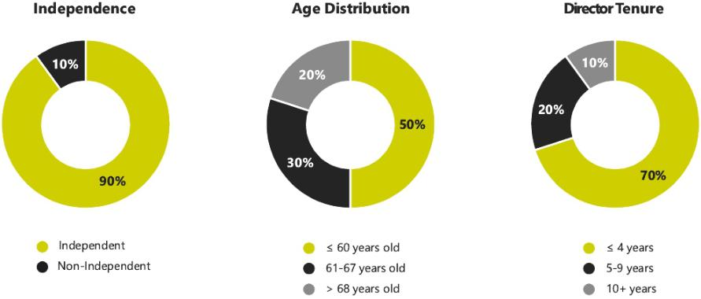

Board Diversity Matrix

Total Number of Directors (10) | Female | Male
Gender Identity | 2 | 8
African American or Black | 0 | 1
White | 2 | 7

16 Shyft Group // 2022 Proxy Statement

TABLE OF CONTENTS

PROPOSAL 1: Election of Directors
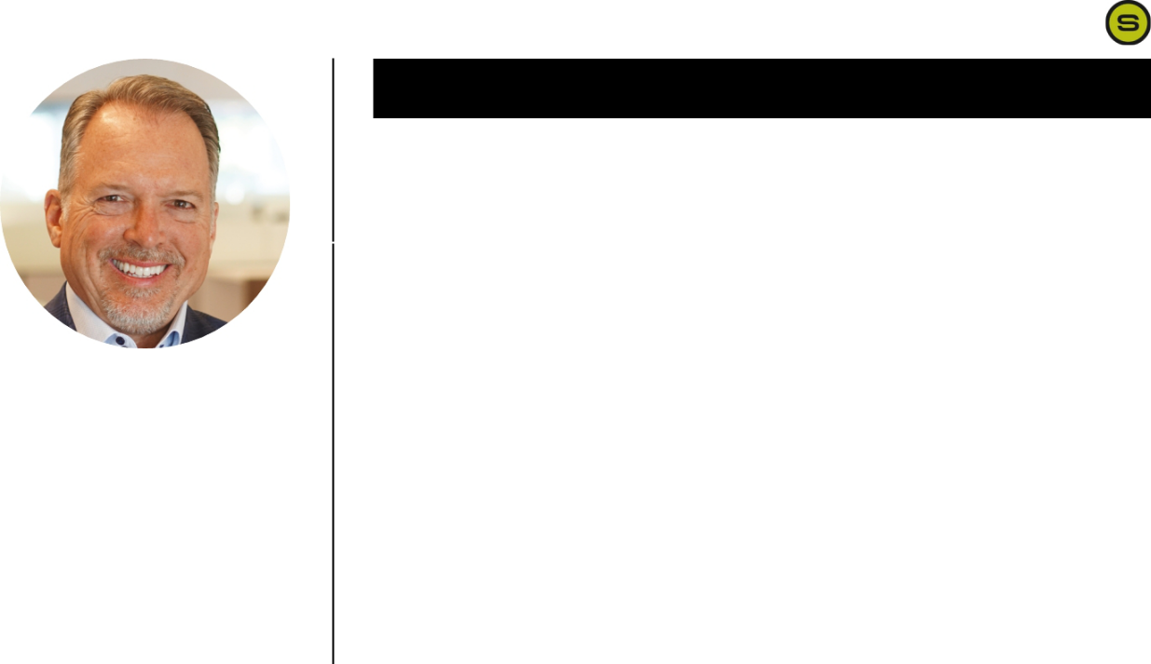

Qualifications:

Mr. Adams is a proven leader with demonstrated success in creating and implementing Shyft’s business strategy. His subject matter expertise includes business portfolio development and management, investor relations, acquisitions and divestitures, and restructuring and realigning operational functions.


DARYL M. ADAMS

Age: 60 Other Public Boards: None

Director Since: December 2014 Committees: None

Mr. Adams joined the Company as Chief Operating Officer in July 2014 and was appointed to the Board of Directors in December 2014, at which time he was also named President and Chief Executive Officer, effective in February 2015. Prior to joining Shyft, Mr. Adams served for seven years as Chief Executive Officer of Midway Products Group, a privately held Tier 1 automotive supplier in stampings and assemblies. Prior to that, he held a succession of management positions over a 17-year career with Lear Corporation, a global automotive technology leader in seating and e-systems, including senior leadership and international roles in Lear’s North American and European operations. Mr. Adams holds a Master of Business Administration degree from Michigan State University and a Bachelor of Science degree in Industrial Management and Manufacturing from Lawrence Technological University. He serves as the board chair of the Lansing Economic Area Partners and is a board member of the Detroit Safety Foundation. Mr. Adams is an active member of Business Leaders for Michigan and various other state leadership and manufacturing associations.


Qualifications:

Mr. Clevinger brings to the Board significant expertise in global commercial vehicle sales and support, with an emphasis in aftermarket parts and service sales and distribution. He has subject matter expertise in supply chain optimization, customer relationship management, and strategic planning.

17

THOMAS R. CLEVINGER

Age: 69 Other Public Boards: None

Director Since: April 2018 Committees: Audit

Since 2016, Mr. Clevinger has served as the Chief Executive Officer and Managing Partner of Cornerstone Growth Advisors, LLC, a consulting firm that focuses on strategic growth initiative advisory services, namely for the automotive and commercial vehicles industries. From 2010 to 2016, Mr. Clevinger served as Senior Vice President/Managing Director – Global at Navistar, Inc., a manufacturer of trucks and buses and provider of related services, where he managed all lines of business outside the U.S. and Canada. Prior to his work at Navistar, Mr. Clevinger served from 1995 to 2010 in various senior leadership roles at PACCAR, Inc., a truck manufacturer, where he oversaw global sales and distribution operations for parts and service support. Mr. Clevinger holds a Bachelor of Science in business and a Master of Arts in leadership and organizational development, both from the City University of Seattle.

Shyft Group // 2022 Proxy Statement

TABLE OF CONTENTS

PROPOSAL 1: Election of Directors
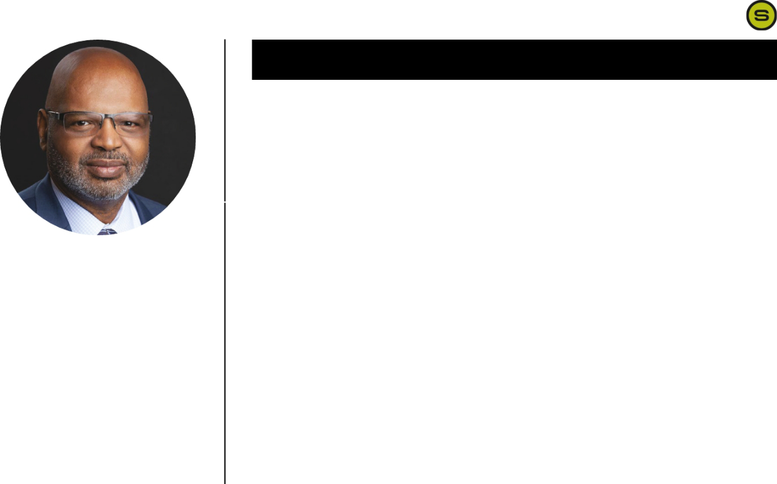

Qualifications:

Mr. Dinkins has extensive experience in executive leadership, financial reporting, accounting and Sarbanes-Oxley compliance. His experience serving as a financial executive with multiple companies provides him with subject matter expertise in acquisitions and divestitures, risk management, asset allocation, and oversight of operational functions.
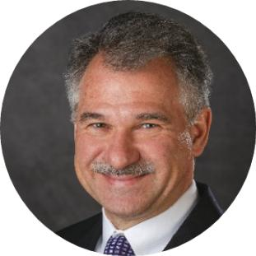

MICHAEL DINKINS

Age: 68 | Other Public Boards: Crane Company and
Director Since: December 2020 | Community Health Systems
Director Since: December 2020 | Committees: Audit (Chair); Governance and
 | Sustainability

Mr. Dinkins is currently President and Chief Executive Officer of Dinkins Financial, a consulting firm that assists small businesses in raising capital. Prior to founding Dinkins Financial in 2017, Mr. Dinkins served in various leadership roles, including as Chief Financial Officer and board member at Integer Holdings Corporation, a medical device manufacturer, from 2012 to 2017. In addition, Mr. Dinkins’ prior experience includes serving as Chief Financial Officer at each of USI Insurance Services, an insurance and risk management provider, Hilb, Rogal & Hobbs Co., an insurance risk and management provider, and NCR, a provider of financial services equipment and software. Mr. Dinkins career began at General Electric where he served for 17 years in multiple financial roles. Mr. Dinkins is National Association of Corporate Directors (NACD) Directorship Certified®. He is a past member of the board of directors of three publicly traded companies and the National Council on Compensation and Insurance. Mr. Dinkins received a Bachelor of Science degree in Finance from Michigan State University and graduated with honors from General Electric's Financial Management Program where he also served as an instructor. He also obtained certified public accountant and certified management accountant certificates.


Qualifications:

Mr. Esposito brings to the Board significant expertise in innovation related to electrification and connectivity in the transportation space, global business operations, engineering, and program management. He has subject matter expertise in product innovation, transportation electrification, and executive management and strategy.

18

CARL A. ESPOSITO

Age: 54 Other Public Boards: None

Director Since: March 2022 Committees: None

Since September 2019, Mr. Esposito has served as Senior Vice President and President of the E-Systems business for Lear Corporation, a global automotive technology leader in seating and E-Systems. He is responsible for implementing global initiatives to further grow and diversify sales, accelerate product innovation, improve financial results, sustain world-class competitiveness, and capitalize on the megatrends of electrification, connectivity, software, and data. Before joining Lear, Mr. Esposito spent 30-years at Honeywell Aerospace, including serving from 2017 to 2019 as President of the Electronic Solutions Strategic Business Unit where he oversaw strategy and product development. Prior to this position, he held various roles during his Honeywell Aerospace tenure, including as Vice President of Marketing and Product Management and various positions in the United States and Europe, in global sales and marketing, product management and strategy, program management, and engineering. Mr. Esposito received a bachelor’s degree in electrical engineering from Rensselaer Polytechnic Institute and master’s degrees in program management and business administration from the Keller Graduate School of Management.

Shyft Group // 2022 Proxy Statement

TABLE OF CONTENTS

PROPOSAL 1: Election of Directors
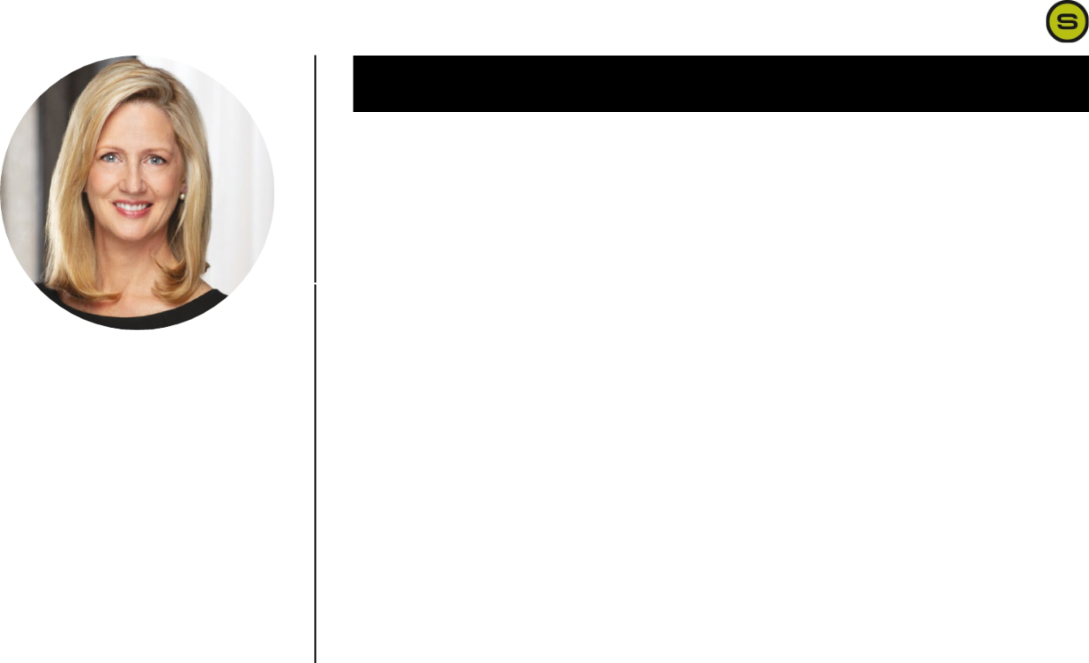

Qualifications:

Ms. Freeman brings extensive public company experience and expertise in human resources, including executive compensation, human capital management, ESG, DEI, government affairs, and investor relations. She has subject matter expertise in strategy creation and deployment, change management, and mergers and acquisitions.
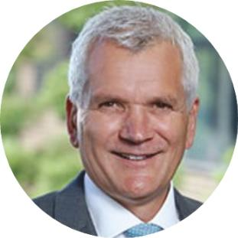

ANGELA K. FREEMAN

Age: 54 Other Public Boards: None

Director Since: August 2019 Committees: Human Resources and

Compensation (Chair); Governance and

Sustainability

Ms. Freeman serves as the Chief Human Resources and ESG Officer at C.H. Robinson, one of the world’s largest third-party logistics providers. At C.H. Robinson, Ms. Freeman leads the company’s global talent, sustainability, DEI, and corporate responsibility strategies. She has been with the company for over 20 years and prior to her current role led Investor Relations, Marketing, and Public Affairs. In addition, she serves as the President of the C.H. Robinson Foundation, the company’s philanthropic affiliate. Ms. Freeman also serves on the Board of the University of North Dakota Alumni Association & Foundation and on the Gartner Global CHRO Leadership Board. Ms. Freeman holds a Master of Science degree in comparative politics from the London School of Economics, in addition to a Bachelor of Arts degree in political science and a Bachelor of Science degree in secondary education from the University of North Dakota.


Qualifications:

Mr. Mascarenas’ professional experience, including as the technology leader of a global public company and other public company board assignments, enables him to contribute his expertise in technology and innovation, industrial manufacturing, public company governance, and executive compensation matters.

PAUL A. MASCARENAS

Age: 60 Other Public Boards: United States Steel

Corporation, Borg Warner, and ON

Director Since: June 2018 Semiconductor Corporation

Committees: Governance and Sustainability

(Chair); Human Resources and Compensation

Mr. Mascarenas served as President and Chair of the Executive Board of the International Federation of Automotive Engineering Societies (FISITA) from 2014 to 2016. Previously, Mr. Mascarenas worked for 32 years at Ford Motor Company, holding various product development and engineering positions, and most recently serving as Chief Technical Officer and Vice President of Research & Advanced Engineering, leading Ford’s worldwide research organization. Mr. Mascarenas is a Fellow of the Institution of Mechanical Engineers, and a Fellow of the Society of Automotive Engineers. He served as General Chairperson for the 2010 SAE World Congress and Convergence and has served on the FISITA board since 2012.

Mr. Mascarenas currently serves as a Venture Partner with Fontinalis Partners, a venture capital fund focused on mobility technology. In 2015, he was awarded an Order of the British Empire (OBE) by her Majesty, Queen Elizabeth II, for his services to the automotive industry. Mr. Mascarenas received a degree in mechanical engineering from University of London, King’s College in England and in 2013 received an honorary doctorate degree from Chongqing University in China.

19 Shyft Group // 2022 Proxy Statement

TABLE OF CONTENTS

PROPOSAL 1: Election of Directors
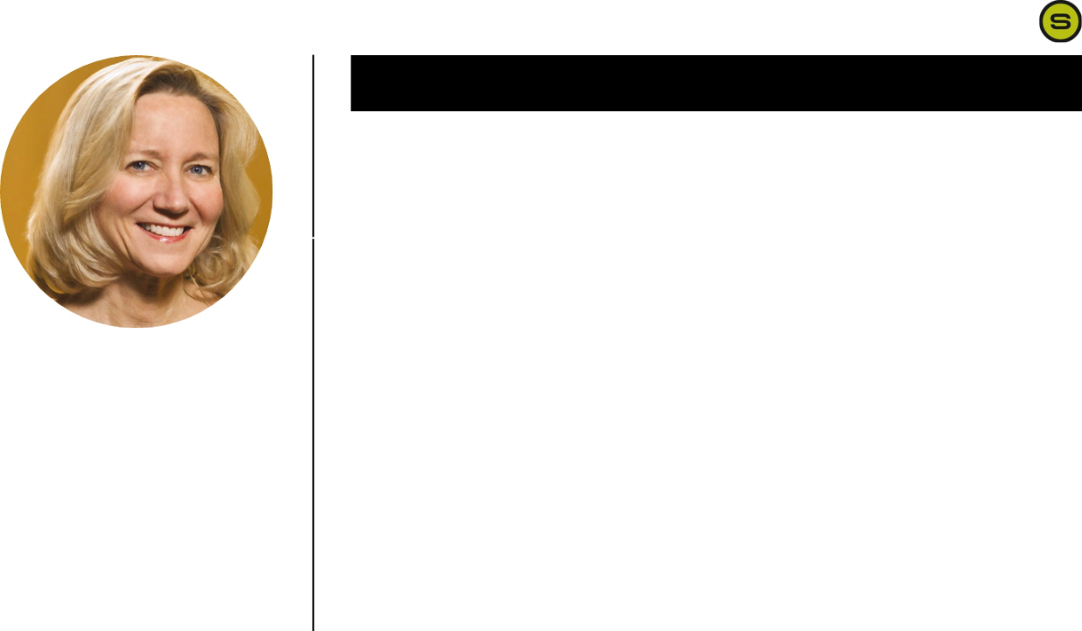

Qualifications:

Ms. Pizzuto is a qualified financial expert with over 40 years of experience in financial and strategy leadership roles. Her areas of expertise include SEC regulatory compliance, global finance and accounting, investor relations, technology transformations, acquisitions and divestitures, and asset management.


TERRI A. PIZZUTO

Age: 63 Other Public Boards: None

Director Since: January 2021 Committees: Audit

Ms. Pizzuto served as a financial officer for Hub Group, Inc., a multi-billion-dollar public company offering comprehensive transportation and logistics management solutions, for 18 years, including the last 13 years as Chief Financial Officer prior to her retirement in June 2020. Ms. Pizzuto retains the title of Chief Financial Officer Emeritus at the Hub Group. Before joining the Hub Group, Ms. Pizzuto was an audit professional at Arthur Andersen LLP for 22 years, including the last 6 years as an audit partner, where she served a wide variety of SEC registrants and other clients in logistics, manufacturing, high tech, and other industries. Ms. Pizzuto serves on the board of directors of IPS Corporation, a privately-held manufacturer. Ms. Pizzuto earned a bachelor’s degree in accounting from the University of Illinois and is a certified public accountant.


Qualifications:

Mr. Rourke brings extensive experience in executive leadership, the trucking industry, and operational and management issues. He has subject matter expertise in the development and implementation of strategic and operational plans, operational excellence, and management.

20

MARK B. ROURKE

Age: 57 Other Public Boards: Schneider National Inc.

Director Since: January 2021 Committees: Human Resources and

Compensation

Since 2019, Mr. Rourke has served as President, Chief Executive Officer and director of Schneider National Inc., a provider of transportation and logistics services, Since starting his career with Schneider National in 1987, he held a series of leadership positions of increasing responsibility, including roles as Executive Vice President and Chief Operating Officer, which he held prior to his current role. He serves on the board of directors of the Trucking Alliance, an industry group focused on advancing safety reforms. Mr. Rourke holds a bachelor’s degree in marketing from the University of Akron and has attended programs on corporate governance and strategic leadership at Harvard University.

Shyft Group // 2022 Proxy Statement

TABLE OF CONTENTS

PROPOSAL 1: Election of Directors


Qualifications:

Mr. Sharman brings extensive knowledge and expertise in executive leadership and operational and management issues relevant to manufacturing environments. He has subject matter expertise in corporate governance, program and project management, customer relationship management, production, and risk management.

JAMES A. SHARMAN

Age: 63 Other Public Boards: None

Director Since: January 2016 Committees: Audit; Governance and

Sustainability

Mr. Sharman has served as Chair of the Board of Directors since 2017. Mr. Sharman is President of GoHealth, a leading provider of technology and service solutions for the health care and insurance industries. From 2014 until he joined GoHealth in 2017, Mr. Sharman served as Chief Operating Officer of Coyote Logistics, a freight broker and logistics services provider and a subsidiary of United Parcel Service. From 2006 through 2014, Mr. Sharman served as Managing Partner of Truecast Capital, LLC, an investment firm. His work history includes President and Chief Executive Officer of World Kitchen, Inc., a manufacturer of kitchen products, and Chief Executive Officer of Rubicon Technology, Inc., a manufacturer of synthetic-crystal components. He was Senior Vice President of Global Supply Chain for CNH Industrial, an agricultural and construction equipment supplier, as well as Vice President and General Manager, Latin America, for the Case Corporation, a machinery and equipment manufacturer. He served as the Commanding Officer of an engineering company in the United States Army and was an assistant professor at the United States Military Academy, West Point. Mr. Sharman is a graduate of the United States Military Academy at West Point and Duke’s Fuqua School of Business.

21 Shyft Group // 2022 Proxy Statement

TABLE OF CONTENTS

Report of the Audit Committee of the Board of Directors

The Audit Committee represents and assists the Board in fulfilling its responsibilities for general oversight of the integrity of the Company’s financial statements, the Company’s compliance with legal and regulatory requirements, the independent registered public accounting firm’s qualifications and independence, the performance of the Company’s internal audit function, the performance of the Company’s independent registered public accounting firm, and risk assessment and risk management. The Audit Committee manages the Company’s relationship with the independent registered public accounting firm, which reports directly to the Audit Committee. The Audit Committee has the authority to obtain advice and assistance from outside legal, accounting and other advisors as it deems necessary to carry out its duties and receives appropriate funding from the Company, as determined by the Audit Committee, for such advice and assistance.

The Company’s management is primarily responsible for the Company’s internal control and financial reporting process. The Company’s independent registered public accounting firm, Deloitte, is responsible for performing an independent audit of the Company’s consolidated financial statements and issuing opinions on the conformity of those audited financial statements with United States generally accepted accounting principles and the effectiveness of the Company’s internal control over financial reporting. The Audit Committee monitors the Company’s financial reporting process and reports to the Board on its findings.

In this context, the Audit Committee hereby reports as follows:

The Audit Committee has reviewed and discussed the audited financial statements for the fiscal year ended December 31, 2021 with the Company’s management;

The Audit Committee has discussed with the independent registered public accounting firm the matters required to be discussed by the applicable requirements of the Public Company Accounting Oversight Board (“PCAOB”) and the SEC; and

The Audit Committee has received the written disclosures and the letter from the independent registered public accounting firm required by applicable requirements of the PCAOB regarding the independent registered public accounting firm’s communications with the Audit Committee concerning independence, and has discussed with the independent registered public accounting firm the independent registered public accounting firm’s independence.

Based on the review and discussions referred to in paragraphs 1 through 3 above, the Audit Committee recommended to the Board, and the Board has approved, that the audited financial statements be included in the Company’s Annual Report on Form 10-K for the fiscal year ended December 31, 2021, for filing with the SEC.

The undersigned members of the Audit Committee have submitted this Report to the Board.

The Audit Committee

Michael Dinkins, Chair

Thomas Clevinger

Terri Pizzuto

James Sharman

22 Shyft Group // 2022 Proxy Statement

TABLE OF CONTENTS

PROPOSAL 2

RATIFICATION OF THE SELECTION OF AUDITORS

The Board proposes and recommends that the shareholders ratify the Audit Committee’s selection of the firm of Deloitte & Touche LLP (“Deloitte”) as independent auditors for Shyft for 2022. Deloitte has been Shyft’s independent auditor since June 28, 2021, when the Board appointed Deloitte to succeed BDO USA, LLP (“BDO”). BDO had served as the Company’s independent auditor since 2007. Although ratification of this selection is not required by law, the Board believes it is desirable as a matter of corporate governance. If the shareholders do not ratify the selection of Deloitte, the Audit Committee will reconsider the appointment of Deloitte as Shyft’s independent auditor. We expect that representatives of Deloitte will attend the Annual Meeting, where they will have an opportunity to make a statement if they wish to do so and to respond to appropriate questions.

Unless otherwise directed by the shareholder, proxies that are properly executed and returned or submitted electronically will be voted for approval of the ratification of Deloitte to audit our consolidated financial statements for 2022.

Annual Evaluation and Selection of Auditors

The Audit Committee is responsible to select, in its sole discretion, the firm of independent auditors to audit Shyft’s financial statements for each fiscal year. The Audit Committee is also directly responsible for the appointment, compensation, retention, and oversight of the work of the independent auditors, including resolution of any disagreements that arise between management and the auditor regarding financial reporting or other audit, review or attest services for the Company. The independent auditors report directly to the Audit Committee.

The Audit Committee annually reviews and evaluates the performance of the Company’s independent auditors. In evaluating the independent auditors, the Audit Committee considers, among other things, the quality of the independent auditor’s service, the sufficiency of its resources, its independence and objectivity, and the length of time the firm has been engaged as Shyft’s independent auditors.

VOTE

The Board recommends voting FOR the ratification of the selection of Deloitte & Touche LLP as the Company’s independent auditor.

23 Shyft Group // 2022 Proxy Statement

TABLE OF CONTENTS

PROPOSAL 2: RATIFICATION OF THE SELECTION OF AUDITORS

Fees Paid to Independent Auditor

Set forth below is a summary of the fees paid by Shyft for the years ended December 31, 2021 and 2020, to its independent auditor for such year and such firm’s affiliates:

 |  |  | 2021 |  |  | 2020
 |  | Deloitte |  | BDO | Deloitte | BDO
Audit fees⁽¹⁾ |  | $875,000 | $239,000 |  | — | $1,100,000
Audit-related fees |  | — |  | — | — | —
Tax fees⁽²⁾ |  | 36,000 | 283,000 |  | — | 303,000
All other fees |  | — |  | — | — | —
Total |  | $911,000 | $522,000 |  | — | $1,403,000

- Audit services consisted of: (i) audit of Shyft’s annual financial statements; (ii) review of Shyft’s quarterly financial statements; (iii) Sarbanes-Oxley Act, Section 404 attestation matters; and (iv) statutory and regulatory audits, comfort letters, consents, and other services related to SEC matters.

- Fees paid for tax compliance services. Except for the amounts disclosed above, there were no tax fees billed by Deloitte or BDO during 2021 or 2020, as the Company retained another firm to provide tax advice. The Audit Committee has determined that the rendering of all non-audit services by Deloitte and BDO in 2021 and 2020 is compatible with maintaining auditor independence.

We have been advised by Deloitte and BDO, respectively, that neither the firm, nor any member of the firm, has any financial interest, direct or indirect, in any capacity in the Company or its subsidiaries.

Pre-Approval Policy and Procedures

SEC rules prohibit independent auditors of public companies from providing certain non-audit services and require that other non-audit services be approved by the Audit Committee. The Company’s policy implementing this requirement:

- specifies certain types of services that our independent auditors are prohibited from performing;

- requires that management prepare a budget for non-prohibited services at the beginning of each fiscal year and present the budget to the Audit Committee for its approval; and

- requires that any expenditure outside of the budget also be approved by the Audit Committee in advance.


VOTE REQUIRED

The proposal to ratify the appointment of Deloitte as The Shyft Group's independent registered public accounting firm for the current fiscal year will be approved if a majority of the shares voted at the meeting are voted in favor of the proposal. (See “Additional Information,” page 56).

24 Shyft Group // 2022 Proxy Statement

TABLE OF CONTENTS

PROPOSAL 3

Advisory Vote on Compensation of Named Executive Officers

Based on the recommendation of shareholders at the Company’s 2017 annual meeting of shareholders, and the Board’s consideration of that recommendation, the Company has determined that it will hold a non-binding advisory vote to approve the compensation paid by the Company to its NEOs every year, until the next required shareholder vote to recommend the frequency of such votes in 2023. In accordance with the requirements of Section 14A of the Securities Exchange Act of 1934 and the related SEC rules, we are asking shareholders to express their opinion on the compensation of the NEOs in 2021, as described in the pages that follow. This vote is non-binding and advisory only; however, the Board will give due consideration to the opinion of the Company’s shareholders as expressed by their vote.

We believe the compensation of our executive officers should be:

- closely linked to the performance of the Company as a whole, the executive’s business segment (as applicable), and the individual executive;

- aligned with the Company’s annual operating plan and long-term strategic plans and objectives;

- attractive in the markets where we compete for executive talent; and

- structured to reward actions in accordance with the Company’s values and standards and to discourage the taking of inappropriate risks, and thereby to uphold Shyft’s high standards of business ethics and corporate governance.

The Compensation Discussion and Analysis beginning on page 27 explains in detail the elements of the Company’s executive compensation program with respect to our “named executive officers,” and the steps taken by the Company to ensure that the program, as implemented in 2021, was aligned with these core principles. Balancing annual and long-term compensation elements, the program directly links incentive compensation for executives with increases in shareholder value, principally by means of annual cash bonuses based on achievement of performance goals set by the Human Resources and Compensation Committee at the beginning of the year, performance-based restricted share units that vest in accordance with the Company’s total shareholder return relative to the Dow Jones U.S. Commercial Vehicles and Truck Index and the Company’s cumulative GAAP net income over a three-year period and time-based restricted share units that vest over a three-year period. The Company believes this system, as put into practice under the supervision of the Human Resources and Compensation Committee, is instrumental in enabling the Company to achieve superior financial performance and investor returns.

VOTE

The Board recommends voting FOR the advisory vote to approve the compensation of our Named Executive Officers

25 Shyft Group // 2022 Proxy Statement

TABLE OF CONTENTS

PROPOSAL 3: ADVISORY VOTE ON COMPENSATION OF NAMED EXECUTIVE OFFICERS

The Board strongly endorses the Company’s actions in this regard and recommends that shareholders vote for the following resolution:

RESOLVED, that the 2021 compensation of the named executive officers as disclosed in the proxy statement for the 2022 Annual Meeting of Shareholders is approved by the shareholders on an advisory basis.

Unless otherwise directed by the shareholders, proxies that are properly executed and returned will be voted for the resolution. Abstentions and broker non-votes will not count as votes for or against the proposal and will not be included in calculating the number of votes in favor of the proposal.


VOTE REQUIRED

The proposal to approve the compensation of our executives, as described in this proxy statement, is an advisory vote only, and will be approved if a majority of the shares voted at the meeting are voted in favor of the proposal. The Company will disclose the results of this vote, but is not required to take action based upon the outcome of this vote. However, the Human Resources and Compensation Committee of the Board intends to consider the outcome of the vote when considering future executive compensation arrangements. (See “Additional Information,” beginning on page 56.)

26 Shyft Group // 2022 Proxy Statement

TABLE OF CONTENTS

Compensation Discussion and Analysis

Introduction

This Compensation Discussion and Analysis (“CD&A”) describes and analyzes the executive compensation program in place at the

Company for our NEOs in 2021. Our 2021 NEOs were:

Daryl Adams

President and Chief Executive Officer

Jonathan Douyard

Chief Financial Officer

Stephen Guillaume

President, Specialty Vehicles

Todd Heavin

Chief Operating Officer

Chad Heminover

President, Fleet Vehicles and Services

Your understanding of our executive compensation program is important to the Company. The goal of this CD&A is to explain:

- our compensation philosophy and objectives for our NEOs in 2021;

- the respective roles of our Human Resources and Compensation Committee (the “Committee”), the Committee’s external executive compensation consultant, and management in the 2021 executive compensation process;

- the key components of our 2021 executive compensation program and the successes and achievements our program is designed to reward;

- how the decisions we made in the 2021 executive compensation process align with our executive compensation philosophy and objectives; and

- how our NEOs’ 2021 compensation aligned with both our financial and operational performance and our shareholders’ long-term investment interests.

2021 Executive Summary

Philosophy and Objectives of Executive Compensation Program

The Company’s executive compensation philosophy is to provide competitive compensation that incentivizes and rewards the achievement of strong performance. The Company’s executive compensation policies are designed to achieve the following five primary objectives:

- attract and retain qualified management;

- align the interests of management with those of shareholders to drive continuing increases in shareholder value;

- align management’s compensation with the achievement of the Company’s annual and long-term performance goals;

- reward excellent corporate performance; and

- recognize individual and team achievements.

27 Shyft Group // 2022 Proxy Statement

TABLE OF CONTENTS

COMPENSATION COMMITTEE

2021 Highlights

2021 was another challenging year for the economy and our business primarily due to the ongoing and simultaneous impacts of the COVID-19 pandemic, labor shortages, and supply chain disruptions. These challenges were beyond the control of management, but they did not impede our employees from stepping up to achieve another year of outstanding performance for our shareholders. Management responded to the ongoing crisis by continuing to maintain a focus on the health and safety protocols for our employees as well as expeditiously making critical business decisions to ensure business continuity.

These actions resulted in minimal impact to our employees and ensured we stayed on track with our strategic initiatives. Our teams demonstrated their strength, character, and compassion during another challenging year.

During 2021, we achieved the following results:

- Exceeded Expectations in a Difficult Period

○

○

Despite the broad, industry-wide challenges, the Shyft team delivered record financial results and strong returns for our shareholders. Our financial highlights include $108.1 million of Adjusted EBITDA, up 41.5% year-over-year on revenue of $991.8 million.

We generated strong cash flow, allowing us to pay down all of our revolving debt during the year. Additionally, we amended and restated our credit facility in 2021, providing us ample liquidity to invest in growth going forward.

  - Our results drove a share price increase of more than 73% in 2021, in turn increasing our market cap to $1.7 billion, a $700 million increase in shareholder value.

- Proactively Managed the Fight Against COVID-19

  - The Shyft Group kept all plants operational during the second year of the pandemic with a relentless focus on employee safety which allowed us to deliver essential products and services to our customers and the markets and communities they serve.

- Achieved Strong Organic Growth

  - We continued to see strong demand for our products as consolidated backlog at December 31, 2021, totaled $963.6 million, up $484.9 million, or 101.3%, compared to $478.7 million at December 31, 2020.

- Positioned for growth in the EV space

  - Announced plans in June 2021 to develop our new electric delivery vehicle on our proprietary purpose built chassis – and unveiled the prototype in March 2022.

- Strengthened the Team Through Management Changes

  - In 2021, Joshua Sherbin joined the Company as the Chief Legal Officer and Chief Compliance Officer and Carrie Wright joined the Company as the Chief Marketing and Communications Officer. These additions reflect our continued focus on attracting top talent to drive continuous improvement and growth.

- Expanded Our Product Offering

○

○

We launched our Velocity product, which went into production late in the first quarter of 2021, and contributed to our significant growth.

We realized new product opportunities, including orders for grocery delivery vehicles and the launch of a Ford Transit BEV pilot program.

28 Shyft Group // 2022 Proxy Statement

TABLE OF CONTENTS

COMPENSATION COMMITTEE

- Outperformed the Industry and Peers

  - With respect to Total Shareholder Return (“TSR”) for the 3-year period ending December 31, 2021, the Company performed at the 100th percentile of the Dow Jones U.S. Commercial Vehicles and Truck Index (the “Dow Jones Commercial Vehicle Index”).
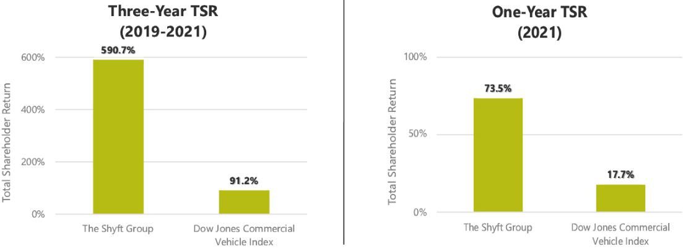

- Linked Pay with Performance

  - In 2019, the Company granted Performance Share Units to executives based on achievement of 3-year growth in cumulative GAAP net income and TSR. This was consistent with the Committee’s continued focus on aligning pay with performance. The measurement period was January 1, 2019, through December 31, 2021. As discussed in the Long-Term Equity Incentive Awards section below, the management team realized 200% achievement of these goals over that 3-year period.

The Company’s Board of Directors believes its executive compensation approach and practices contribute to the Company’s success in enhancing shareholder value and driving long-term growth and profitability, as discussed in this CD&A.

29 Shyft Group // 2022 Proxy Statement

TABLE OF CONTENTS

COMPENSATION COMMITTEE

Compensation Best Practices

The Committee is firmly committed to implementing an executive compensation program that aligns management and shareholder interests, encourages executives to drive sustainable shareholder value creation, mitigates risk, attracts top talent, and helps retain key people. A summary of what we do and do not do in that regard follows:

WHAT WE DO |  | WHAT WE DON’T DO

Pay for Performance We tie pay to performance. The majority of NEO pay is not guaranteed, but is generally conditioned upon the achievement of predetermined financial goals related to corporate performance.


Mitigate Undue Risk Our compensation practices are designed to discourage excessive risk-taking as related to performance and payout under our compensation programs.

Reasonable Executive Severance and Change-of-Control Benefits Our post-employment and change-of-control severance benefits are designed to be consistent with competitive market practice.

Share Ownership Guidelines Our guidelines for share ownership align executives’ interests with those of our shareholders. Each NEO has exceeded this share ownership requirement.

Regular Review of Share Utilization We evaluate share utilization by reviewing the dilutive impact of equity compensation on our shareholders and the aggregate shares awarded annually as a percentage of total outstanding shares.

Clawback Policy We have a policy to recoup incentive compensation awards (1) if made to an executive as the result of a material financial restatement attributable to the executive’s misconduct or (2) in the case of certain misconduct.

Review Tally Sheets The Committee reviews tally sheets for our NEOs to ensure they have a clear understanding of the impact of various decisions, including possible payments under various termination scenarios prior to making annual executive compensation decisions.

Double Trigger Change-of-Control Severance Benefits Our Management Severance Plan provides for payment of cash severance and accelerated vesting of equity awards after a change-of-control only if an executive experiences a qualifying termination of employment within a limited period following the change-of-control.

Independent Compensation Consulting Firm The Committee benefits from its utilization of an independent compensation consulting firm which provides no other services to the Company.

No Excise Tax Gross-Ups Upon Change-of-Control We do not provide for excise tax gross-ups on change-of-control payments.


No Repricing Underwater Stock Options or Stock Appreciation Rights Without Shareholder Approval We do not permit underwater stock options or stock appreciation rights to be repriced without shareholder approval.

No Hedging Transactions, Short Sales or Pledging Our policies prohibit all employees, including NEOs, and directors from engaging in hedging or short sales with respect to the Company’s stock and executives from pledging Company stock.

No Excessive Perquisites for Executives We provide only limited perquisites.

No Guaranty on Incentive Payouts No guaranteed minimum payout of annual or long-term performance awards.

30 Shyft Group // 2022 Proxy Statement

TABLE OF CONTENTS

COMPENSATION COMMITTEE

Summary of Key Compensation Decisions and Outcomes for 2021

The key compensation decisions the Committee made for 2021 are summarized below and discussed in greater detail in the remainder of this CD&A.

Base Salary Adjustments

The Committee approved base salary increases for all NEOs in 2021 to better align their pay with market median per our compensation philosophy and to recognize individual performance.

Annual Incentive Compensation Program

For fiscal year 2021, the annual incentive compensation program (“AIC”) for Messrs. Adams, Douyard, and Heavin was subject to the following performance metrics and weightings to evaluate and determine final payouts for the year: Company Adjusted EBITDA: 65%, Company free cash flow: 15%, and individual management business objectives (“MBO”): 20%.

- Based on performance, the 2021 AIC payouts for Messrs. Adams and Douyard were earned at 148% of target and Mr. Heavin’s was earned at 138% of target.

For fiscal year 2021, the AIC for Messrs. Guillaume and Heminover was subject to the following performance measures and weightings to evaluate and determine final payouts for the year: Company Adjusted EBITDA: 40%, Company free cash flow: 10%, segment Adjusted EBITDA 30%, and individual MBOs: 20%.

- Based on the performance of the Company, our Fleet Vehicles and Services segment and Mr. Heminover’s MBO performance, his 2021 AIC payout was earned at 144% of target.

- Based on the performance of the Company, our Specialty Vehicles segment and Mr. Guillaume’s MBO performance, his 2021 AIC payout was earned at 126% of target.

Long-Term Incentive Compensation Program

In 2021, the Committee granted performance share units (“PSUs”) and service-based restricted share units (“RSUs”) to the NEOs. For each NEO, the total long-term incentive (“LTI”) target award value was allocated 70% to PSUs and 30% to RSUs. All awards earned will be settled in shares. Specifically:

- In March 2021, the Committee approved an annual LTI award of RSUs and PSUs to the NEOs. The RSUs vest in three equal installments on the first three anniversaries of the grant date of the award. The PSUs are subject to a performance period of 36 months and cliff vesting at the end of the performance period following Committee approval. These PSU awards are subject to TSR and cumulative GAAP net income performance measures, as further described below.

In addition to the 2021 annual LTI award, as previously disclosed in the Company’s proxy statement for its 2021 annual meeting of shareholders, the Committee approved the following equity awards:

- Each of the NEOs received a one-time special grant of RSUs in recognition of their performance in response to the COVID-19 pandemic, labor shortages, and supply chain disruptions. The RSUs were granted to each NEO on March 30, 2021 and vest ratably over a three-year period.

- Mr. Heminover received a special equity award of 12,000 RSUs on March 30, 2021, which cliff vests on the third anniversary of the award subject to his continued employment. This award was given to recognize the increasing importance of the Fleet Vehicles and Services segment to the overall performance of the Company, the scope of Mr. Heminover’s responsibilities, and the retention of his services.

31 Shyft Group // 2022 Proxy Statement

TABLE OF CONTENTS

COMPENSATION COMMITTEE

Say-on-Pay Vote and Shareholder Engagement

The advisory vote on executive compensation was conducted at our annual meeting of shareholders in 2021, based on the disclosure of our executive compensation in the proxy statement for that meeting. Of the shares of common stock represented at that meeting in person or by proxy that participated in the advisory vote, over 91% voted to approve the resolution. Our Board considered the results of this vote to be supportive of the Company’s compensation policies and programs and did not make any changes to such policies and programs as a result of such vote.

The Company takes meaningful measures to engage with its shareholders, including through attendance at multiple investor conferences throughout the year and regular phone calls, in-person meetings, and other communications, including periodic investor/analyst day events. Although the COVID-19 pandemic required many of our shareholder interactions in 2021 to be conducted virtually, the Company increased its shareholder interactions in 2021 over prior years, including participating in a virtual investor/analyst day event to stay well-connected with shareholders and their concerns. The Company works to be responsive to all shareholder inquiries raised to the Company in an effort to fully engage with shareholders and respond to shareholder concerns.

Compensation Framework

The mix of target total direct compensation (base salary, target annual incentive awards, and target long-term incentive awards) for 2021 was structured to deliver the approximate proportions set forth below of total compensation to our Chief Executive Officer and the other NEOs (on average) if target levels of performance are achieved. The Committee believes the percentage of an executive’s total compensation that is “at risk” should increase as the executive’s responsibilities and ability to influence profits increase. For this reason, the percentage of an executive officer’s potential compensation that is based on bonuses and equity awards is larger relative to other employees.
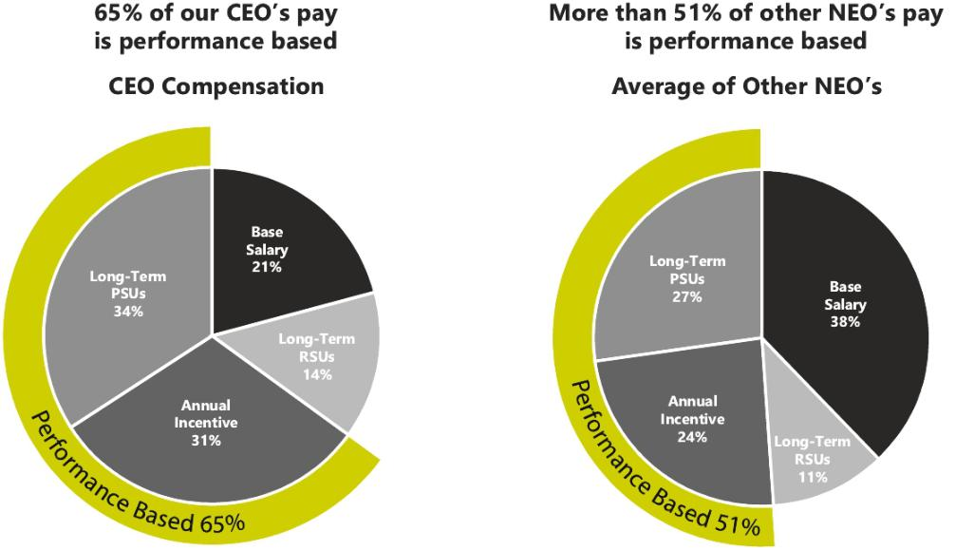

32 Shyft Group // 2022 Proxy Statement

TABLE OF CONTENTS

COMPENSATION COMMITTEE

Elements of Compensation

The 2021 Leadership Team Compensation Plan (the “LTC Plan”) sets forth the framework for compensation of the Company’s executive officers and other key employees, including each of the NEOs. The LTC Plan is intended to provide management with incentives to drive strategies and investments that maximize shareholder value, use financial measurements consistent with the market’s evaluation of the Company’s performance, and communicate the Company’s financial objectives in a clear and quantifiable manner. Total compensation is targeted at the median of the market and our peer group. The Committee is responsible for annually reviewing the provisions of the LTC Plan and all resulting payouts.

A summary of the primary features of the LTC Plan is as follows:

Component | Pay Element |  |  | 2021 Metrics & Weighting |  | Objectives
Base Salary | Cash |  | • Benchmark: Peer group median |  |  | • Attract and retain qualified executives
Annual | Cash |  | Annual cash incentive bonuses are capped at |  |  | • Drive profitability, growth, and progress
Incentive |  |  | 200% of target and are based on achieving |  |  | against strategy
Compensation |  |  | the following performance metrics:
(AIC) |  |  | Corporate Officers: Metrics for 2021 were |  |  | • Individual MBO goals set to motivate
 |  |  | weighted as follows: |  |  | executives to deliver on certain goals and
 |  |  |  |  |  | objectives specific to their areas of
 |  |  | • Company Adjusted EBITDA: 65% |  |  | responsibility
 |  |  | • Company Free Cash Flow: 15%
 |  |  | • | MBO Goals: 20%
 |  |  | Segment Presidents: Metrics for 2021
 |  |  | were weighted as follows:
 |  |  | • Company Adjusted EBITDA: 40%
 |  |  | • Company Free Cash Flow: 10%
 |  |  | • Segment Adjusted EBITDA: 30%
 |  |  | • | MBO Goals: 20%
Long-Term | Performance |  |  | 70% LTIC weighting |  | • Focus executives on shareholder value
Incentive | Share Units |  |  |  |  | creation
Compensation | (PSU)
(LTIC) |  |  | • PSUs are capped at 200% of target and |  |  | • Relative TSR closely aligns our executive
 |  |  |  | are based on achieving the following |  | level measurement system with the
 |  |  |  | performance metrics: |  | experience of shareholders
 |  |  | • Three-year TSR relative to the Dow |  |  | • Net income is a key indicator of
 |  |  |  | Jones Commercial Vehicle Index: 60% |  | profitability and company performance
 |  |  | • Three-year cumulative GAAP net income:
 |  |  |  | 40%
 | Restricted |  |  | 30% LTIC weighting |  | • Retention, ownership, and full alignment
 | Stock Units |  |  |  |  | with shareholder interests
 | (RSU) |  | • Awards vest ratably over three years

33 Shyft Group // 2022 Proxy Statement

TABLE OF CONTENTS

COMPENSATION COMMITTEE

Benchmarking

The Committee periodically engages independent third-party consultants to provide data and analysis regarding the compensation of executives at our peer group companies and at companies with whom we compete for talent. The Committee uses this data to design and implement competitive compensation programs.

With the assistance of its third-party consultant, Mercer, the Committee has established a group of peer companies that are:

- in similar industries in which the Company competes for executive talent and capital, including auto parts and equipment, automobile manufacturers, construction machinery and heavy trucks, electronic manufacturing services, and industrial machinery; and

- of similar size (as primarily measured by annual revenue), within a range of approximately one-third to three times the Company’s revenue that results in a median revenue close to that of the Company’s.

The Company’s 2021 peer group used for this purpose consisted of ⁽¹⁾:

Alamo Group, Inc. | Enerpac Tool Group Corporation | REV Group, Inc.
Altra Industrial Motion Corporation | ESCO Technologies, Inc. | Shiloh Industries, Inc.
Astec Industries, Inc. | Federal Signal Corporation | Standard Motor Products
Blue Bird Corporation | LCI Industries, Inc. | The Manitowoc Company, Inc.
Columbus McKinnon Corporation | Lindsay Corporation | Wabash National Corporation
Commercial Vehicle Group, Inc. | Lydall Corporation
Douglas Dynamics, Inc. | Miller Industries, Inc.

- Since this analysis was completed, the following companies were removed from the Peer Group: Lydall Corporation due to merger and Shiloh Industries, Inc. due to it being acquired.

In late 2020, the Committee engaged Mercer to update the benchmarking analysis that reviewed total direct compensation (consisting of base salary, target bonus, and the value of long-term incentive grants) of the NEOs at the median of the peer group, with the intention that the total direct compensation of these executives would be set at amounts that are in the market median range. In performing this review, Mercer conducted benchmarking analysis of the NEO’s compensation, including base salaries, short- and long-term incentives, and severance practices, using information from proxy disclosures and published surveys.

The Committee considered the peer group data when making compensation decisions in 2021. The NEO compensation levels generally reflect the Committee’s views on general business conditions, each NEO’s tenure in the applicable role, and the importance of placing higher value on performance-based compensation.

Neither Mercer nor any of its affiliates provided any additional services during 2021 to the Company or any of its affiliates (beyond those described above).

Base Salary

Base salary is a fundamental component of the Company’s compensation program, and overall competitive salary levels are necessary to attract and retain well-qualified executives. The Committee determines recommended compensation for executive officers by evaluating the responsibilities of the position, experience of the individual, Company performance, performance of the individual, competitive marketplace for similar management talent, and other relevant factors. The Committee does not give specific weight to any particular factor.

34 Shyft Group // 2022 Proxy Statement

TABLE OF CONTENTS

COMPENSATION COMMITTEE

As noted above, Mercer was engaged in late 2020 to benchmark the salaries of the Company’s NEOs. The Committee made recommendations for 2021 base salaries consistent with this competitive benchmarking process. For 2021, the Company implemented the base salary adjustments shown below in April 2021.

 | Base Salary - | Base Salary - | % Change from
Named Executive Officer | July 2020 | April 2021 | Prior Year
Daryl Adams | $735,000 | $800,000 | 8.8%
Jonathan Douyard | $425,000 | $437,800 | 3.0%
Stephen Guillaume | $336,000 | $346,100 | 3.0%
Todd Heavin | $385,000 | $396,600 | 3.0%
Chad Heminover | $380,000 | $400,000 | 5.3%

These base salary adjustments are intended to provide greater alignment of executive total compensation levels with the Company’s stated compensation philosophy of targeting the market median.

Annual Incentive Compensation Awards

The LTC Plan provides an opportunity for our NEOs to earn an AIC bonus based upon achievement against key metrics that reflect the top priorities for business performance. The LTC Plan requires management to annually review the metrics and weightings based upon current business conditions and to obtain approval of the proposed framework from the Committee.

Each participant’s AIC bonus is determined as follows:
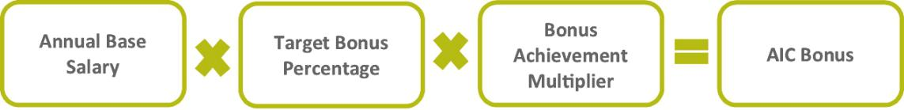

The target bonus percentage is a percentage of the participant’s salary. The LTC Plan establishes the target bonus percentage at 150% of base salary for our CEO, 70% of base salary for our CFO, and 60% of base salary for each of our other NEOs. In 2021, the Committee increased the CFO’s target bonus percentage from 60% to 70% based on its assessment of Mercer’s benchmarking review.

The AIC bonus achievement multiplier is a multiple of the target bonus percentage. For example, achievement of bonus metrics at exactly the target amounts would result in a bonus multiplier of 1.0X. The threshold (minimum) bonus multiplier is 0.5X and the maximum bonus multiplier is 2.0X. At the end of each year, based on management’s recommendations, the Committee evaluates performance against the pre-established metrics to determine the bonus achievement multiplier.

35 Shyft Group // 2022 Proxy Statement

TABLE OF CONTENTS

COMPENSATION COMMITTEE

The AIC award opportunities and results for our NEOs for 2021 were as follows:

Annual Cash Incentive Award Opportunity and Actual Award as a % of Base Salary

 | Named Executive Officer | Threshold | Target | Maximum | Actual
 | Daryl Adams | 75% | 150% | 300% | 222%
 | Jonathan Douyard | 35% | 70% | 140% | 104%
 | Stephen Guillaume | 30% | 60% | 120% | 76%
 | Todd Heavin | 30% | 60% | 120% | 83%
 | Chad Heminover | 30% | 60% | 120% | 86%

The LTC Plan prohibits an AIC bonus to our NEOs for any year in which the Company incurs a net loss. However, the Board retains the right to make adjustments or grant discretionary bonuses as it deems appropriate. The Board did not grant any discretionary cash bonuses in 2021.

At the discretion of the Committee, any AIC bonus payable under the LTC Plan may be paid in the form of the Company’s common stock. All AIC bonuses for 2021 were paid in cash.

Executives subject to the LTC Plan for a partial year are eligible for annual incentive bonuses on a prorated basis, unless otherwise approved by the Committee.

2021 Annual Incentive Compensation

For 2021, the tables below show the performance metrics and targets established for our NEOs to earn an AIC bonus under the LTC Plan. The Committee selected Company Adjusted EBITDA as the key metric for all of our NEOs because it is viewed as the primary indicator of the performance and strength of our business on a long-term basis. For similar reasons, the Adjusted EBITDA of a segment is used as a metric for the leader of that segment. Free cash flow is used as a metric for our NEOs because of its relationship to the Company’s profitability. For each executive, the AIC bonus is also based, in part, on MBOs, specific objectives established for that executive’s near-term performance.

36 Shyft Group // 2022 Proxy Statement

TABLE OF CONTENTS

COMPENSATION COMMITTEE

Corporate Incentive Plan Metrics (Messrs. Adams, Douyard, and Heavin):

 |  | Performance Criteria for Payouts at ($ in 000s):
 |  | Min. | Target | Max.
 |  | (50% | (100% | (200% | Actual | Actual |  | Weighted
Metric |  | payout) | payout) | payout) | Performance | Payout % | Weight | %
Company Adjusted EBITDA⁽¹⁾ |  | $81,998 | $102,497 | $122,996 | $108,066 | 127% | 65% | 83%
Company Free Cash Flow⁽¹⁾ |  | $32,560 | $ 40,700 | $ 48,840 | $ 51,007 | 200% | 15% | 30%
 |  |  |  |  | Financial Objectives Factor |  |  | 113%
For Messrs. Adams and Douyard:
MBO Goals Achievement⁽²⁾ |  | 0% | 100% | 200% | 175% | 175% | 20% | 35%
 |  |  |  | Total Financial and MBO Multiplier |  |  |  | 148%
For Mr. Heavin: MBO Goals
Achievement⁽³⁾ |  | 0% | 100% | 200% | 125% | 125% | 20% | 25%
 |  |  |  | Total Financial and MBO Multiplier |  |  |  | 138%

- See GAAP reconciliation in Appendix A. Appendix A also reflects certain additional adjustments that were made to the Adjusted EBITDA reported by the Company in its Annual Report on Form 10-K filed with the SEC on February 24, 2022 (the “2021 Form 10-K”), for purposes of calculating the NEOs annual cash incentive compensation for 2021.

- The Committee recognized the contributions Messrs. Adams and Douyard made in 2021 with a 175% multiple of their MBO metric.

Mr. Adams was recognized for his role in guiding our strong and consistent financial performance in fiscal 2021. Under his disciplined management of our business, we continued to deploy capital in an effective manner including with the formation of Shyft Innovations, our dedicated corporate mobility research and development team focused initially on introducing a Class 3 purpose built EV chassis. In addition, Mr. Adams’ executive leadership positioned the Company to deliver shareholder return of more than 73% in 2021.

Mr. Douyard was recognized for his leadership of the Company’s 2021 financial performance. His leadership also facilitated continued success in developing a strong financial team, implementing process improvements, and enhancing our internal control environment.

- The Committee recognized Mr. Heavin’s contributions in 2021 with a 125% multiple of his MBO metric. During 2021, Mr. Heavin provided leadership in setting up our Velocity® F2 manufacturing facilities and the continued standardization of Shyft manufacturing. Mr. Heavin was also instrumental in the deployment of capital expenditures that drove improvements in our manufacturing locations.

Fleet Vehicles and Segment Unit Incentive Plan Metrics (Mr. Heminover):

 |  | Performance Criteria for Payouts at ($ in 000s):
 |  | Min. | Target | Max.
 |  | (50% | (100% | (200% | Actual | Actual |  | Weighted
Metric |  | payout) | payout) | payout) | Performance | Payout % | Weight | %
Company Adjusted EBITDA⁽¹⁾ |  | $81,998 | $102,497 | $122,996 | $108,066 | 127% | 40% | 51%
Company Free Cash Flow |  | $32,560 | $ 40,700 | $ 48,840 | $ 51,007 | 200% | 10% | 20%
Segment Adjusted EBITDA⁽¹⁾⁽²⁾ |  | $88,012 | $110,015 | $132,018 | $117,712 | 135% | 30% | 41%
MBO Goals Achievement⁽³⁾ |  | 0% | 100% | 200% | 160% | 160% | 20% | 32%
 |  |  |  | Total Financial and MBO Multiplier |  |  |  | 144%

- See GAAP reconciliation in Appendix A. Appendix A also reflects certain additional adjustments that were made to the Adjusted EBITDA reported by the Company in its 2021 Form 10-K, for purposes of calculating the NEO’s annual cash incentive compensation for 2021.

- See Note 17, Business Segments in the Notes to Consolidated Financial Statements of our 2021 Form 10-K. Segment Adjusted EBITDA used above is adjusted to reflect actual timing of the segment reorganization versus the full year recast required within our 2021 Form 10-K.

- The Committee recognized Mr. Heminover’s contributions in 2021 with a 160% multiple of his MBO metric primarily due to his role in the 2021 financial performance of the FVS business and disciplined focus on innovation, including the introduction of key products such as the Velocity® F2, a Class 2 walk-in van, and the Velocity® M3 walk-in van.

37 Shyft Group // 2022 Proxy Statement

TABLE OF CONTENTS

COMPENSATION COMMITTEE

Specialty Vehicles Segment Incentive Plan Metrics (Mr. Guillaume):

 |  | Performance Criteria for Payouts at ($ in
 |  |  | 000s):
 |  | Min. | Target | Max.
 |  | (50% | (100% | (200% | Actual | Actual |  | Weighted
Metric |  | payout) | payout) | payout) | Performance | Payout % | Weight | %
Company Adjusted EBITDA⁽¹⁾ |  | $81,988 | $102,497 | $122,996 | $108,066 | 127% | 40% | 51%
Company Free Cash Flow |  | $32,560 | $ 40,700 | $ 48,840 | $ 51,007 | 200% | 10% | 20%
Segment Adjusted EBITDA⁽¹⁾⁽²⁾ |  | $28,488 | $ 35,610 | $ 42,732 | $ 35,230 | 99% | 30% | 30%
MBO Goals Achievement⁽³⁾ |  | 0% | 100% | 200% | 125% | 125% | 20% | 25%
 |  |  |  | Total Financial and MBO Multiplier |  |  |  | 126%

- See GAAP reconciliation in Appendix A. Appendix A also reflects certain additional adjustments that were made to the Adjusted EBITDA reported in our 2021 Form 10-K, for purposes of calculating the NEOs’ annual cash incentive compensation for 2021.

- See Note 17, Business Segments in the Notes to Consolidated Financial Statements in our 2021 Form 10-K. Segment Adjusted EBITDA used above is adjusted to reflect actual timing of the segment reorganization versus the full year recast required within our 2021 Form 10-K.

- The Committee recognized Mr. Guillaume’s contributions in 2021 with a 125% multiple of his MBO metric primarily based on his role in the 2021 financial performance of the Specialty Vehicle business and his success in assuming leadership of our Montebello, California truck body operation and Strobes-R-Us brand in Florida.

Long-Term Equity Incentive Awards

The Company’s equity compensation plans are designed to encourage long-term investment in the Company by participating executives and employees, more closely align executive and shareholder interests, and reward executive officers and other employees for building shareholder value. The Committee believes stock ownership by management and other employees is beneficial to all Company stakeholders. See the minimum stock ownership requirements for executive officers under “Risk Mitigation - Director and Executive Share Ownership Requirements” below.

The Company currently has the ability to grant equity-based compensation to its NEOs pursuant to the 2016 Stock Incentive Plan, as amended (the “2016 Stock Plan”). The Committee administers all aspects of the 2016 Stock Plan.

Long-term equity incentives for NEOs include (1) the grant of RSUs with time-based vesting, and (2) the grant of PSUs, which are subject to the achievement of certain performance metrics over a cumulative three-year period. The Committee believes using a combination of PSUs and RSUs further enhances alignment of executive compensation with shareholder value creation and achievement of key business objectives while focusing participants on long term performance and strategic decision making. As such, 30% of an NEO’s target long-term incentive compensation (“LTIC”) award is comprised of RSUs and the other 70% is awarded in PSUs. The greater proportion allocated to PSUs reflects the Committee’s emphasis on performance-based rather than time-based equity compensation. These awards are described in more detail below.

Each NEO’s target LTIC award for a particular year is based on a percentage of the executive’s annual base salary. The LTC Plan establishes the target LTIC award at 235% of base salary for our CEO; 125% of base salary for our CFO; 100% of base salary for our COO and the President of our Fleet Vehicles and Services segment; and 75% of base salary for the President of our Specialty Vehicles segment. Based on the benchmarking analysis completed in late 2020, the Committee increased the target awards for our CEO (from 225% to 235%), our CFO (from 100% to 125%), and the President of our Specialty Vehicles segment (from 70% to 75%). These decisions are consistent with our compensation philosophy described above to align executive pay with the market median.

Restricted Share Units (RSUs)

The LTC Plan provides that 30% of the value of each executive’s annual LTIC award will be granted in the form of RSUs. The award is generally made on the last business day of March, with the number of RSUs granted based on the average of the closing stock price over the preceding 30 calendar days. The RSUs vest ratably over a three-year period, subject to any exceptions set forth in the applicable award agreement.

38 Shyft Group // 2022 Proxy Statement

TABLE OF CONTENTS

COMPENSATION COMMITTEE

Performance Share Units (PSUs)

The portion of each annual LTIC award to be made in the form of PSUs is designed to reward the NEOs based upon achievement of cumulative financial performance over a three-year period (with cliff vesting at the end of such three-year performance period) starting with the performance year in which the annual LTIC award is granted. For grants made in 2021, two cumulative financial performance metrics apply:

- 60% of the value of the PSUs is based on the Company’s TSR over the three-year performance period relative to the Dow Jones Commercial Vehicle Index; and

- 40% of the value of the PSUs is based on the Company’s cumulative GAAP net income over the three-year performance period. For this purpose, net income is calculated in accordance with GAAP, subject to such adjustments as may be approved by the Committee.

The LTC Plan provides that the number of PSUs earned with respect to a three-year performance period is determined as follows:

- Achievement of TSR over the performance period relative to the Dow Jones Commercial Vehicle Index (60% weighting):

Percentile Rank Compared to Index | Payout as Percentage of Target
Less than 25th percentile | 0%
25th percentile (Threshold) | 50%
50th percentile (Target) | 100%
75th percentile (Maximum) | 200%

With respect to both the Company’s stock and the stock of each company in the Dow Jones Commercial Vehicle Index, TSR performance will be calculated (a) using a 20-trading day average of the stock price ending on the first day and last day of the performance period, and (b) assuming all dividends declared during the performance period are reinvested at the closing price on the applicable ex-dividend date. Achievement between the stated percentages will be interpolated on a straight-line basis.

- Achievement of cumulative GAAP net income over the performance period (40% weighting):

Cumulative GAAP Net Income |  | Payout as Percentage of Target
Less than $119,500,000 |  | 0%
$119,500,000 (threshold) |  | 50%
$170,700,000 | (target) | 100%
$204,800,000 | (maximum) | 200%

Achievement between the stated dollar amounts will be interpolated on a straight-line basis.

At the end of the three-year performance period, the executive will be issued shares of the Company’s common stock in settlement of the PSUs, if earned, with the number of shares calculated based on the Company’s TSR over the three-year performance period relative to the Dow Jones Commercial Vehicle Index and the Company’s cumulative GAAP net income over the three-year performance period. The aggregate number of shares earned may be between 0% and 200% of the number of PSUs granted.

39 Shyft Group // 2022 Proxy Statement

TABLE OF CONTENTS

COMPENSATION COMMITTEE

2021 Long-Term Equity Incentive Compensation

For 2021, our NEOs were granted the following annual LTIC awards:

 |  |  | Number of RSUs | No. of PSUs
 |  |  | Granted | Granted
 |  | Target LTIC | (30% of Target | (70% of Target
Named Executive Officer |  | Award for 2021 | LTIC Award) | LTIC Award)
Daryl Adams | $1,880,000 |  | 15,452 | 36,055
Daryl Adams |  | (235% of base salary) | 15,452 | 36,055
Jonathan Douyard | $547,250 |  | 4,498 | 10,495
Jonathan Douyard |  | (125% of base salary) | 4,498 | 10,495
Stephen Guillaume | $259,575 |  | 2,134 | 4,978
Stephen Guillaume |  | (75% of base salary) | 2,134 | 4,978
Todd Heavin | $396,600 |  | 3,260 | 7,606
Todd Heavin |  | (100% of base salary) | 3,260 | 7,606
Chad Heminover | $400,000 |  | 3,288 | 7,672
Chad Heminover |  | (100% of base salary) | 3,288 | 7,672

All of these RSUs and PSUs were granted on March 30, 2021 and were calculated using the average stock price of the Company’s common stock over the preceding 30 calendar days, which was $36.50 per share. The RSUs granted in 2021 will vest ratably over a three-year period. The PSUs granted in 2021 will be earned (or forfeited) based on the Company’s performance over the three-year period from January 1, 2021 through December 31, 2023, based on the metrics described above.

Results of 2019 Grant of PSUs for 2019 - 2021 Performance Period

The following information describes the performance goals for the PSU awards made in 2019 (the “2019 PSU Award”), the results relative to such performance goals, and the shares awarded pursuant to the 2019 PSU Award.

The PSU awards made to the participating NEOs in 2019 consisted of 60% that could be earned based on the achievement of the Company’s TSR percentile rank relative to the Dow Jones Commercial Vehicle Index, and 40% that could be earned based on cumulative GAAP net income performance, in each case based on the performance period January 1, 2019 through December 31, 2021. Overall achievement could vary from 0% of the target award to 200% of the target award (assuming maximum performance), with no portion of the award earned with respect to a metric if performance fell below the threshold level for that metric.

The TSR and cumulative GAAP net income performance levels, achieved results, and resulting percentage of target award achieved for the 2019 PSU Awards are summarized in the following tables. If performance was above the threshold level for either metric but between two performance levels shown in the applicable table, the payout percentage was determined based on straight-line interpolation.

- TSR performance matrix (60% weighting):

Percentile Rank Compared to Index | Payout as Percentage of Target
Less than 25th percentile | 0%
25th percentile (Threshold) | 50%
50th percentile (Target) | 100%
75th percentile (Maximum) | 200%

40 Shyft Group // 2022 Proxy Statement

TABLE OF CONTENTS

COMPENSATION COMMITTEE

- Cumulative GAAP net income matrix (40% weighting)

 |  | Payout as
Cumulative GAAP Net Income |  | Percentage of Target
Less than $47,100,000 |  | 0%
$47,100,000 | (Threshold) | 50%
$67,300,000 | (Target) | 100%
$80,700,000 | (Maximum) | 200%

Over the three-year performance period, achievement under the 2019 PSU Awards was as follows:

 |  |  |  | % of Target
 | Results Achieved | Attainment | Weighting | Achieved
 | TSR = 591%, | 200% | 60% | 120%
TSR | 100th Percentile | 200% | 60% | 120%
Cumulative GAAP net income⁽¹⁾ | Achieved | 200% | 40% | 80%
Cumulative GAAP net income⁽¹⁾ | $137million | 200% | 40% | 80%
 |  | Total Payout |  | 200%

- The Board approved an adjustment to cumulative GAAP net income for asset impairments, accelerated depreciation, and loss on sale of certain discontinued operations. Without the approved adjustment, cumulative GAAP net income would still have reached 200% attainment. Operating results of discontinued operations are included in the measurement.

Shares earned by the executives as a result of the achievement mentioned above for the 2019 PSU Awards are as follows:

 | Target PSU | Shares Awarded
 | Awards at 100% | as a Result of
Named Executive Officer | Attainment | 200% Attainment
Daryl Adams | 111,617 | 223,234
Jonathan Douyard | N/A⁽¹⁾ | —
Stephen Guillaume | 14,590 | 29,180
Todd Heavin | N/A⁽¹⁾ | —
Chad Heminover | 14,064 | 28,128

- Messrs. Douyard and Heavin were not employed at the time of this grant in 2019.

Human Resources and Compensation Committee Processes and Procedures

The Committee develops and recommends to the Board of Directors the Company’s executive compensation policies. The Committee also administers the Company’s executive compensation program and recommends for approval to the Board the compensation to be paid to the CEO and other executive officers. The Committee is made up of independent directors, none of whom is a current or former employee of the Company.

The Company’s Chief Human Resources Officer (CHRO) serves as a coordinator at Committee meetings but does not participate in any decisions regarding executive or Board compensation. The Company’s CEO, CFO, and Chief Legal Officer (CLO) participate only to assist in the process of determining the compensation for executives other than themselves and to provide information to the Committee regarding Company performance, operations, strategies, and other information requested by the Committee. Other than the CEO, CFO, CLO and CHRO, none of the Company’s executive officers participate in any discussions of the Committee.

41 Shyft Group // 2022 Proxy Statement

TABLE OF CONTENTS

COMPENSATION COMMITTEE

The Committee’s written charter provides that the Committee will review and make recommendations regarding the compensation of executive officers. The Committee’s policy is to conduct benchmarking of executive officers’ salaries at least once every two years. Executive compensation decisions must be approved by a majority of the independent members of the Board.

Personal Benefits and Perquisites

We believe that compensation in the form of perquisites and personal benefits does not provide transparency for shareholders or serve our compensation philosophy. Therefore, the Company offers limited perquisites in the form of executive physicals, additional life and disability insurance, occasional spousal travel and reimbursement of the CEO’s club membership dues. The limited perquisites and personal benefits we provide are disclosed in the Summary Compensation Table below and detailed in footnote 4 to that table.

Retirement and Other Benefits

We do not provide a defined benefit pension plan to our NEOs, although we do provide a defined contribution plan (401(k) plan). In addition, we provide a Supplemental Executive Retirement Plan (SERP) as part of a compensation package to attract and retain executives. The SERP is a non-qualified defined contribution plan that allows our executives to defer compensation and provides for certain matching contributions by the Company in addition to those provided under the Company’s qualified retirement plans. The Company offers this additional program for the potential to enhance total executive pay so that it remains competitive in the market. The SERP is described in more detail under “Non-Qualified Deferred Compensation” below.

Risk Mitigation

We believe our compensation policies and programs are designed in a manner such that they do not create incentives or risks that are reasonably likely to result in a material adverse effect on the Company. These policies and programs are designed to balance our executive compensation among appropriate short- and longer-term incentives and create the appropriate mix of fixed compensation as well as compensation that is contingent on the achievement of objectives, we believe will enhance shareholder value. In addition, we have several policies and practices in place designed to mitigate risks associated with our executive compensation practices, including:

Director and Executive Share Ownership Requirements

Our Board members and executives are required to attain ownership of our common stock, within five years of being named to their position, at least equal to the following minimums:

• | Non-employee directors: | 5 times annual cash Board retainer
• | CEO: | 5 times annual base salary
• | All other named executives: | 3 times annual base salary

Shares owned directly by Board members or executives, shares owned through a 401(k) plan or IRA, unvested restricted shares or RSUs that are subject to time-based vesting, shares previously owned by executives but placed in irrevocable trusts for family members or in revocable trusts, and shares determined to have actually been earned and issuable pursuant to PSUs awarded to the director or executive are counted toward these ownership requirements. Unexercised options, unexercised stock appreciation rights, and shares underlying PSUs (except to the limited extent described in the preceding sentence) are not counted toward the ownership requirements. As of December 31, 2021, all of the NEOs and directors were in compliance with the share ownership guidelines then applicable to them.

42 Shyft Group // 2022 Proxy Statement

TABLE OF CONTENTS

COMPENSATION COMMITTEE

Anti-Hedging Policy

The Company’s anti-hedging policy prohibits employees, including NEOs, and directors from engaging in any transaction that is designed to hedge or offset any decrease in the market value of our stock, including transactions in puts, calls, prepaid variable forward contracts, equity swaps, collars and exchange funds. This policy includes stock held directly or indirectly by a director or executive officer, as well as any stock granted to a director or executive officer by the Company as part of the compensation of a director or executive officer. The policy also prohibits our employees, including our NEOs, and directors from engaging in short sales related to the common stock. Under the policy, directors and executive officers are prohibited from pledging shares of the Company’s stock.

Pricing of Equity Awards

The price used to determine the number of RSUs granted to our executives is generally an average of the closing share price for the 30 calendar days prior to the grant date. We do not “backdate” any equity-based awards. The Board is committed to maintaining the integrity of our compensation philosophy and programs. As part of this commitment, the Company believes that the disclosure of material nonpublic information should never be manipulated for the purpose of enriching compensation awards. We do not time the release of public information to affect the value of share-based awards, and we do not time the grant of share-based awards to take advantage of the disclosure of information.

Clawback Provision

The Committee has implemented a recoupment (or clawback) policy subjecting incentive compensation and grants under the Company’s equity compensation plans to executive officers to potential recoupment. The Board has the authority to trigger recoupment in the event of (1) a material financial restatement or manipulation of a financial measure on which compensation is based and where the employee’s intentional misconduct contributed to the restatement or manipulation and, but for such misconduct, a lesser amount of compensation would have been paid, or (2) certain misconduct by the executive. The Committee will reevaluate and, if necessary, revise the Company’s recoupment policy to comply with the Dodd-Frank Wall Street Reform and Consumer Protection Act once the rules implementing the recoupment requirements have been finalized by the SEC.

43 Shyft Group // 2022 Proxy Statement

TABLE OF CONTENTS

Summary Compensation Table

 |  |  |  | Non-Equity | All Other
 |  |  | Stock | Incentive Plan | Compen-
Name and Principal |  | Salary⁽¹⁾ | Awards⁽²⁾ | Compensation⁽³⁾ | sation⁽⁴⁾ | Total
Position | Year | ($) | ($) | ($) | ($) | ($)

 | 2021 | $782,500 | $2,554,773 | $1,776,000 | $34,654 | $5,147,927
Daryl Adams | 2020 | 710,500 | 1,978,913 | 1,764,000 | 42,354 | 4,495,767
President and Chief Executive Officer
 | 2019 | 703,460 | 1,749,581 | 1,890,000 | 52,780 | 4,395,821
Jonathan Douyard | 2021 | 434,354 | 730,236 | 453,561 | 16,019 | 1,634,170
Chief Financial Officer | 2020 | 322,673 | 753,377 | 408,000 | 423,184 | 1,907,234
 | 2021 | 343,547 | 403,539 | 261,652 | 16,831 | 1,025,569
Stephen Guillaume | 2020 | 317,450 | 281,452 | 241,920 | 28,764 | 869,586
President,
Specialty Vehicles
 | 2019 | 288,118 | 228,697 | 329,400 | 25,808 | 872,023
Todd Heavin | 2021 | 393,477 | 538,326 | 328,385 | 37,350 | 1,297,538
Chief Operating Officer | 2020 | 364,000 | 1,064,369 | 369,600 | 22,752 | 1,820,721
 | 2021 | 394,615 | 983,214 | 345,600 | 12,059 | 1,735,488
Chad Heminover | 2020 | 351,700 | 454,724 | 364,800 | 28,488 | 1,199,712
President, Fleet
Vehicles and Services
 | 2019 | 286,154 | 220,446 | 317,520 | 48,843 | 872,963

- 2021 salary amounts reflect the total base wages paid to each NEO during the year.

- Amounts shown in this column represent the aggregate grant date fair value of stock awards noted in the Grants of Plan-Based Awards table below. The fair values were determined in accordance with FASB ASC Topic 718, “Stock Compensation.” For information regarding valuation assumptions for the 2021 awards, see Note 14 – Stock Based Compensation to the Consolidated Financial Statements for the year ended December 31, 2021. Assuming the highest level of performance is achieved for the PSUs granted in 2021, the grant date fair values of all stock awards granted in 2021 would be $4,319,810 for Mr. Adams, $1,244,009 for Mr. Douyard, $910,679 for Mr. Heavin, $1,358,785 for Mr. Heminover, and $647,236 for Mr. Guillaume.

- Amounts shown in this column represent the annual cash incentive bonuses paid to our NEOs under our LTC Plan, as described above.

- The amounts reported in this column consist of the following:

 |  | Dividends
 | 401(k) | Paid on
 | Matching | Restricted
Named Executive | Contribution | Stock | Executive |  | Other^{(a)} | Total
Officer | ($) | ($) | Life Insurance |  | Other^{(a)} | ($)
Daryl Adams | $8,990 | $1,429 | $11,029 | $13,206 |  | $34,654
Jonathan Douyard | 9,750 | — | 3,065 | 3,204 |  | 16,019
Stephen Guillaume | 8,186 | 208 | 6,400 | 2,037 |  | 16,831
Todd Heavin | 9,750 | — | 27,600 |  | — | 37,350
Chad Heminover | 7,704 | 203 | 760 | 3,392 |  | 12,059

- For Mr. Adams, these costs include $9,611 for a club membership and $3,595 for spousal travel. For Messrs. Douyard, Heminover and Guillaume, these amounts are for spousal travel.

44 Shyft Group // 2022 Proxy Statement

TABLE OF CONTENTS

Summary Compensation Table

Grants of Plan-Based Awards During 2021

The following table provides information concerning each grant of a plan-based award made to the NEOs in the last completed fiscal year.

Grants of Plan-Based Awards

 |  |  |  | Estimated Possible |  |  |  | Estimated Possible |  |  |  |  | All Other
 |  |  |  |  |  |  |  |  |  |  |  |  | Stock
 |  |  |  | Payouts Under Non-Equity |  |  |  | Payouts Under Equity |  |  |  |  | Awards: |  | Grant Date
 |  |  |  | Incentive Plan Awards⁽¹⁾ |  |  |  | Incentive Plan Awards⁽²⁾ |  |  |  |  | Number of |  | Fair Value of
 |  |  |  |  |  |  |  |  |  |  |  |  | Shares of |  | Stock and
 | Award / |  |  |  |  |  |  |  |  |  |  |  | Stock or |  | Option
Named Executive | Grant | Grant |  | Threshold | Target | Maximum |  | Threshold | Target | Maximum |  |  | Units |  | Awards
Officer | Type | Date |  | ($) | ($) | ($) |  | (#) | (#) | (#) |  |  | (#)⁽³⁾ |  | ($)⁽⁴⁾
 | AIC |  | $600,000 |  | $1,200,000 | $2,400,000 |  | — | — | — |  |  | — |  | —
Daryl Adams | PSUs | 3/30/21 |  | — | — | — |  | 18,028 | 36,055 | 72,110 |  |  | — |  | $1,765,036
 | RSUs | 3/30/21 |  | — | — | — |  | — | — | — |  | 21,507 |  |  | 789,737
 | AIC |  | 153,230 |  | 306,460 | 612,920 |  | — | — | — |  |  | — |  | —
Jonathan Douyard | PSUs | 3/30/21 |  | — | — | — |  | 5,248 | 10,495 | 20,990 |  |  | — |  | 513,772
 | RSUs | 3/30/21 |  | — | — | — |  | — | — | — |  | 5,895 |  |  | 216,464
 | AIC |  | 103,830 |  | 207,660 | 415,320 |  | — | — | — |  |  | — |  | —
Stephen Guillaume | PSUs | 3/30/21 |  | — | — | — |  | 2,489 | 4,978 | 9,956 |  |  | — |  | 243,697
 | RSUs | 3/30/21 |  | — | — | — |  | — | — | — |  | 4,353 |  |  | 159,842
 | AIC |  | 118,980 |  | 237,960 | 475,920 |  | — | — | — |  |  | — |  | —
Todd Heavin | PSUs | 3/30/21 |  | — | — | — |  | 3,803 | 7,606 | 15,212 |  |  | — |  | 372,352
 | RSUs | 3/30/21 |  | — | — | — |  | — | — | — |  | 4,520 |  |  | 165,974
 | AIC |  | 120,000 |  | 240,000 | 480,000 |  | — | — | — |  |  | — |  | —
Chad Heminover | PSUs | 3/30/21 |  | — | — | — |  | 3,836 | 7,672 | 15,344 |  |  | — |  | 375,571
 | RSUs | 3/30/21 |  | — | — | — |  | — | — | — |  | 16,548 |  |  | 607,643

- The amounts reported in these three columns relate to the annual cash incentive awards granted to the executives in March 2021 pursuant to our LTC Plan. These awards were payable based on various objectives to be achieved during 2021, as discussed under “Compensation Discussion and Analysis – Annual Cash Incentive Awards” above. In March 2022, the actual amounts payable to the executives pursuant to these awards were determined and paid as reflected in the “Non-Equity Incentive Plan Compensation” column of the Summary Compensation Table above.

- The amounts reported in these three columns reflect the grant of PSUs in 2021 pursuant to our LTC Plan. The PSUs represent shares of the Company’s common stock and are issuable to executives following the three-year performance period of 2021 - 2023 based on the Company’s TSR relative to the Dow Jones Commercial Vehicle Index and cumulative GAAP net income over such performance period, as discussed under “Compensation Discussion and Analysis – Long-Term Equity Incentive Awards” above. Each threshold amount assumes an LTIC multiple of 0.5X; each target amount assumes an LTIC multiple of 1.0X; and each maximum amount represents the maximum number of shares issuable pursuant to the PSUs granted, which for 2021 was a multiple of 2.0X.

- These are the RSUs granted to each executive on March 30, 2021, as discussed under “Compensation Discussion and Analysis – Long-Term Equity Incentive Awards” above. All such RSUs vest ratably over a three-year period, with the exception that Mr. Heminover also received a grant of 12,000 RSUs listed in this column that vests on the third anniversary of the award.

- Amounts reported in this column represent the aggregate grant date fair value of the equity-based awards (PSUs and RSUs) and were computed in accordance with FASB ASC Topic 718.

The Company paid the compensation set forth in the Summary Compensation Table and the Grants of Plan Based Awards table pursuant to the philosophy, procedures, and practices as described in the “Compensation Discussion and Analysis” section above.

45 Shyft Group // 2022 Proxy Statement

TABLE OF CONTENTS

Summary Compensation Table

Outstanding Equity Awards at December 31, 2021

The following table provides information concerning outstanding equity awards as of December 31, 2021.

Outstanding Equity Awards at Fiscal Year-End

 |  |  | Stock Awards
 | Number of | Market Value of | Equity Incentive Plan | Equity Incentive Plan
 | Shares or Units | Shares or Units | Awards: Number of | Awards: Market or Payout
 | of Stock That | of Stock That | Unearned Shares, Units or | Value of Unearned Shares,
 | Have Not | Have Not | Other Rights That Have | Units or Other Rights That
Named Executive | Vested⁽¹⁾ | Vested⁽²⁾ | Not Vested⁽³⁾ | Have Not Vested⁽²⁾
Officer | (#) | ($) | (#) | ($)
Daryl Adams | 83,445 | $4,099,653 | 246,248 | $11,887,102
Jonathan Douyard | 26,150 | 1,284,750 | 65,252 | 1,706,039
Stephen Guillaume | 13,038 | 640,557 | 34,783 | 1,620,160
Todd Heavin | 24,666 | 1,211,841 | 113,078 | 2,852,488
Chad Heminover | 27,449 | 1,348,569 | 55,603 | 2,132,242

- This column reports the total number of shares underlying outstanding RSUs that have not vested as of December 31, 2021. Vesting dates for these outstanding awards are as follows:

 |  |  |  | Vesting Dates
Named Executive Officer |  | 3/29/2022 | 3/30/2022 | 4/15/2022 | 3/30/2023 | 3/30/2024
Daryl Adams |  | 19,056 | 20,638 | 15,945 | 20,637 | 7,169
Jonathan Douyard |  | — | 12,093 | — | 12,092 | 1,965
Stephen Guillaume |  | 2,770 | 3,367 | 2,084 | 3,366 | 1,451
Todd Heavin |  | — | 11,579 | — | 11,580 | 1,507
Chad Heminover |  | 2,702 | 4,611 | 2,009 | 4,611 | 13,516

- The market value of unvested shares is determined by multiplying the closing market price of the Company’s common stock as of December 31, 2021 ($49.13) by the number of unvested shares.

- This column reports the number of shares underlying unearned PSUs.

In calculating the number of performance shares and their value, we compare the Company’s performance through 2021 under each outstanding performance share grant against the threshold, target, and maximum performance levels for the grant and report in this column the applicable potential or forecasted payout amount. If the performance is between levels, we report the potential payout at the next highest level.

 |  |  | Vesting Dates
Named Executive Officer |  | 12/31/2022^{(a)} | 12/31/2023^{(b)}
Daryl Adams |  | 188,560 | 57,688
Jonathan Douyard |  | 48,460 | 16,792
Stephen Guillaume |  | 26,818 | 7,965
Todd Heavin |  | 100,908 | 12,170
Chad Heminover |  | 43,328 | 12,275

- For the shares that vest on 12/31/2022, the PSUs subject to the cumulative GAAP net income and TSR performance metrics are forecast and shown at maximum.

- For the shares that vest on 12/31/2023, the PSUs subject to the cumulative net GAAP income performance metric are forecast and shown at target. The PSUs subject to the TSR performance metric are forecast and shown at maximum.

46 Shyft Group // 2022 Proxy Statement

TABLE OF CONTENTS

Summary Compensation Table

Stock Vested in 2021

The following table provides information concerning the vesting of restricted stock during 2021 for each of the NEOs.

 | Stock Awards
 | Number of Shares | Value Realized
 | Acquired on Vesting | on Vesting⁽¹⁾
Named Executive Officer | (#) | ($)
Daryl Adams | 83,779 | $3,073,407
Jonathan Douyard | 10,129 | 371,937
Todd Heavin | 10,075 | 369,954
Chad Heminover | 10.489 | 384,390
Stephen Guillaume | 11,901 | 436,253

- The amounts in this column are determined by multiplying the number of shares of stock vesting by the market value of the underlying shares on the vesting date (or, if the vesting date is not a trading day, the trading day immediately preceding the vesting date).

Non-Qualified Deferred Compensation

The Company maintains a Supplemental Executive Retirement Plan (the “SERP”), a non-qualified defined contribution plan administered by the Committee, that allows eligible participants to defer compensation and incentive amounts and provides for discretionary matching and profit-sharing type contributions by the Company. The SERP is operated much like the Company’s 401(k) plan, but participation is limited to a select group of employees determined by the Board of Directors. The SERP is a funded plan, however, the participants are merely general creditors of the Company. The SERP’s assets are subject to the claims of other creditors of the Company in some circumstances. In 2021, none of the NEOs participated in the SERP.

The SERP allows participants to defer up to 25% of their base salary and up to 50% of their cash bonuses each year. At the beginning of each plan year, the Committee may elect to match all or a specified portion of each participant’s contribution for that year. The Committee will generally provide that each participant will receive a matching contribution equal to the matching contribution that the participant would have received under the Company’s 401(k) plan but for limitations imposed by federal tax law. In addition, the Committee may, in its discretion, make an additional matching contribution and/or a profit-sharing type contribution to the SERP each year.

Contributions to the SERP are transferred to an irrevocable rabbi trust where each participant has a bookkeeping account in their name. Earnings on each participant’s SERP balance are determined by the investment election of the participants. The investment options available to participants consist primarily of mutual funds offered by Fidelity Investments.

All participants are always fully vested in their elective deferrals, and such deferrals will be distributed upon termination of employment, death, disability, or a change in control of the Company. Amounts are also distributable upon an unforeseeable emergency. Matching and profit-sharing contributions contributed by the Company will vest at a rate of 20% per year over a five-year period and may be distributed upon the later of attainment of age 60 and termination of employment, or upon earlier death, disability, or change in control of the Company. Any unvested matching or profit-sharing contributions will become fully vested if a participant retires upon reaching age 60, dies, or becomes disabled. Matching contributions and profit-sharing contributions may be forfeited if the participant enters into competition with the Company, divulges confidential information about the Company, or induces Company employees to leave their employment to compete with the Company.

Distributions from the SERP may be made in a lump sum or in an installment plan not to exceed 10 years (at the election of the participant).

47 Shyft Group // 2022 Proxy Statement

TABLE OF CONTENTS

Summary Compensation Table

Severance Benefits

We maintain a Management Severance Plan (“Severance Plan”) for the primary purpose of providing certain severance benefits to a select group of our key management employees designated by our Committee. All of our NEOs participate in the Severance Plan.

Under the Severance Plan, a participant who is terminated by the Company without cause (as defined in the Severance Plan) is entitled to receive the following severance benefits:

- Base salary continuation (at the rate in effect immediately prior to qualifying termination or, if greater, the rate in effect at any time within 180 days prior to the qualifying termination) for a period of 18 months following termination for our CEO and a period of 12 months for the other NEOs.

- If the threshold is satisfied for annual incentive cash bonus eligibility under the LTC Plan for the fiscal year in which the qualifying termination occurs, the severance benefit will include a pro rata portion of the target incentive bonus for that year (based on the number of complete calendar months that have elapsed in that year prior to the qualifying termination). Any such pro rata bonus will be calculated and paid following completion of the performance year in question.

- If the executive enrolls in COBRA, then during the applicable salary continuation period (18 months for our CEO and 12 months for the other NEOs), the Company will pay a portion of the executive’s COBRA premiums equal to the portion of such premiums (if any) the Company would have paid with respect to the executive had employment with the Company continued.

- All outstanding unvested shares of restricted stock and RSUs will be fully vested as of the date of termination. PSUs that are outstanding at the date of termination will generally be settled (i.e., shares of common stock issued to the executive) at the time the PSU would have otherwise been settled in accordance with its terms, following completion of the relevant performance period and subject to the achievement of the performance conditions for such PSUs, but with the executive receiving only a pro rata portion of the shares the executive would have otherwise received (based on the number of complete calendar months that have elapsed in the performance period prior to the qualifying termination).

- The executive will be entitled to receive reasonable outplacement services during the applicable salary continuation period (18 months for our CEO and 12 months for the other NEOs), up to a maximum of $10,000 per year.

Notwithstanding the foregoing, if the employment of an NEO is terminated by the Company without cause (as determined by the Committee) or by the executive for “good reason” following a “change in control” of the Company, as each of those terms is defined in our 2016 Stock Plan, then the severance benefit payable to our CEO is equal to twice his annual salary plus the target annual incentive cash award (without proration), and the severance benefit payable to our other NEOs is equal to the respective NEO’s annual salary plus the target annual incentive cash award (without proration).

An executive’s receipt of these severance benefits is conditioned on the participant executing a release of claims in favor of the Company and complying with certain non-competition, non-solicitation, confidentiality, and other provisions in favor of the Company for the applicable salary continuation period (18 months for our CEO and 12 months for the other NEOs).

This summary of the Severance Plan is subject in its entirety to the actual provisions of the plan.

Potential Payments Upon Termination or Change-in-Control

The following table summarizes the payments and benefits payable to the Company’s NEOs upon termination of employment in connection with each of the triggering events set forth in the table below, assuming, in each situation, that the triggering event took place on December 31, 2021. The closing market price of The Company’s common stock was $49.13 on December 31, 2021. The summary provided below is subject to the actual provisions of each applicable plan. Upon voluntary resignation, no payments are due to any NEO in the table below.

48 Shyft Group // 2022 Proxy Statement

TABLE OF CONTENTS

Summary Compensation Table

Triggering Events, Payments and Benefits

 | Change in Control
 | and NEO Resigns
 | for Good Reason or
 | is Terminated | Termination |  |  | Death or
Named Executed Officer | Without Cause | Without Cause | Retirement⁽¹⁾ |  | Disability⁽²⁾
Daryl Adams
Vesting of equity awards | $7,778,098 | $7,778,098 | $ |  | $10,503,011
Severance | 1,600,000 | 1,200,000 |  |  | —
Annual incentive cash | 2,400,000 | 1,200,000 |  |  | 1,776,000
COBRA & Outplacement | 47,830 | 47,830 |  |  | —
Total | $ 11,825,928 | $ 10,225,928 | $ | — | $12,279,011
Jonathan Douyard
Vesting of equity awards | $2,250,236 | $2,250,236 | $ |  | $2,990,789
Severance | 437,800 | 437,800 |  |  | —
Annual incentive cash | 306,460 | 306,460 |  |  | 453,561
COBRA & Outplacement | 34,495 | 34,495 |  |  | —
Total | $ 3,028,991 | $ 3,028,991 | $ | — | $3,444,350
Stephen Guillaume
Vesting of equity awards | $1,079,746 | $1,079,746 | $ |  | $1,299,341
Severance | 346,100 | 346,100 |  |  | —
Annual incentive cash | 207,660 | 207,660 |  |  | 261,697
COBRA & Outplacement | 36,486 | 36,486 |  |  | —
Total | $ 1,669,992 | $ 1,669,992 | $ | — | $1,561,038
Todd Heavin
Vesting of equity awards | $2,988,938 | $2,988,938 | $ |  | $4,064,328
Severance | 396,600 | 396,600 |  |  | —
Annual incentive cash | 237,960 | 237,960 |  |  | 328,385
COBRA & Outplacement | 27,185 | 27,185 |  |  | —
Total | $ 3,650,683 | $ 3,650,683 | $ | — | $4,392,713
Chad Heminover
Vesting of equity awards | $2,183,779 | $2,183,779 | $ |  | $2,789,847
Severance | 400,000 | 400,000 |  |  | —
Annual incentive cash | 240,000 | 240,000 |  |  | 345,600
COBRA & Outplacement | 34,495 | 34,495 |  |  | —
Total | $ 2,858,274 | $ 2,858,274 | $ | — | $3,135,447

- In the event of a “qualified retirement” during the performance year (defined as the NEO reaching age 62 and 5 years of continuous service with the Company), our LTC Plan provides for a prorated payment of the annual cash incentive bonus actually earned for a performance year and our equity award agreements generally provide that unvested equity awards are not forfeited. However, none of our NEOs had reached age 62 as of December 31, 2021 and so would not meet the requirements for a qualified retirement.

- In the event of an NEO’s termination due to death or disability, per the terms of the LTCP and the 2016 Stock Plan, the NEO would be entitled to receive accelerated vesting of all outstanding unvested shares of restricted stock and RSUs and all unvested PSUs at target, and a pro rata portion of the target incentive bonus for that year (based on the number of complete calendar months that have elapsed in that year prior to the qualifying termination). Any such pro rata bonus will be calculated and paid following completion of the performance year in question.

49 Shyft Group // 2022 Proxy Statement

TABLE OF CONTENTS

Summary Compensation Table

CEO Pay Ratio

As required by SEC rules, we are providing the following information to explain the relationship between the annual total compensation of Mr. Adams, who served as the President and CEO in 2021, and the annual total compensation of the median employee of the Company, excluding our CEO.

As of December 31, 2021, the Company employed approximately 3,250 employees, all located within the United States. The Company’s philosophy is to pay our employees competitively and equitably with similar positions in the applicable labor markets by providing a combination of competitive base pay, incentives, and other benefits. We benchmark our compensation levels by position and adjust compensation to align with the applicable labor market. By doing so, we believe it allows us to maintain a high quality and stable workforce.

To identify, and determine the annual total compensation of, the median employee, we used the following methodology:

- The Company selected December 31, 2021 as the determination date for identifying the median employee for purposes of this pay ratio disclosure.

- We examined the annual compensation paid to each of our employees (including full-time and part-time employees, but excluding contract employees employed through a third party) that were employed as of December 31, 2021. This consisted of a total of approximately 3,250 employees (excluding Mr. Adams), all located within the United States.

- The annual compensation used for this analysis included each element of compensation listed in the Summary Compensation Table above, as well as employer contributions toward benefits such as health insurance that are available on an equal basis to all employees (which are not required to be included in the Summary Compensation Table).

- We annualized the total compensation for any employee who was not employed for all of 2021. We did not make any other adjustments to any employee’s compensation or exclude any employees for this analysis.

- We then ranked all of our employees (except for Mr. Adams) in terms of total compensation from highest to lowest and identified the employee that ranked as the median.

Following this methodology, the components of our pay ratio disclosure for 2021 were reasonably estimated as follows:

- The annual total compensation of the median employee was $43,273.

- The annual total compensation of our CEO, Mr. Adams, was $5,163,910.

- The ratio of our CEO’s compensation to the compensation of the median employee was 119:1.

50 Shyft Group // 2022 Proxy Statement

TABLE OF CONTENTS

Compensation of Directors

Compensation for the Board of Directors is established by the full Board based on input from external compensation experts. Decisions regarding the Company’s non-employee director compensation program are informed by market practice data gathered from the same peer group companies utilized for executive compensation benchmarking. The following table provides the compensation paid to the directors for the Company’s last completed fiscal year.

 |  | Fees Earned or | Stock Awards⁽²⁾
 | Name⁽¹⁾ | Paid in Cash | Stock Awards⁽²⁾ |  | Total
 | Name⁽¹⁾ | ($) | ($) |  | ($)
James Sharman, Chair |  | $110,000 | $142,314 |  | $252,314
Daryl Adams⁽¹⁾ |  | — | — |  | —
Thomas Clevinger |  | 60,000 | 101,627 |  | 161,627
Richard Dauch⁽³⁾ |  | 56,739 | 101,627 |  | 158,366
Michael Dinkins |  | 67,500 | 101,627 |  | 169,127
Carl Esposito⁽⁴⁾ |  | — | — |  | —
Angela Freeman |  | 70,000 | 101,627 |  | 171,627
Ronald Harbour |  | 60,000 | 101,627 |  | 161,627
Paul Mascarenas⁽⁵⁾ |  | 70,000 | 101,627 |  | 171,627
Terri Pizzuto⁽⁶⁾ |  | 45,000 | 101,627 |  | 146,627
Mark Rourke⁽⁷⁾ |  | 45,000 | 101,627 |  | 146,627

- Mr. Adams received no additional compensation for his service as a director. All compensation paid to Mr. Adams as president and CEO is reported in the Summary Compensation Table above.

- Amounts shown in this column represent the aggregate grant date fair value of the stock awards granted during 2021. As of December 31, 2021, each independent director had outstanding the following aggregate number of unvested stock awards:

 | Outstanding
 | Stock Awards:
Name | Number of Shares
James Sharman, Chair | 3,837
Thomas Clevinger | 2,740
Richard Dauch⁽³⁾ | —
Michael Dinkins | 2,740
Carl Esposito⁽⁴⁾ | —
Angela Freeman | 2,740
Ronald Harbour | 2,740
Paul Mascarenas | 2,740
Terri Pizzuto | 4,137
Mark Rourke | 4,137

- Mr. Dauch resigned from the Board on July 26, 2021.

- As Mr. Esposito joined the Board on March 14, 2022, he did not receive any compensation in 2021.

- As Mr. Mascarenas elected to receive 33% of his cash retainer in stock under the terms of the Directors’ Stock Purchase Plan (discussed below), he received $22,993 of fees earned in the form of stock.

- Ms. Pizzuto joined the Board on January 4, 2021.

- Mr. Rourke joined the Board on January 4, 2021.

51 Shyft Group // 2022 Proxy Statement

TABLE OF CONTENTS

Compensation of Directors

Cash-Based Compensation

In 2021, each non-employee director other than the Chair of the Board received an annual retainer of $60,000. The Chair of the Board received an annual retainer of $110,000. Each of the chairs of the Human Resources and Compensation Committee and the Governance and Sustainability Committee received an additional annual retainer of $10,000 while the chair of the Audit Committee received an additional annual retainer of $15,000.

Equity-Based Compensation

Non-employee directors serving on the Board on the date of the annual meeting (other than any directors retiring from the Board on that date) are awarded RSUs with a value of $100,000, except that the Board Chair receives RSUs with a value of $140,000. The number of RSUs to be granted is calculated using the stock price on the trading day immediately preceding the grant date. All RSUs vest in full on the one-year anniversary of the grant date. These RSUs are considered to be granted for future service of the directors (i.e., in advance). As a result, non-employee directors who join the Board after the annual meeting receive a prorated grant of RSUs based on the number of weeks served prior to the next annual meeting.

Directors’ Stock Purchase Plan

Directors are also eligible to participate in the Company’s Directors’ Stock Purchase Plan. This plan provides that non-employee directors may elect to receive at least 25% and up to 100% of their “director’s fees” in the form of the Company’s common stock. “Director’s fees” means the amount of income payable to a non-employee director for their service as a director of the Company, including payments for any retainer fee paid to such persons as members of the Board or any committee. A non-employee director who elects to receive common stock in lieu of some or all of their director’s fees will, on or shortly after each “applicable date,” receive a number of shares of common stock (rounded down to the nearest whole share) determined by dividing (1) the dollar amount of the director’s fees payable to the director on the applicable date by (2) the market value of common stock on the applicable date. The term “applicable date” means any date on which a director’s fee is payable to the participant. In 2021, a total of 640 shares of our common stock were issued to directors pursuant to this plan.

52 Shyft Group // 2022 Proxy Statement

TABLE OF CONTENTS

Compensation of Directors

Compensation Committee Report

The Human Resources and Compensation Committee has reviewed and discussed with management the information provided under the heading “Compensation Discussion and Analysis” above. Based on this review and discussion, the Human Resources and Compensation Committee recommended to the Board of Directors that the Compensation Discussion and Analysis be included in Shyft’s annual report on Form 10-K and in this proxy statement.

Respectfully submitted,

Angela Freeman, Chair

Ronald Harbour

Paul Mascarenas

Mark Rourke

53 Shyft Group // 2022 Proxy Statement

TABLE OF CONTENTS

Ownership of Securities

The following table sets forth information with respect to the beneficial ownership of the common stock as of the Record Date by:

- Each person known by us to beneficially own more than 5% of the Common Stock;

- Each of the Company’s directors and director nominees;

- Each of the NEOs; and

- All of the Company’s directors and executive officers as a group.

The percentages of common stock beneficially owned are reported on the basis of regulations of the SEC governing the determination of beneficial ownership of securities. Under the rules of the SEC, a person is deemed to be a beneficial owner of a security if that person has or shares (1) voting power, which includes the power to vote or to direct the voting of the security,

- investment power, which includes the power to dispose of or to direct the disposition of the security, or (3) rights to acquire common stock that are currently exercisable or convertible, or will become exercisable or convertible within 60 days of the Record Date. Except as indicated in the footnotes to this table, each beneficial owner named in the table below has sole voting and sole investment power with respect to all shares beneficially owned. As of the Record Date, the Company had 35,022,947 shares outstanding.

Shares Beneficially Owned

 | Name and Beneficial Owner |  | Number | Percentage
 | abrdn plc⁽¹⁾
 | 1 George Street, Edinburgh, United Kingdom, EH2 2LL | 3,119,679 |  | 8.90%
 | BlackRock, Inc.⁽²⁾
 | 55 East 52nd Street, New York, NY 10055 | 2,288,814 |  | 6.53%
 | The Rayburn Group⁽³⁾
 | 1526 Ute Blvd., Suite 209, Room 6, Park City, Utah 84068 | 1,930,000 |  | 5.51%
 | Daryl Adams | 412,153 |  | 1.18%
 | Thomas Clevinger | 36,957 |  | *
 | Michael Dinkins | 4,480 |  | *
 | Jonathan Douyard | 18,944 |  | *
 | Carl Esposito |  | — | *
 | Angela Freeman | 15,228 |  | *
 | Stephen Guillaume | 63,017 |  | *
 | Ronald. Harbour | 26,230 |  | *
 | Todd Heavin | 17,250 |  | *
 | Chad Heminover | 37,959 |  | *
 | Paul Mascarenas | 44,630 |  | *
 | Terri Pizzuto | 4,137 |  | *
 | Mark Rourke | 4,137 |  | *
 | James Sharman | 107,258 |  | *
 | Other executive officers (1 person) |  | — | *
 | All directors and executive officers as a group (15 persons) | 792,380 |  | 2.26%

- Less than 1%.

- Information contained in the columns above and this footnote is based on a report on Schedule 13G filed with the SEC on January 28, 2022 by abrdn pls (“abrdn”). abrdn had shared voting power with respect to 3,039,484 shares of common stock and shared dispositive power with respect to 3,119,679 shares of common stock.

- Information contained in the columns above and this footnote is based on a report on Schedule 13G filed with the SEC on February 1. 2022 by BlackRock, Inc (“BlackRock”). BlackRock had sole voting power and sole dispositive power with respect to 2,288,814 shares of common stock.
- Information contained in the columns above and this footnote is based on a report on Schedule 13G filed with the SEC on December 4, 2015 by The Rayburn Group (“Rayburn”). Rayburn had sole voting power and sole dispositive power with respect to 1,930,000 shares of common stock. Rayburn also disclosed an additional 70,000 shares of common stock (in addition to the those disclosed in the column above) owned by Alexander C. McAree, the portfolio manager for Rayburn.

54 Shyft Group // 2022 Proxy Statement

TABLE OF CONTENTS

Delinquent Section 16(a) Reports

Section 16(a) of the Securities Exchange Act (“Section 16”) requires our directors, each “officer” within the meaning of Rule 16a-1(f) promulgated under the Securities Exchange Act (“Section 16 Officers”) and persons who beneficially own more than 10% of a registered class of our equity securities to file with the SEC initial reports of beneficial ownership and reports of changes in beneficial ownership of any of our equity securities. To our knowledge, based solely on a review of reports on Forms 3, 4 and 5 and amendments thereto filed electronically with the SEC and written representations from certain reporting persons that no other reports were required, we believe all of our directors and Section 16 Officers made all filings required under Section 16 during 2021 on a timely basis, except that, due to administrative error, on September 8, 2021, one Form 4 report for Mr. Harbour reporting a stock sale, was filed late. In addition, shares withheld by the Company on March 29, 2021 to satisfy tax withholding obligations incident upon the vesting of shares previously granted to Messrs. Adams, Guillaume, Heminover, and Roney were inadvertently not reported until after the applicable due date.

55 Shyft Group // 2022 Proxy Statement

TABLE OF CONTENTS

Additional Information

What is the purpose of the Annual Meeting?

During the Annual Meeting, holders of the Company’s Common Stock will act upon the matters outlined in the accompanying notice of Annual Meeting, including: to elect three directors to serve until the annual meeting in 2025; to ratify the appointment of Deloitte as the Company’s independent registered public accounting firm for the fiscal year ending December 31, 2022; to approve, on a non-binding advisory basis, the compensation paid to the Company’s NEOs; and to transact such other business as may properly come before the meeting. In addition, management will report on the performance of the Company and will respond to appropriate questions submitted by shareholders before the start of the Annual Meeting.

How will the Company conduct the Annual Meeting?

As permitted by Michigan law and our bylaws, we will conduct the Annual Meeting via webcast. In preparation for the virtual Annual Meeting (i) we will implement reasonable measures to verify that each person deemed present and permitted to vote at the meeting is a shareholder or proxy holder, (ii) we will implement reasonable measures to provide shareholders and proxy holders a reasonable opportunity to participate in the meeting and to vote on matters submitted to shareholders, including an opportunity to read or hear the proceedings of the meeting substantially concurrently with such proceedings, and (iii) we will maintain a record of any votes or other action taken by shareholders or proxy holders at the meeting. During the Q&A session of the meeting, we will answer appropriate questions submitted before the start of the Annual Meeting related to the business of the Annual Meeting, as time permits.

How do I attend and participate during the virtual Annual Meeting?

Our completely virtual Annual Meeting will be conducted on the internet via live webcast. You will be able to participate in the Annual Meeting online during the meeting by visiting www.virtualshareholdermeeting.com/SHYF2022. You also will be able to vote your shares electronically at the Annual Meeting.

All shareholders of record as of March 21, 2022 (the “Record Date”), or their duly appointed proxies, may participate in the Annual Meeting. To participate in the Annual Meeting, you will need the 16-digit control number included on your Notice, on your proxy card or on the instructions that accompanied your proxy materials. The Annual Meeting webcast will begin promptly at 10:00 a.m., Eastern Time, on May 18, 2022. We encourage you to access the meeting prior to the start time. Online access will begin at 9:45 a.m., Eastern Time, on May 18, 2022.

How do I submit questions before the virtual Annual Meeting?

Shareholders may submit questions before the Annual Meeting. If you wish to submit a question, you may do so by logging into the virtual meeting platform at www.virtualshareholdermeeting.com/SHYF2022, typing your question into the “Ask a Question” field, and clicking “Submit.” Please submit any questions before the start time of the meeting.

We reserve the right to edit profanity or other inappropriate language and to exclude questions irrelevant to the business of the Corporation or to the business of the Annual Meeting relating to or that may take into account material, nonpublic information, or relating to pending or threatened litigation, derogatory in nature or related to a personal grievance. Also, if we receive substantially similar questions, then we may group such questions together and provide a single response to avoid repetition. Questions regarding topics that are not pertinent to meeting matters or company business will not be answered.

Appropriate questions related to the business of the Annual Meeting will be answered during the Annual Meeting, subject to time constraints. Any such questions that cannot be answered during the Annual Meeting due to time constraints will be posted and answered at www.theshyftgroup.com as soon as practical after the Annual Meeting.

56 Shyft Group // 2022 Proxy Statement

TABLE OF CONTENTS

What if I have technical difficulties during the virtual Annual Meeting?

Technical support, including related technical support phone numbers, will be available on the virtual meeting platform at www.virtualshareholdermeeting.com/SHYF2022 beginning at 9:45 a.m., Eastern Time, on May 18, 2022 through the conclusion of the Annual Meeting.

Why didn’t I receive a paper copy of this proxy statement?

We have chosen to distribute our proxy materials by sending our shareholders a Notice of Internet Availability of Proxy Materials that explains how to access our proxy materials and vote online. Many other companies have transitioned to this more contemporary way of distributing annual meeting materials, often called “electronic proxy” or “Notice and Access.”

This “Notice and Access” process expedites our shareholders’ receipt of these materials, lowers the costs of proxy solicitation, and reduces the environmental impact of our annual meeting.

What if I would like to receive a paper copy of this proxy statement?

If you received a notice and would like us to send you a printed copy of our proxy materials, please follow the instructions included in your notice to request a copy.

Who is entitled to vote?

The Company’s common stock constitutes the only voting stock of the Company. As of the Record Date, there were no outstanding shares of preferred stock of the Company. Only record holders of common stock at the close of business on the Record Date are entitled to receive notice of the Annual Meeting and to vote those shares of common stock that they held on the Record Date. Each outstanding share of common stock is entitled to one vote on each matter to be voted upon at the Annual Meeting. To participate in the Annual Meeting, you will need the 16-digit control number on your Notice of Internet Availability of Proxy Materials, your proxy card or on the instructions that accompanied your proxy materials. We encourage you to access the Annual Meeting before the start time of 10:00 a.m., Eastern Time, on May 18, 2022. Please allow ample time for online check-in, which will begin at 9:45 a.m., Eastern Time, on May 18, 2022.

What constitutes a quorum?

For business to be conducted at the Annual Meeting, a quorum must be present. The presence at the Annual Meeting, in person or by proxy, of the holders of a majority of the shares of common stock issued and outstanding and entitled to vote on the Record Date will constitute a quorum for all purposes. As of the Record Date, 35,022,947 shares of common stock were issued and outstanding and entitled to vote. Broker non-votes and proxies marked with abstentions or instructions to withhold votes will be counted as present in determining whether there is a quorum.

What is the difference between holding shares as a shareholder of record and being a beneficial owner?

Shareholders of Record. If, at the close of business on the Record Date, your shares are registered directly in your name with the Company’s transfer agent, American Stock & Transfer, you are considered the shareholder of record with respect to those shares, and these proxy materials (including a proxy card) are being sent directly to you by the Company. As a shareholder of record, you have the right to grant your voting proxy directly to the Company via the proxy card or to vote electronically during the Annual Meeting.

57 Shyft Group // 2022 Proxy Statement

TABLE OF CONTENTS

Beneficial Owners. If, at the close of business on the Record Date, your shares were not issued directly in your name, but were held in a stock brokerage account or by a bank, trustee or other nominee, you are considered the beneficial owner of shares, and these proxy materials (which should also include a voting instruction card) are being forwarded to you by your broker, trustee, bank or nominee who is considered the shareholder of record with respect to those shares. As the beneficial owner, you have the right to direct your broker, trustee, bank or nominee on how to vote the shares in your account and are also invited to attend the Annual Meeting. However, since you are not the shareholder of record, you may not vote these shares during the Annual Meeting unless you request and obtain a proxy from your broker, trustee, bank or nominee. Your broker, trustee, bank or nominee should provide you with a voting instruction card for you to use in directing the broker, trustee, bank or nominee on how to vote your shares.

How do I vote?

Shareholders of Record. If you complete and properly sign the proxy card and return it to the Company, it will be voted as you direct. You may also vote via telephone or internet (as indicated on your proxy card). If you attend the virtual Annual Meeting, you may vote online during the Annual Meeting.

Beneficial Owners. If you complete and properly sign the voting instruction card and return it to your broker, trustee, bank or other nominee, it will be voted as you direct. You may also vote via telephone or internet (as indicated on your voting instruction card). If you want to vote your shares electronically during the Annual Meeting, you must request and obtain a proxy from such broker, trustee, bank or other nominee confirming that you beneficially own such shares and giving you the power to vote such shares.

Can I change my vote after I return my proxy card or voting instruction card?

Shareholders of Record. You may change your vote at any time before the proxy is exercised by filing with the Corporate Secretary of the Company, at 41280 Bridge Street, Novi, Michigan 48375, either written notice revoking the proxy or a properly signed proxy that is dated later than the proxy card. If you attend the Annual Meeting online, the individuals named as proxy holders in the proxy card will nevertheless have authority to vote your shares in accordance with your instructions on the proxy card unless you properly file such notice or new proxy.

Beneficial Owners. If you hold your shares through a bank, trustee, broker or other nominee, you should contact such person to submit new voting instructions prior to the time such voting instructions are exercised.

How will my shares be voted?

Shareholders of Record. All shares represented by the proxies mailed to shareholders will be voted electronically during the Annual Meeting in accordance with instructions given by the shareholders. Where no instructions are given, the shares will be voted (1) for the election of the Board of Directors’ nominees for three directors, (2) for the ratification of the appointment of Deloitte as the Company’s independent registered public accounting firm for the year ending December 31, 2022 and (3) for the approval, on a non-binding advisory basis, the compensation paid to the Company’s NEOs.

Beneficial Owners. The brokers, banks or nominees holding shares for beneficial owners must vote those shares as instructed, and if no instructions from the beneficial owner are received on a matter deemed to be non-routine, they may not vote the shares on that matter. Under applicable law, a broker, bank or nominee has the discretion to vote on routine matters, such as Proposal 2, but does not have discretion to vote with respect to non-routine matters, such as Proposals 1 or 3. Common stock subject to broker non-votes will be considered present at the meeting for purposes of determining whether there is a quorum. Broker non-votes will have no effect in determining the outcome of the vote on Proposals 1 or 3. Because Proposal 2 is a “routine” matter for which a broker, bank, or nominee has the discretion to vote, the Company does not expect any broker non-votes on Proposal 2. . In order to avoid a broker non-vote of your shares on this proposal, you must send voting instructions to your bank, broker or nominee.

58 Shyft Group // 2022 Proxy Statement

TABLE OF CONTENTS

What are the Board’s recommendations?

The Board recommends a vote:

Proposal 1— FOR the election of the nominated slate of directors.

Proposal 2 — FOR the ratification of the appointment of Deloitte as the Company’s independent registered public accounting firm for the fiscal year ending December 31, 2022.

Proposal 3 — FOR the approval, on a non-binding advisory basis, of the compensation paid to the Company’s NEOs.

What vote is required to approve each item?

Proposal 1 - Election of Directors.

The three nominees who receive the most votes cast at the Annual Meeting will be elected as directors, provided a quorum of at least a majority of the outstanding shares of the Company’s common stock is represented at the meeting. However, we have adopted a majority vote standard that is applicable in uncontested director elections. This means that the plurality standard will determine whether a director nominee is elected, but our majority vote standard will further require that the number of votes cast “for” a director must exceed the number of votes “withheld” from that director or the director must submit their offer of resignation for consideration by the Board. See “Majority Vote Standard” above for more details. A proxy card marked “Withhold” or “For All Except” with respect to the election of one or more directors will not be voted with respect to the director or directors indicated. Abstentions and broker non-votes will each be counted as present for purposes of determining the presence of a quorum, but will have no effect on the election of directors.

Proposal 2 - Ratification of the Appointment of Independent Registered Public Accounting Firm.

The affirmative vote of a majority of the shares of common stock voted at the meeting will be necessary to ratify the Audit Committee’s appointment of Deloitte as the Company’s independent registered public accounting firm for the fiscal year ending December 31, 2022, provided that a quorum is present. In counting votes on this proposal, abstentions and broker non-votes will be counted as not voted and therefore will not affect the outcome of this proposal. Although shareholder ratification of the appointment is not required by law and is not binding on the Company, the Audit Committee will take the appointment under advisement if such appointment is not so ratified.

Proposal 3 - Approval, on a Non-binding Advisory Basis, of the Compensation Paid to the Company’s NEOs.

The proposal to approve the compensation of our NEOs, as described in this proxy statement, is an advisory vote only. The Company will disclose the results of this vote, but is not required to take action based upon the outcome of this vote. However, the Human Resources and Compensation Committee of the Board intends to consider the outcome of the vote when considering future executive compensation arrangements. In counting votes on this proposal, abstentions and broker non-votes will be counted as not voted and therefore will not affect the outcome of this proposal.

What will happen if other matters are raised at the meeting?

If any other matter is properly submitted to the shareholders at the Annual Meeting, its adoption will generally require the affirmative vote of a majority of the shares of common stock outstanding on the Record Date that is present or represented at the Annual Meeting. The Board does not propose to conduct any business at the Annual Meeting other than as stated above.

59 Shyft Group // 2022 Proxy Statement

TABLE OF CONTENTS

How do I find out the voting results?

Preliminary voting results will be announced at the Annual Meeting and final voting results will be published by the Company in a Current Report on Form 8-K.

How may I obtain an additional copy of the proxy materials?

If you share an address with another shareholder, you may receive only one set of proxy materials unless you have provided contrary instructions. If you wish to receive a separate set of proxy materials now or in the future, please request the additional copy by contacting The Shyft Group, Inc, Attention: Investor Relations, 41280 Bridge Street, Novi, Michigan 48375, Telephone 517-543-6400, or by email to shyftlegal@theshyftgroup.com. Additionally, if you have been receiving multiple sets of proxy materials and wish to receive only one set of proxy materials, please contact the Company’s Investor Relations department in the manner provided above.

What does it mean if I receive more than one proxy card or voting instruction card?

If you receive more than one proxy card or voting instruction card, it means that you have multiple accounts with banks, trustees, brokers, other nominees and/or the Company’s transfer agent. Please sign and deliver each proxy card and voting instruction card that you receive to ensure that all of your shares will be voted. We recommend that you contact your nominee and/or the Company’s transfer agent, as appropriate, to consolidate as many accounts as possible under the same name and address.

Who pays for the solicitation of proxies?

The accompanying proxy is being solicited by the Company’s Board. The Company will bear the cost of soliciting the proxies. Officers and other management employees of the Company will receive no additional compensation for the solicitation of proxies and may use mail, e-mail, personal interview and/or telephone.

How can I access the Company’s proxy materials and Annual Report on Form 10-K?

The Financial Information subsection under “Investors” on the Company’s website, www.theshyftgroup.com, provides access, free of charge, to SEC reports as soon as reasonably practicable after the Company electronically files such reports with, or furnishes such reports to, the SEC, including proxy materials, Annual Reports on Form 10-K, Quarterly Reports on Form 10-Q, Current Reports on Form 8-K and amendments to these reports. The Company has posted printable and searchable 2021 proxy materials to the Company’s website at www.theshyftgroup.com. A copy of the Company’s Annual Report on Form 10-K for the year ended December 31, 2021, as filed with the SEC, will be sent to any shareholder, without charge, upon written request sent to the Company’s executive offices at The Shyft Group, Inc., Attention: Investor Relations, 41280 Bridge Street , Novi, Michigan 48375 or by email to shyftlegal@theshyftgroup.com.

The references to the website addresses of the Company and SEC in this proxy statement are not intended to function as a hyperlink and, except as specified herein, the information contained on such websites is not part of this proxy statement.

Is a registered list of shareholders available?

The names of shareholders of record entitled to vote electronically at the Annual Meeting will be available to shareholders entitled to vote at the meeting on May 18, 2022 at the Company’s headquarters and during the meeting, at www.virtualshareholdersmeeting.com/SHYF2022.

60 Shyft Group // 2022 Proxy Statement

TABLE OF CONTENTS

How and when may I submit a shareholder proposal or director nomination for the 2023 Annual Meeting?

For a shareholder proposal to be considered for inclusion in the Company’s proxy statement for the 2023 Annual Meeting, the Corporate Secretary must receive the written proposal at the Company’s principal executive offices no later than December 6, 2022. Such proposals also must comply with SEC regulations under Rule 14a-8 regarding the inclusion of shareholder proposals in company-sponsored proxy materials. Proposals should be addressed to The Shyft Group, Inc. Chief Legal Officer, 41280 Bridge Street, Novi Michigan 48375.

Any shareholder proposal must set forth (a) a brief description of the matter the shareholder desires to present for shareholder action, (b) the name and record address of the shareholder proposing the matter for shareholder action (c) the number of shares of the Company’s stock that are beneficially owned by the shareholder;, (d) any material interest of the shareholder in the matter proposed for shareholder action, and (e) any additional information that is required to be provided by the shareholder pursuant to Regulation 14A under the Exchange Act and the Company’s bylaws.

For a shareholder director nomination to be considered for inclusion in the Company’s proxy statement for the 2023 Annual Meeting, the Corporate Secretary must receive written notice of the shareholder’s intent to make a nomination or nominations at the Company’s principal executive offices no later than December 6, 2022.

A shareholder who intends to solicit proxies in support of director nominees other than the Company’s nominees must provide notice that sets forth the information required by Rule 14a-19 under the Exchange Act, which notice must be postmarked or transmitted electronically to the Company at its principal executive office no later than 60 calendar days prior to the anniversary date of the immediately preceding annual meeting of shareholders. However, if the date of the annual meeting is changed by more than 30 calendar days from such anniversary, then notice must be provided by the later of 60 calendar days prior to the date of the annual meeting or the 10th calendar day following the day on which public announcement of the date of the annual meeting is first made by the Company. Accordingly, for the 2023 Annual Meeting, the Company must receive such notice no later than March 19, 2023.

61 Shyft Group // 2022 Proxy Statement

TABLE OF CONTENTS

Appendix A

Non-GAAP Reconciliations

This proxy statement contains adjusted EBITDA (earnings before interest, taxes, depreciation and amortization) and free cash flow, which are non-GAAP financial measures that were used in determining annual incentive compensation for our named executives. Adjusted EBITDA is calculated by excluding items that we believe to be infrequent or not indicative of our underlying operating performance, as well as certain non-cash expenses. For the periods covered by this proxy statement, such items include restructuring and other related charges, acquisition related expenses and adjustments, and non-cash stock-based compensation expenses, loss from liquidation of JV, and non-recurring professional fees. Free cash flow is calculated as operating cash flow less capital expenditures.

The following table reconciles Income from continuing operations to Adjusted EBITDA for 2021.

 |  | 2021
 | Income from continuing operations | $69,974
 | Less: Net income attributable to non-controlling interests | (1,230)
 | Add:
 | Interest expense | 414
 | Income tax expense | 14,506
 | Depreciation & Amortization expense | 11,356
 | EBITDA | 95,020
 | Restructuring and other related charges | 505
 | Acquisition related expenses and adjustments | 1,585
 | Non-cash stock-based compensation expense | 8,745
 | Loss from liquidation of JV | 643
 | Non-recurring professional fees | 1,568
 | Adjusted EBITDA for annual cash incentive compensation | $108,066
 | A-1 | Shyft Group // 2022 Proxy Statement

TABLE OF CONTENTS

Appendix A

The following table reconciles the net increase in cash and cash equivalents to free cash flow for 2021.
 | Operating Activities
 | Net income | $ | 70,155
 | Depreciation & amortization |  | 11,356
 | Non-cash stock based compensation expense |  | 8,745
 | (Gain) on disposal of assets |  | (110)
 | Deferred income taxes |  | 880
 | Change in working capital | (17,017)
 | Net cash provided by operating activities | 74,009 (A)
 | Capital expenditures | (23,002) (B)
 | Proceeds from sale of property, plant and equipment |  | 22
 | Acquisition of businesses, net of cash acquired |  | 904
 | Proceeds from long-term debt |  | 45,000
 | Payments on long-term debt | (67,400)
 | Payments of debt issuance costs |  | (1,360)
 | Payment of dividends |  | (3,551)
 | Purchase and retirement of common stock |  | (3,348)
 | Exercise and vesting of stock incentive awards |  | (2,949)
 | Purchase of non-controlling interest |  | (2,162)
 | Net increase in cash and cash equivalents | $ | 16,163
 | Free cash flow (A+B) | $ | 51,007
A-2 |  | Shyft Group // 2022 Proxy Statement

TABLE OF CONTENTS
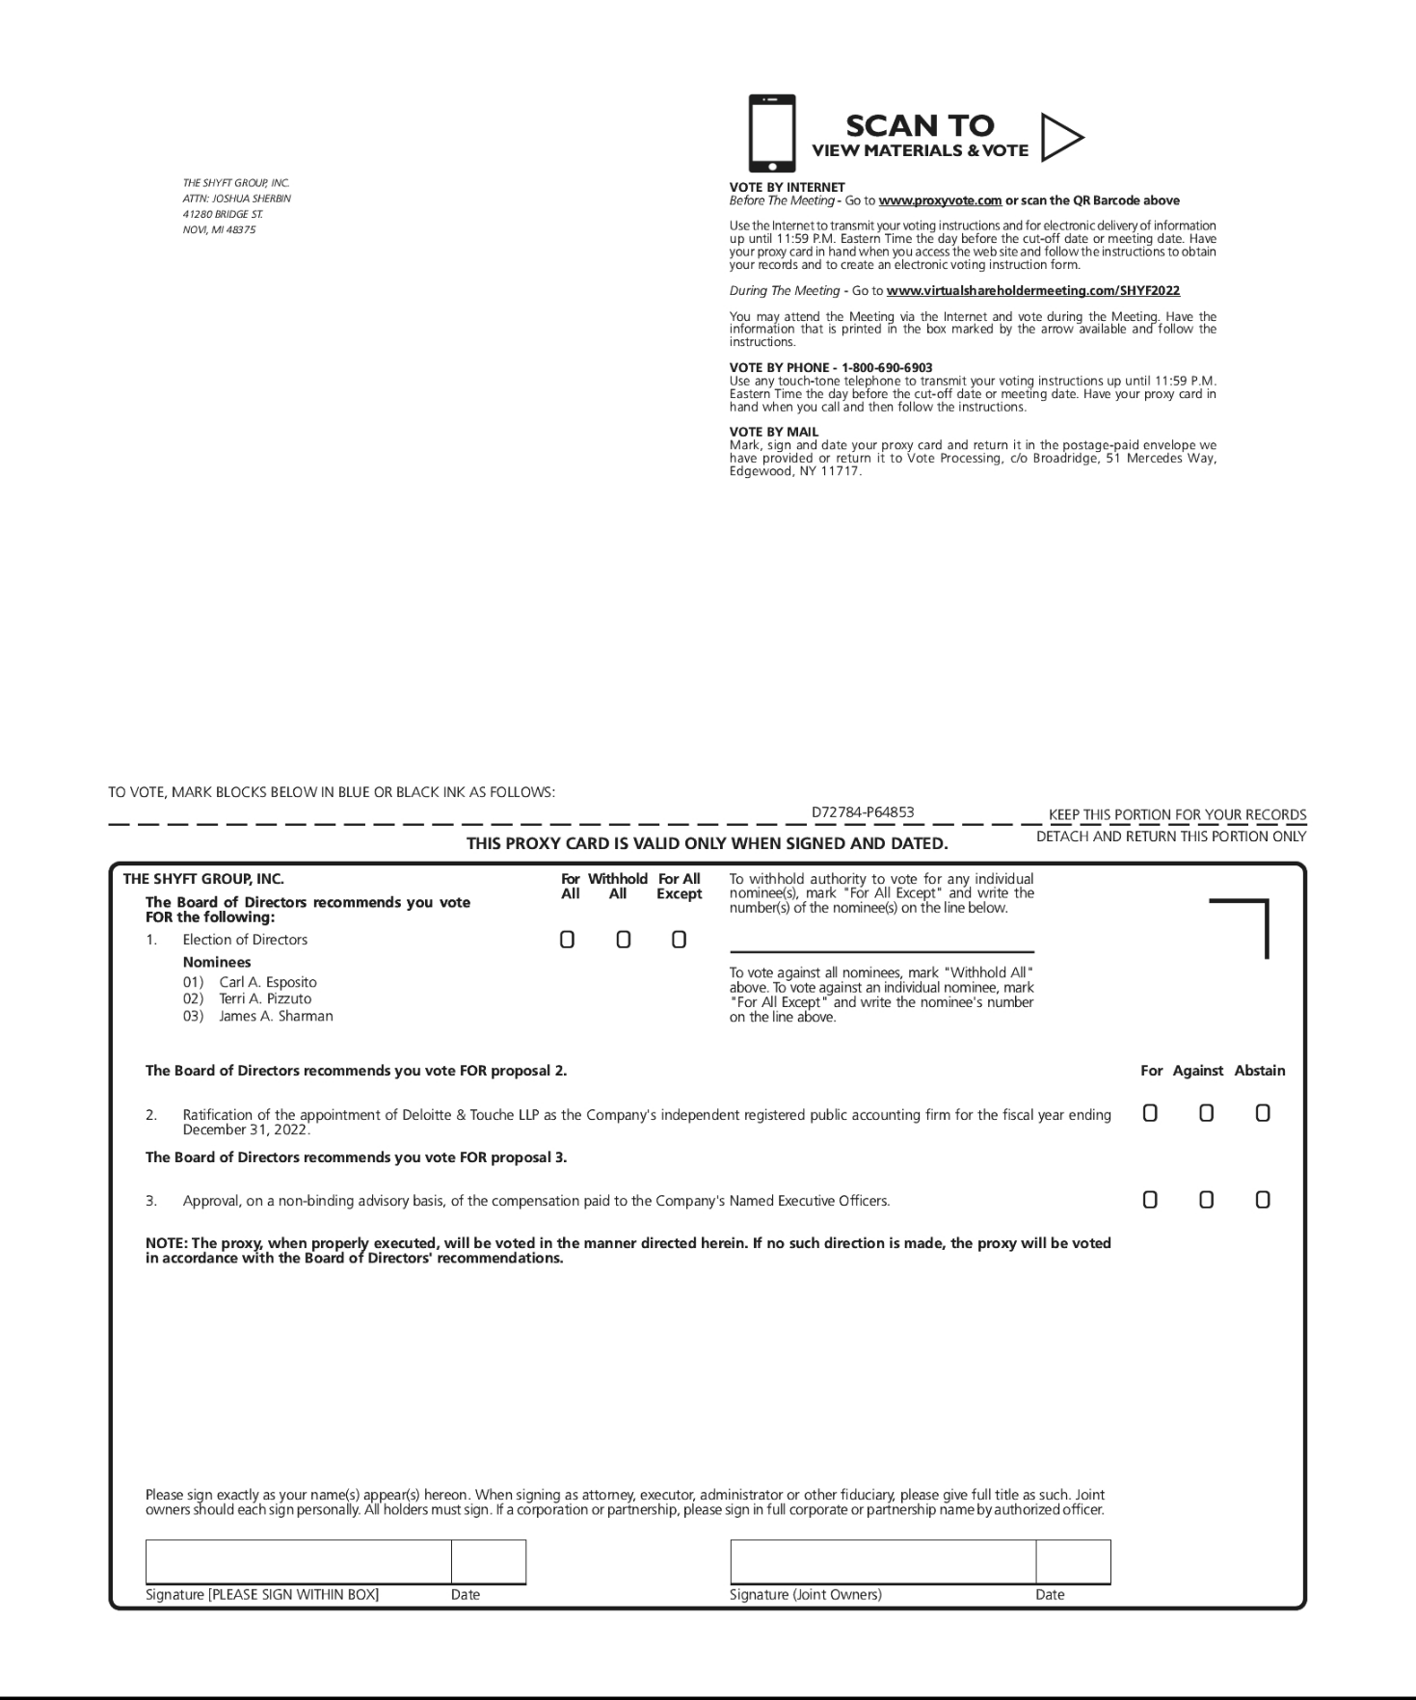

TABLE OF CONTENTS


